Effects of Compressive Stress on the Magnetostrictive Characteristics of Sm-Fe-B Films
Zhou Baiyang, Weng Zhangzhao, Li Siwen, Chen Zhijian, Liu Quanzhou,
Li Jianxin

Fuzhou University, Fuzhou 350108, China

Abstract: A set of Sm-Fe-B films with different compressive stresses were prepared on substrates with different prestrains by ion beam spurting deposition (IBSD). The influence of compressive stress on the magnetic anisotropy and the magnetostriction in sputter-deposited amorphous Sm-Fe-B films were investigated. Films affected by compressive stress all show in-plane anisotropy and easy axis along the direction of stress is induced in the film with compressive stress increasing. Magnetostriction of Sm-Fe-B films affected by compressive stress is improved in low magnetic field while saturation of magnetostriction decreases slightly. At the same time, the magnetostriction rises rapidly in low field measured in a field parallel to the film plane at room temperature with the growth of compressive stress. It is also found that the magnetic domain component which is perpendicular to the film plane increases on a small scale, though the magnetic domain or the magnetic domain component parallel to film plane still exist dominantly.

Key words: Sm-Fe-B film; compressive stress; magnetostrictive characteristics; magnetic domain

The giant magnetostrictive materials (GMM) have shown enormous magnetostriction with the value over 1000×10⁻⁶. With rising of application in micro-electro-mechanical- systems (MEMS), the giant magnetostriction materials exhibit more merits such as, highly-responsive, large dimensional change with low voltage operation and can provide a fast-responding microactuator.
The magnetostrictive susceptibility of GMM is strongly affected by the change of internal stress due to ion bombardment during depositing process ^{[1]}. Hiroyuki Wakiwaka et al. described the magnetic characteristic of stress applied Sm-Fe-B film. For amorphous magnetoelastic films, owing to the absence of magnetocrystalline anisotropy, their magnetic anisotropy is influenced greatly by stress induced anisotropy ^{[2]}. The previous report discussed that magnetostrictive susceptibility of Sm-Fe thin film increased with the increase of compressive stress, especially in low fields. However, the changing trend of magnetic properties and magnetic anisotropy with different compressive stresses is not clear. In amorphous magnetoelastic film, a controlled amount of stress can be induced by strain growth ^{[3, 4]}. Since Sm-Fe-B thin film shows higher magnetostriction susceptibility than Sm-Fe thin film due to lattice expansion with boron addition ^{[5]}, the different internal stresses of Sm-Fe-B thin film could be expressed by the substrate with different curvature^{[6, 7]} during deposition. Due to all samples being bended toward to film surfaces for the lattice mismatch between glass substrate and film (no matter the film is deposited on concave side or convex side of substrate), the compressive stress in films was produced when the substrate returned to its original state. In the present experiment, we mainly studied the effects of compressive stress on magnetostriction and magnetic anisotropy of Sm-Fe-B GMM films.

1 Experiment
Sm-Fe-B thin films with different compressive stresses (7, 10, 13 and 16 GPa) were prepared on glass substrates by IMS500 type ultra-high vacuum IBSD machine, as shown in Fig.1. During the sputtering, the substrates were kept on a water-cooled holder and high purity argon was used as the sputtering gas. Meanwhile, Sm-Fe-B alloy samples (60 mm × 60 mm × 5 mm) fabricated by vacuum casting was used as the target. Other parameters are listed as follows: base pressure of vacuum furnace < 3.0×10⁻⁵ Pa, partial pressure of sputtering gases pressure was maintained at 2.0×10⁻² Pa. Total time for film preparation was 4 h and the thickness of Sm-Fe thin film was 0.5 μm.
The compressive stress of the Sm-Fe-B thin film was calculated by the Stoney formula ^{[8, 9]} as follows:
(1)
where $σ$-compressive stress, Pa; E_{s}-Young’s modulus of substrate, Pa; t_{s}-thickness of substrate, m; v_{s}-Poisson ratio of substrate; R-radius, m; t_{F}-thickness of thin film, m.
Magnetic measurements were performed using 2900/ 3900-0015 type alternating gradient magnetometer (AGM) of America PMC company, by which hysteresis loops were measured parallel to the film surface along the long axis (X), axis direction (Y) and the direction (Z) that were perpendicular to the film surface. The magnetic domain was determined through USA Agilent 5500LS type magnetic force microscope (MFM) to investigate the influence of the compressive stress on the magnetic anisotropy.
Upon testing magnetostriction, a magnetic field held in

cantilever geometry was applied along the longitudinal direction of the film. The deflections of the cantilevers at different magnetic fields were measured by a LK-G150 laser micro-displacement sensor. The magnetostrictive coefficient (λ) for each film is given by the following equation:
(2)
where D is the deflection of the cantilever, l is the length of the cantilever, E is Young’s modulus, d is the thickness, v is the Poisson’s ratio, and subscripts of s and f are referred to the substrate and the film, respectively ^{[10]}.

2 Results and Discussion
To study the magnetic anisotropy, hysteresis loops of the magnetization were measured with the applied field parallel and perpendicular to the film plane. Fig.2 shows the
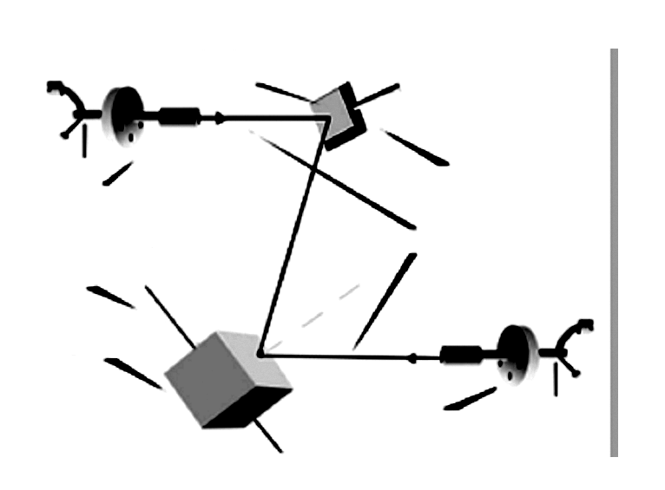
Ion gun Ⅱ
Water-cooled
Ion beam
Substrate
Rotating shaft
Rotating target
Ion gun Ⅰ

Fig.1 Schematic diagram of the IMS500 type ultra-high vacuum ion beam sputtering instrument

Fig.2 Magnetization characteristics of Sm-Fe-B GMF under different compressive stresses: (a) 7 GPa, (b) 10 GPa, (c) 13 GPa, and
(d) 16 GPa

magnetization characteristics of Sm-Fe-B thin film under different compressive stresses. The loop shapes of plane (X and Y) with large coercive field and high remanence indicate the presence of in-plane anisotropy with magnetization processes mainly connected to domain wall motion. Compressive stress induces an easy direction of the magnetization (easy axis) parallel to the film plane. However, the magnetic anisotropy hysteresis loops between the long axis (X) and short axis (Y) show difference, i.e., in-plane anisotropy. An easy direction of the magnetization changes from short axis (Y) to the long axis (X) (along the direction of stress) with compressive stress increasing.
The easy axis changes from Y to X caused by the increase of compressive stress to decrease magnetoelastic coupling energy. Any magnetostrictive material always tries to compensate the external or internal stresses by appropriate rotation of the spins ^{[11]}. For Sm-Fe-B film with negative magnetostriction, compressive stress leads to a spin distribution in the film plane.
It is found that residual magnetism in Z direction are 1, 2, 4, and 5 A·m²/g, when the compressive stress are 7, 10, 13 and 16 GPa, respectively. So, the perpendicular anisotropy of the Sm-Fe-B film increases with the growth of the compressive stress, though in-plane anisotropy still plays dominant roles.
In addition the magnetostrictions (λ//) of these films were measured applying the external field parallel to the long axis (X) of film plane. Fig.3 shows the dependence of applied magnetic field (H) on magnetostrictive coefficient (λ) of the Sm-Fe-B film with different compressive stress. As shown in Fig.3, the magnetostriction of the Sm-Fe-B film in low field increases clearly with the increase of compressive stress, due to the easy axis turning to the in-plane caused by compressive stress. Magnetostriction rises to 89×10⁻⁶, 116×10⁻⁶, 172×10⁻⁶ and 210×10⁻⁶ at 103 kA/m when compressive stresses are 7, 10, 13 and 16 GPa, respectively, while that of the as- deposited film is 45×10⁻⁶. With compressive stress elevates, the saturation magnetostriction decreases slightly less than 20%, while the magnetostriction in low field is improved apparently. There is an obvious difference when heat treatment method is used to improve magnetostriction in low field, which is regarded as another effective way to improve the magnetostriction in low field, while the saturation magnetostriction is reduced greatly. Hence, the better magnetostrictive properties of Sm-Fe-B thin film could be obtained by the higher value of compressive stress.
In Fig.4 the magnetic images of the remanent domain

Fig.3 λ-H curves of the Sm-Fe-B GMF with different
compressive stresses

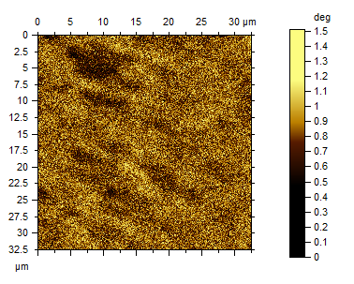
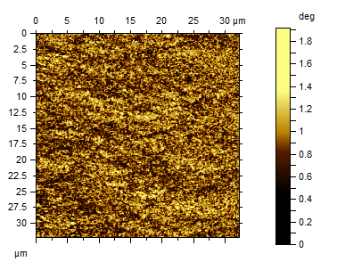
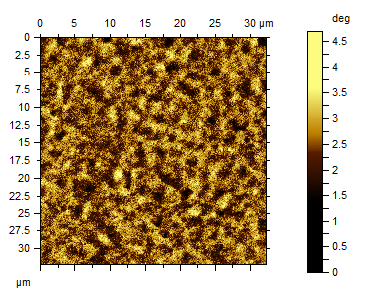
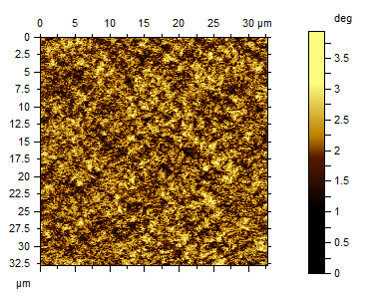
a
b
c
d

Fig.4 MFM images of Sm-Fe-B GMF with different compressive stresses: (a) 7 GPa, (b) 10 GPa, (c) 13 GPa, (d) 16 GPa (san sizes: 30 μm×30 μm)

structure in a Sm-Fe-B film structure with different compre-
ssive stresses are shown by MFM. Compressive stress leads easy axis in the film plane for the low magnetic contrast, which means that the magnetic domain lies in film plane. With the increase of the compressive stress, the magnetic contrast of the MFM image increases, which is corresponding with hysteresis loops of the magnetization in Z axis. The saturation magnetostriction could be maintained with increase of remanent domain structure in perpendicular direction.

3 Conclusions

1) Compressive stress leads easy axis in the film plane, and the magnetic domain (or whose main component) lying parallel to film plane exists dominantly.

2) With the increase of compressive stress, easy axis turns from the short axis (Y) to the long axis (X) in film plane, and magnetic domain component perpendicular to the film plane increase on a small scale.
3) Magnetostriction of Sm-Fe-B films with compressive stress is improved rapidly in low magnetic field and the value can reach 210×10⁻⁶ at 103 kA/m when compressive stress is 16 GPa, while saturation of magnetostriction does not deteriorate obxiously. The better magnetostrictive properties of the Sm-Fe-B thin film can be obtained by the higher value of compressive stress.

References
- Takeuchi M, Matsummura Y, Uchida H. J Japan Inst Metal[J], 2005, 69(8): 667
- Peng B, Zhang W L, Jiag H C et al. Phys B[J], 2010, 405: 916
- Garcia D, Munoz J L, Kurlyandskaya G et al. J Magn Magn Mater[J], 1999, 191: 339
- Mandal K, Vazquez M, Garcia D et al. J Magn Magn Mater[J], 1999, 196: 259
- Lim S H et al. J Magn Magn Mater[J], 1988, 189(1): 1
- Hiroyuki Wakiwaka, Kazuyuki Ohtake, Naoki Itoh et al. Materials Science Forum[J], 2011, 670: 82
- Li Siwen, Zhou Baiyang, Weng Zhangzhao. Journal of Functional Materials and Devices[J], 2012, 18(2): 165
- Hoffman R W. Physics of Thin Films, Vol.3 [M]. New York: Academic, 1966: 211
- Wakiwaka H. Sensor Letters[J], 2009(7): 240
- Klokholm E. IEEE Transactions on Magnetics[J], 1976(12): 819
- Schatz F, Hirscher M, Schnell M et al. J Appl Phys[J], 1994, 76(9): 5380

压应力对Sm-Fe-B磁致伸缩性能的影响

周白杨，翁章钊，黎思文，陈志坚，刘全洲，李建新
(福州大学，福建 福州 350108)

摘 要：利用特制夹具，使玻璃衬底在镀膜过程中受到不同应力作用，镀膜结束后，当玻璃衬底从夹具取下后，利用其恢复到原来状态，可以对稀土 Sm-Fe-B 薄膜产生压应力作用。通过调整夹具使衬底具有不同的预应力，可得到受到玻璃衬底不同压应力作用的薄膜样品。利用 LK-G150 激光微位移传感器与交变梯度磁强计 (AGM) 分别测试薄膜悬臂梁自由端偏转量与磁滞回线，以研究具有不同压应力对薄膜的磁致伸缩性能的影响，并且利用磁力显微镜 (MFM) 测试了薄膜样品垂直表面的磁畴分布情况。实验结果表明：受到压应力作用的薄膜易磁化轴都位于膜面内，以面内各向异性为主，磁畴结构基本分布在面内。随着压应力的增加，易磁化轴由膜面内的短轴转向膜面内的长轴，这一转变有利于器件的设计，但是磁畴在垂直膜面方向略有提高，薄膜的低场磁致伸缩性能也随着压应力的增大而有显著 提高。
关键词：Sm-Fe-B薄膜；压应力；磁致伸缩特性；磁畴

作者简介：周白杨，男，1957年生，硕士，教授，福州大学材料科学与工程学院，福建 福州 350108, E-mail: zby@fzu.edu.cn

