A New High Emissivity Coating on Ni-Based Superalloy Substrate
Wu Yongbin, Ma Xiaofei, Zhang Huazhen, Zhou Yang

Shanghai YS Information Technology Co., Ltd, Shanghai 200240, China

Abstract: In the present paper, we prepared a new high emissivity coating by a spray painting method. The coating contains amorphous borosilicate glass, Mg₂B₂O₅, MoSi₂ and SiB₄ and has the thickness of about 50 μm. Results show that the coating exhibits excellent thermal shock resistance (more than 100 thermal cycles from 950 °C to water temperature). The average emissivity of the coating is 0.905±0.024 at 950 °C and has a slight degradation after 100 thermal cycles.

Key words: coating; emissivity; thermal protection system; thermal shock resistance

With the development of inherent ductility, design flexibility and low maintenance cost metallic thermal protection systems (MTPS) for hypersonic flight vehicles^{[1,2]}, a research is initiated to provide a stable and high emissivity coating on superalloy substrate. And the coating is applied on metallic thermal protection system to decrease the surface temperature by radiation. However, the thermal shock resistance and emissivity remain a challenge to the current MTPS.
To increase thermal shock resistance of the coating on TPS panel, the coating on the MPTS need to be investigated. To our knowledge, due to borosilicate glasses with high viscosity, chemical passivity, and good ability for moistening different materials, the SiO₂-B₂O₃ system is a good basis for the elaboration of coatings^{[3]}. Such coating possesses high emissivity and stability at peak heating under operational conditions, achieved by introduction of nonvolatile components into the borosilicate matrix. The nonvolatile additive is transition metal oxide including Cr₂O₃, CoO_{x}, Fe₂O₃^{[4]}, SiB₄, SiB₆^{[5]}, MoSi₂^{[6]} and so on. With its high melting point, moderate density and excellent high temperature oxidation resistance, MoSi₂ becomes an important anti-oxidation candidate material of high temperature alloy or C/C composite. However, “Pesting” phenomenon occurs in MoSi₂ at 400~600 °C^{[7]} due to vigorous oxidation. Therefore, MoSi₂ should be pulverized into powder, which will surely limit the application temperature range of MoSi₂. With thermodynamic compatibility of SiB₄ and MoSi₂ and excellent oxidation resistance of SiB₄, SiB₄ becomes one of major additives to improve the performance of MoSi₂. Moreover, SiB₄ has a high emissivity^{[8]}, so it could be widely deposited as high emissivity coating. Here we reported a new SiB₄-MoSi₂ composite coating by adding some toughening agent Mg₂B₂O using a spray painting method, which has high emissivity and excellent thermal shock resistance. This coating has the potential application in metallic thermal protection systems.
1 Experiment
Haynes 214 alloy was used as a substrate with the dimension of 100 mm×100 mm×0.07 mm. The substrate was polished with 200 mesh sand paper and ultrasonically cleaned in ethyl alcohol and acetone for 15 min and then dried. A coating slurry was prepared by ball-milling fine Mg₂B₂O₅ whisker and Na₂Si₂O₃, SiO₂, BC₄, MoSi₂ and SiB₄ particles for 8 h in distilled water, and then sprayed onto the substrate. Subsequently, the coating was dried in an oven at 100 °C for 1 h, and finally it was sintered at 850 °C for 1 h.
XRD was carried on a PANalytical X’Pert Pro X-ray diffractometer with Cu Kα radiation. The surface morphology of the coating was examined by scanning electron microscope (SEM). The AFM surface topography was examined by the instrument NanoScope (R) Ⅲ, Version 5.3, Veeco instrument Ltd, with a scan rate of 0.5 Hz and scan range of 20 μm by tapping mode operation. The cross-sectional images of samples were examined by back-scattered electrons.
The spectral emissivity values of the coatings were measured on a self-made infrared radiometer of Harbin Institute of Technology, China. The spectral emissivity was determined by comparing the radiative fluxes between the samples and a blackbody under the same conditions. The radiation emitted by the front surface of sample was detected by a Fourier Transform Infrared spectrometer (JASCO FT/IR-6100), and its radiance was compared with the radiance of a blackbody radiator (Land R1500T Infrared, Dronfield, Sheffield S186DJ, England). The estimated uncertainly was less than 5%. Details of the emissivity measurement could be found in Ref.[8].
The thermal shock resistance was evaluated by a heating- cooling cycle test. The sample was heated up to 950 °C for 10 min, and then quenched by water for 5 min. This cycle was repeated for 100 times.
2 Results and Discussion
2.1 Phase compositions of the coating
The XRD patterns of the as-prepared coating of the Haynes 214 before and after 100 times thermal shock testing are shown in Fig.1. The XRD results indicate that the coating involves the amorphous borosilicate glass, Mg₂B₂O₅(JCPDS 15-0537), MoSi₂(JCPDS 41-0612), SiB₄(JCPDS 35-0777) and substrate. The amorphous glass borosilicate between 15°and 25° of 2θ is one of the phases. The thermal shock testing does not give rise to the phase composition change of the coating. This means that high temperature does not cause any chemical reaction among them.
2.2 Microstructure of the coating
The SEM images of the coating on Ni-base alloy are shown in Fig.2. The coating surface shows dense morphology without any crack, and exhibits the repeatable grooved finish, like V-shaped grooves, circular grooves, and pyramidal grooves which are commonly used to model the emissivity enhancement. Meanwhile, SiB₄ and MoSi₂ surface is oxi-

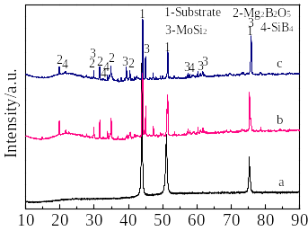
2θ/(°)

Fig.1 XRD patterns of the substrate (a), and the coating before (b) and after thermal shock (c)

dized to form dense SiO₂ film during sintering. And the fused borosilicate glass (main glass-forming constituents SiO₂ and B₂O₃) is less sticky and easy to flow into the crack, and thus self-heals the micro-cracks during sintering.
Fig.3 presents the cross-sectional image of the coating on Ni-base alloy. The coating is compact and has no crack within the coating thickness. The interface is clear, indicating there is no obvious inter-diffusion. The elemental distribution along coating thickness also confirms no inter-diffusion between substrate and the coating.
2.3 Thermal shock resistance tests

Thermal shock tests were carried out to detect the mechanical integrity and durability of the coatings at high temperature. Coating samples experienced the heat-up and cool-down cycle for 100 times. The surface morphologies of the coating before and after thermal shock testing are shown in Fig.4. After thermal shock testing for 100 cycles, the coating is still intact without flaking and burning, indicating that the coating has good thermal stability and thermal shock resistance.

Fig.5 is the comparison of AFM reports before and after thermal shock. The surface topography of the coating before thermal shock (Fig.4a) is very rough with mean surface roughness value (Ra) of 255.81 nm. Many surface protrusions are observed on the surface of the coating. In contrast, the mean surface roughness value (Ra) of the coating after thermal

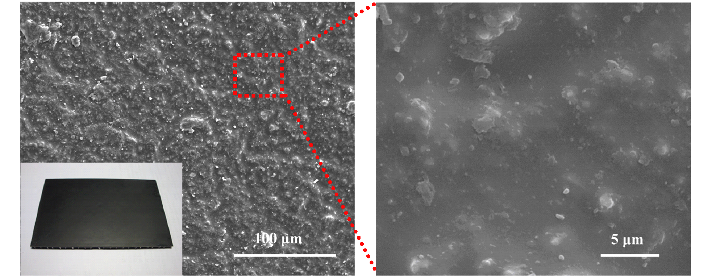
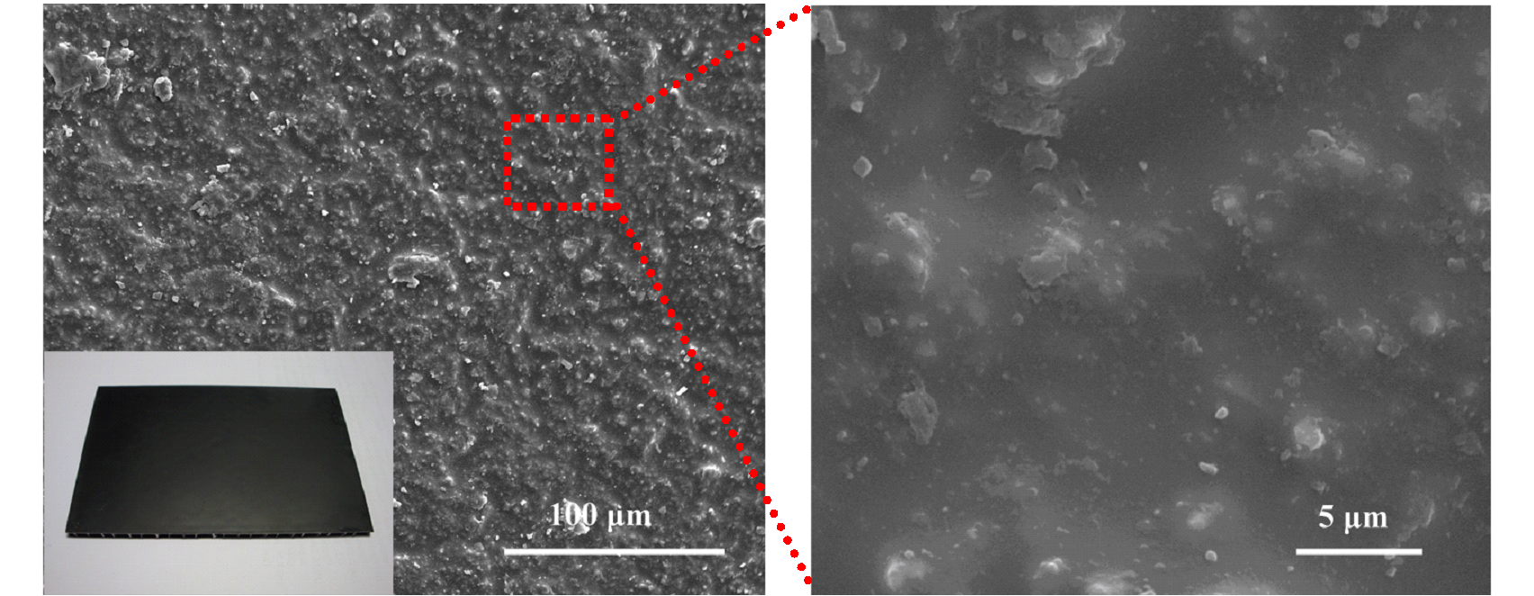
100 μm
5 μm

Fig.2 SEM images of the surfaces of the coatings

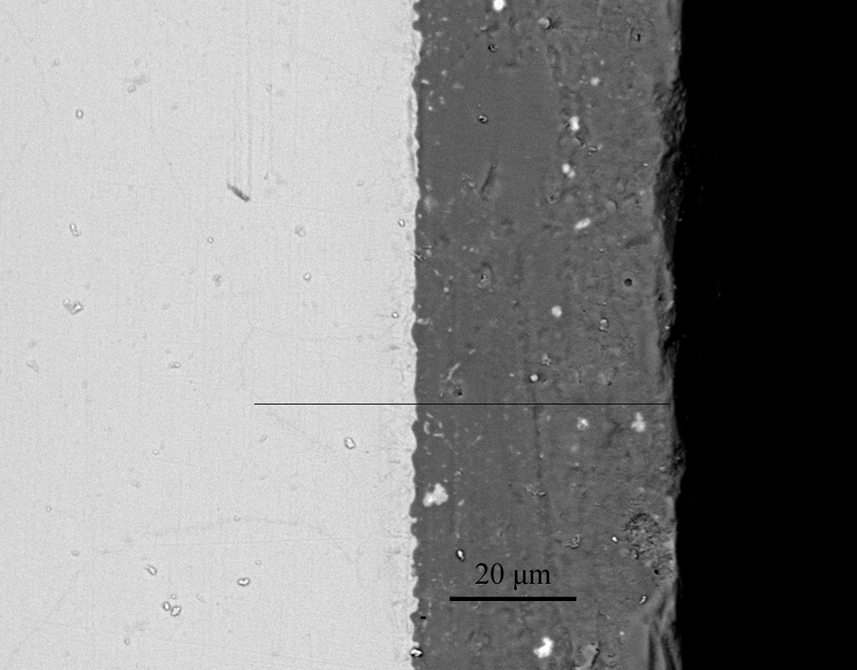
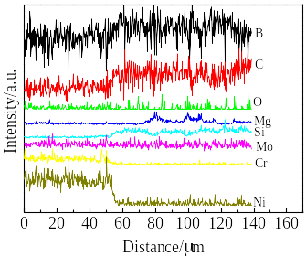
a
b
20 μm

Fig.3 Cross-sectional image of the coating on Ni-base alloy (a) and elemental distribution along coating thickness (b)

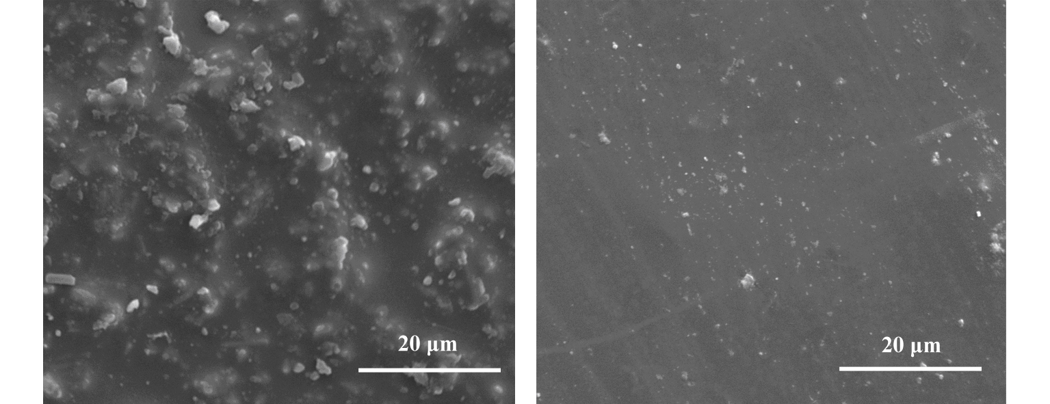
a
b
20 μm

Fig.4 SEM images of the surfaces of the coatings before (a) and after 100 times (b) heating-cooling cycles

shock is 70.48 nm. It can be seen that the coating is generally dense and uniform after 100 times thermal shock.

Fig.6 shows cross-sectional backscattered electron images of the coating on Ni-base substrate after 20, 40, 80 and 100 times of thermal shock. After 20 times, there is almost no visible crack within the coating thickness. However, after 40
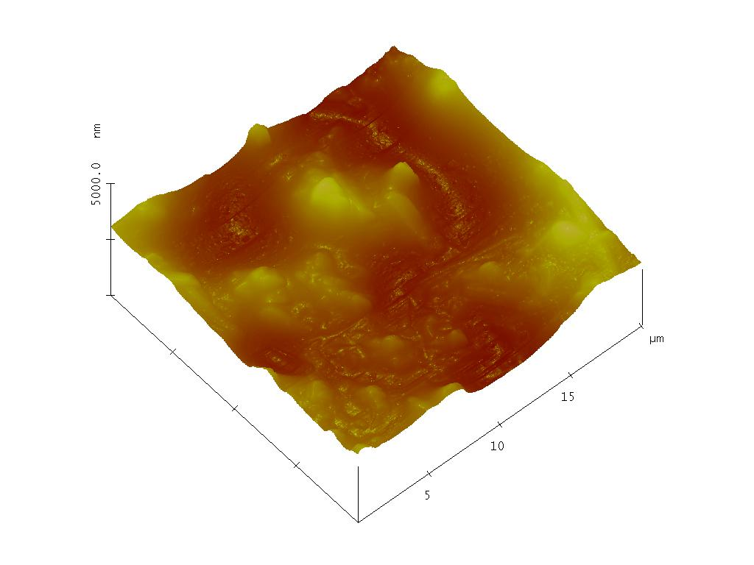
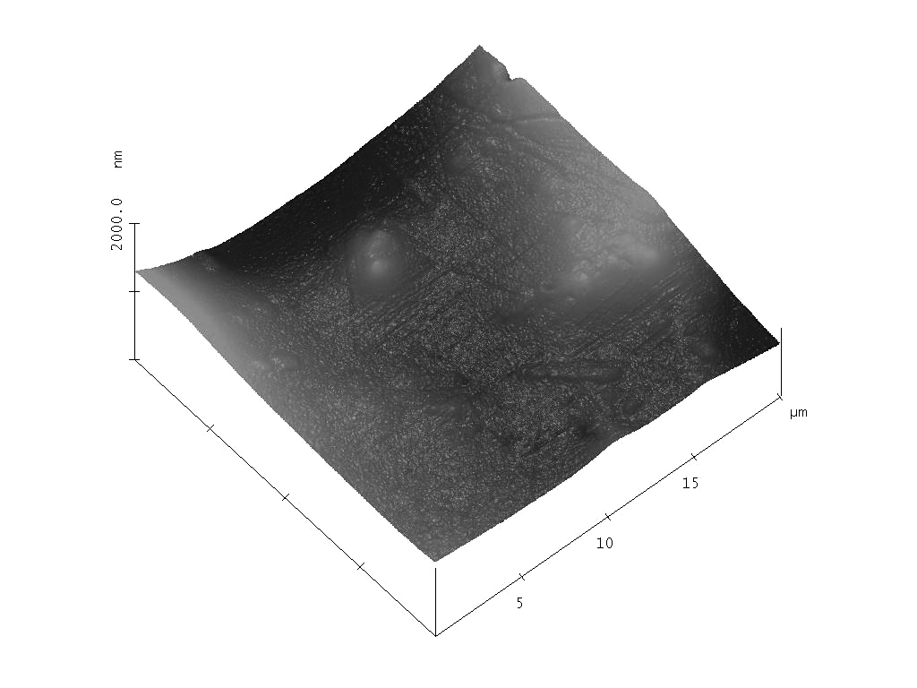
5000.0 nm
5
10
15
μm
2000.0 nm
a
5
10
15
μm
b

Fig.5 AFM surface topographies of the coating before (a) and after thermal shock (b)

times, some cracks are observed. With more thermal shock cycles, such as 80 and 100 times, the crack density becomes higher but the coating is still adhered onto the substrate. No peeling off phenomenon is observed. Generally speaking, under thermal cycling conditions, when the thermal expansion coefficient of the coating is less than the matrix, the matrix bears compressive stress while the coating bears tensile stress at the elevated temperature. As a result, the coating is easy to crack. On the contrary, during cooling down process, the matrix bears tensile stress while the coating bears compressive stress, so the crack is difficult to propagate.
After many repeating tests of thermal shock, the coating is modified both on surface and in the bulk. According to the surface morphology by SEM, after 100 times, the coating surface becomes smoother and denser. And according to the cross-section morphology by SEM, there are a lot of increased pores but the coating shows no tendency of peeling, indicating that the cracks of pores on surface could be healed by some kind of materials during the thermal shock cycles. The main reactions are as follows^{[9,10]}:
(1)
(2)
(3)
(4)
According to Eqs. (1) and (2), the volatilization of Si(OH)₄ and MoO₃ would lead to cracks of the coatings, which results
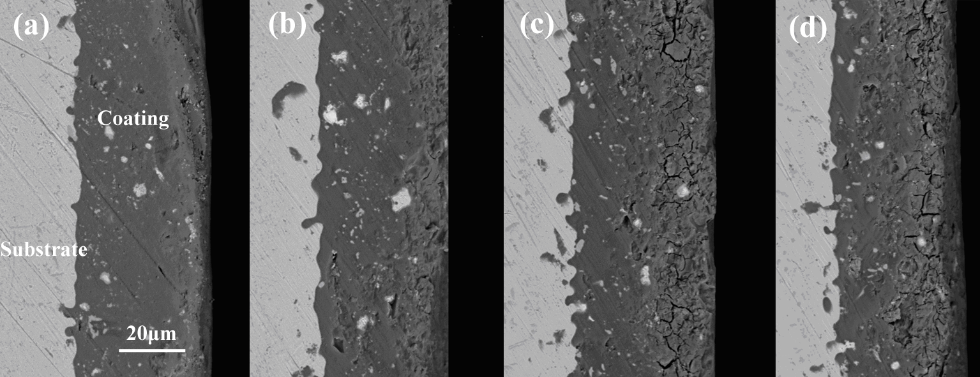
a
b
c
d
20 μm

Fig.6 Cross-sectional backscattered electron images of the coated samples after thermal cycles at 950 ºC for 5 min followed by water-cooling for different times: (a) 20 times, (b) 40 times, (c) 80 times, and (d) 100 times

in the increased porosity in the bulk. In the other hand, SiO₂(l) and B₂O₃(l) would react into the fluid SiO₂·xB₂O₃, which could penetrate into the cracks or pores at a certain depth; in other words, the coating surface would be healed by the viscous glass. As mentioned above, the micro-cracks could be healed during heating up process as the borosilicate glass was melting, which can improve thermal shock resistance of the coating.
2.4 Emissivity characterization
Fig.7 shows spectral emissivity results of the coating in the wavelength band between 2.5 and 20 μm at 950 °C. In the wavelength range from 2.5 μm to 7 μm, the spectral emissivity values increase with the increase of wavelength. The spectral emissivity of the coating reaches maximum at a wavelength of about 6.2 μm. The emittance tends to decrease when the wavelength changes from 6.2 μm to 7.5 μm, increases again from 7.2 μm to 8.5 μm, and then decreases from 8.5 μm to 9.7 μm. The relatively low values at 7, 9 and 15 μm are characteristics of the reststrahlen bands of the silicon dioxide materials. The highest emissivity associated with the strongest molecular vibration band of quartz usually exhibits the principal Christiansen feature and transition on metal compounds such as MoSi₂ and SiB₄. Doping transition metal impurities into the host lattice could enhance the lattice vibration, and thus emissivity could be improved. The data are calculated from the average spectral emittance values between 2.5 and 20 μm according to Eq. (5):
(5)

where ε is the emissivity, λ is the wavelength, and P_{bb} is the blackbody emission spectrum^{[11]}. The average spectral emissivity value of the as-received coating is around 0.905± 0.024 in the wavelength of 2.5~20 μm. After 100 times thermal shock testing, the average spectral emissivity value of the coating is around 0.849±0.032，which has a degradation (around 8% decrease) compared to that before thermal shock testing. This reveals that the component emissivity and surface roughness have a significant effect on the emissivity of the

Fig.7 Spectral emissivity curves of the coating before and after the water quenching

coating. And the degradation of the emissivity results from the lower surface roughness value of the coating after thermal shock testing. Moreover, this means that this coating is suitable to be used in re-usable MTPS for hypersonic flight vehicles.
3 Conclusions
1) A new coating with high emissivity and excellent thermal shock resistance can be prepared.
2) The average emissivity of the coating is 0.905±0.024 at 950 °C.
3) After 100 times of thermal shock testing, the average emissivity only has 8% degradation. The coating has very good thermal shock resistance. It is promising to be used in re-usable MTPS for hypersonic flight vehicles and other radiation applications.

References
- He X D, Li Y B, Wang L D et al. Thin Solid Films[J], 2009, 517(17): 5120
- Yi J, He X D, Sun Y, Li Y B. Applied Surface Science[J], 2007, 253(9): 4361
- Stolyarova V L, Archakov I Y, Gordeev A N et al. Rapid Communication in Mass Spectrometry[J], 1993, 7(2): 127
- Wu Yongbin, He Xiaodong, Li Jun et al. Rare Metal Materials and Engineering[J], 2013, 42(S1): 459 (in Chinese)
- Leiser D B, Churchward R, Katvala V et al. Journal of the American Ceramic Society[J], 1989, 72(6): 1003
- Wu Yongbin, He Xiaodong, Li M W et al. Rare Metal Materials and Engineering[J], 2012,41(S3): 323 (in Chinese)
- Chou T, Nieh T. Journal of the Minerals, Metals and Materials Society[J], 1993, 45: 15
- Wang Y M, Tian H, Quan D L et al. Surface and Coatings Technology[J], 2012, 206(18): 3772
- Matsushita J, Sawada Y. Journal of the Ceramic Society of Japan[J], 1997, 105(10): 922
- Tong C Q, Cheng L F, Yin X W et al. Composites Science and Technology[J], 2008, 68(3-4): 602
- Zhao X, He X D, Sun Y et al. Materials Letters[J], 2011, 65 (17-18): 2592

一种镍基高温合金基体表面的新型高辐射涂层

武勇斌，马小飞，张华振，周 阳
(上海跃盛信息技术有限公司，上海 200240)

摘 要：通过空气喷涂方法制备了一种新型的高辐射涂层。涂层主要成分包括无定型硼硅玻璃粉、Mg₂B₂O₅、MoSi₂和SiB₄。涂层的厚度约50 μm。通过实验发现，涂层具有优良的抗热震性能（能够经受超过100次的从950 ℃到水温的冷热循环）。在950 ℃，涂层的平均辐射率为0.905±0.024。经过100次的热循环后，涂层的辐射系数有轻微的减小。
关键词：涂层；辐射率；热防护系统，抗热震性能

作者简介：武勇斌，男，1982年生，博士，上海跃盛信息技术有限公司，上海 200240，电话：021-60912791，E-mail: yoopin@126.com

