Microstructure and Properties of Ag-SnO₂ Coating Fabrica- ted by Plasma Spraying
Fu Chong¹, Hou Jinli¹, Guo Tianfu¹, Wang Junbo¹, Ding Bingjun², Zheng Jing³

¹ Xi’an Polytechnic University, Xi’an 710048, China; ² National Laboratory for Materials Strength, Xi’an Jiaotong University, Xi’an 710049, China; ³ Northwest Institute for Nonferrous Metal Research, Xi’an 710016, China

Abstract: Ag-SnO₂ coating on copper substrate has been prepared by an atmospheric plasma spraying method using high energy ball milled Ag-12wt%SnO₂ composite powder as raw material. The microstructures of the Ag-SnO₂ coating were characterized by XRD and SEM. The mechanical properties and arc erosion performance of the as sprayed coating have been determined by tensile test, microhardness and arc erosion tests, respectively. The results show that the Ag-SnO₂ coating presents a compact microstructure, and the nanosized SnO₂ particles are uniformly dispersed in the Ag matrix of the coating. The mechanical properties and the arc erosion performance of the Ag-SnO₂ coating are close to those of Ag-SnO₂ bulk. After arcing test, the surface of the coating presents the dispersion of cathode spots and a little erosion, indicating that the Ag-SnO₂ coating has excellent arc-erosion resistance. Plasma spray technique is an effective approach to manufacture Ag-SnO₂ contact coating with good mechanical properties and arc erosion resistance.

Key words: plasma spraying; Ag-SnO₂; contact material; arc erosion

The Ag-SnO₂ contact material has shown a promising prospect in applications of low-voltage switches because of its remarkable resistance to arc-erosion and welding during arcing test and friendly environmental characteristic ^{[1,2]}.
Two traditional commercial methods preparing Ag-SnO₂ contact alloys include:^{[3,4]} the internal oxidation technology (IO) of a silver-tin alloy; powder metallurgy approach (PM), and the Ag-SnO₂ composite powders can be prepared by high-energy ball milling ^{[5]}, chemical plating ^{[6]}, reactive synthesis ^{[7]}, reactive milling ^{[8]} and hydrothermal method ^{[9]}. However, the internal oxidation of Ag-Sn alloys can result in oxide-rich layers on the surface and an oxide-free zone in the center of alloys ^{[2]}. The powder metallurgy route includes pressing, sintering and extrusion, but it has some difficulty because of the brittleness of Ag-SnO₂ materials, which results in the repeating press working and annealing during manufacture process ^{[10, 11]}.
Plasma spraying is a versatile method which can be used to deposit powders as dense, adherent and homogeneous coatings with low porosity. A dispersion of hard and brittle phases in a ductile matrix has been achieved by co-deposition of powder mixtures, and a suitable distri- bution of reinforcement phase can be obtained by plasma spraying under optimized processing parameters ^{[12, 13]}.
In the present paper, Ag-SnO₂ coating on the Cu substrate was prepared by atmospheric plasma spraying, and the phase structure, the microstructure, the mechanical properties and the arc erosion performance of Ag-SnO₂ coating have been studied further.

1 Experiment
SnO₂ nanopowder with an average particle size of 30~50 nm was synthesized by the chemical co-precipitation method ^{[14]}. And then, Ag powder (99.9% purity) with an average particle size less than 70 μm and SnO₂ nanopowder (12 wt%) were mixed uniformly for 2 h in a high-energy ball mill (QM-3A) using stainless steel ball, the rotation speed was 1200 r/min and the weight ratio of ball to mixed powder was 10:1. The concept of Ag-SnO₂ feedstock design in the present study is schematically shown in Fig.1.
The HEPJ-100 atmospheric plasma spraying equipment with PQ-1S plasma gun was applied to prepare Ag-SnO₂ coating. During spraying, the substrate and the coating were cooled by compressed air. Before spraying, the pure copper substrates were cleaned by acetone solution and sandblasted by corundum, and the prepared feedstock powder suffered sieving and drying. The thickness of the prepared coating was about 600 μm. The spraying parameters are shown in Table 1. For comparison, Ag-SnO₂ bulk material was prepared by hot-pressing-sintering using the same ball-milled powder. The ball-milled mixture was pressed into green compact under a pressure of 100 MPa for 1min, and further hot-pressing sintered in an electric resistance furnace at a pressure of 200 MPa for 2 h ^{[15]}.
The phase compositions of the powder and the as-sprayed coating were analyzed by the X-ray diffraction (XRD, Shimadzu 7000), using Cu Kα radiation (λ = 0.154 18 nm). The 2θ scan range was 15°~80°, with a step size of 0.02° and a resolution of 0.01°. The morphologies of the coating were investigated by scanning electron microscope (SEM, JEOL JSM-6700F).
The bonding strength of the coating with Cu substrate was evaluated by tensile test (SANS-CMT5000) according to the ASTM C 633-79. Five measurements were performed to determine the average bonding strength of the coating. The microhardness was determined on the polished surface of the coating at room temperature using a Vickers microhardness tester (MH-3, Light-Mach Ltd, Shanghai, China) under a load of 200 g for 10 s. The average of 10 tests was used as an indicator of the coatings hardness.
A self-designed experimental apparatus was used for the arc erosion test ^{[15-17]}. The Φ10 mm coating and bulk samples were fixed into brass holders for 500 times discharging operation. The arc current and the arcing time were recorded by Tektronics TDS-2024B (200MHz) digital memory oscilloscope. After discharging operation, the samples were weighed by ES-180J Photovoltaic Analysis Balance (the resolution is 0.l mg) to measure the mass loss and the surface of sample was examined by SEM. The arc erosion rate of coating could be calculated as follows:
(1)
where V is the arc erosion rate of coating, μg/C, Δm is the mass loss of coating before and after arcing, μg, and Q is
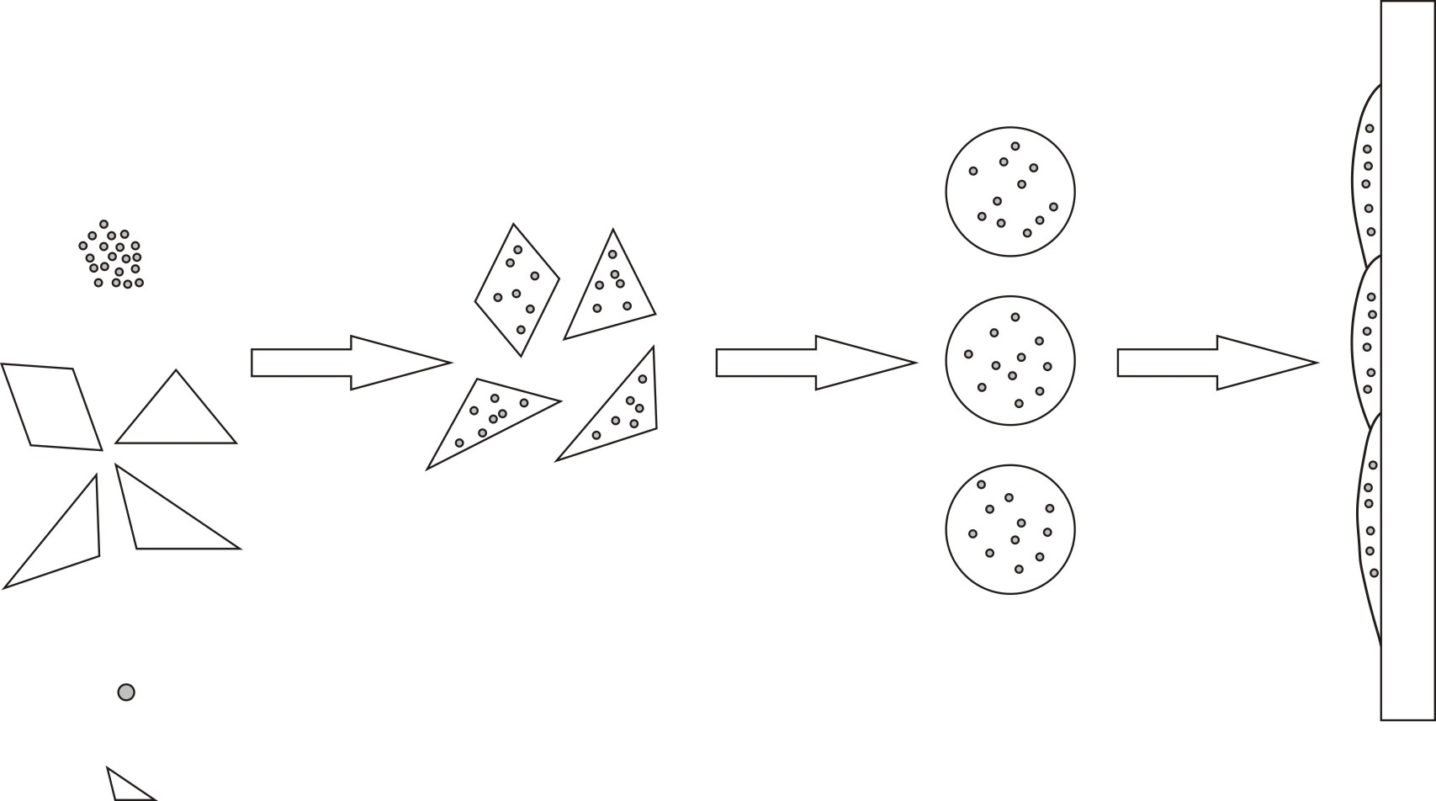
SnO₂ particle
Metal Ag particle
High energy
ball milling mixing
Drying
Sieving
Plasma
spraying
Substrate

Fig.1 Schematic diagram showing the concept of spraying powder design of Ag-SnO₂ coating

the total discharge quantity during acing test, C.

2 Results and Discussion

2.1 Characterization of spraying powder
Fig.2 shows the surface morphologies of the spraying powder. It can be observed that the Ag particles with irregular and angular morphology uniformly embed SnO₂ nanoparticles, as shown in Fig.2b and 2c. During the high-energy ball milling, the hard and brittle SnO₂ nanoparticles are embedded into the high plastic Ag, which is attributed to the enormous energy of high-energy ball milling.
2.2 Characterization of the coating
Fig.3 presents the XRD patterns of Ag-SnO₂ powder and the prepared coating. It can be found that there is no obvious change of the phase structure of Ag-SnO₂ before and after plasma spraying, which consist of Ag and SnO₂ phases.
The cross-sectional micrograph of as sprayed Ag-SnO₂ coating is shown in Fig.4. It is illustrated that the interface between the coating and the substrate has no crack and porosity, which manifests that the bonding between the coating and the substrate is very tight. Fig.5 shows the cross-section SEM backscattered electron images of Ag-SnO₂ coating. In Fig.5a, it can be observed that the coating has the typical splat-like morphology of the thermally sprayed coating, and there are few pores in the coating, indicating that the coating has high relative density. Fig.5b shows the magnified area in the frame of Fig.5a. In this area, SnO₂ particles are distributed in the silver matrix homogeneously with an average particle size less than 100 nm.

Table 1 Plasma spray parameters of Ag-SnO₂ coating preparation
Current/A | Voltage/V | Primary gas (Ar)  flow rate/L·min⁻¹ | Secondary gas (H₂) flow rate/L·min⁻¹ | Carrier gas (Ar) flow rate/L·min⁻¹ | Powder feed rate/g·min⁻¹ | Spraying distance/mm
330 | 95 | 95 | 10 | 4 | 25 | 100

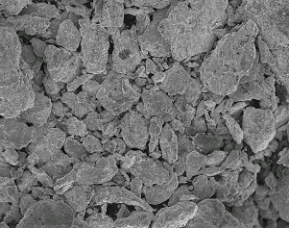
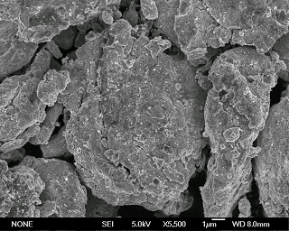
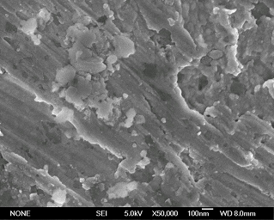
10 μm
a
b
1 μm
Ag
SnO₂
100 nm
c

Fig.2 SEM images of surface (a) and its magnification (b, c) of Ag-SnO₂ powder

Fig.3 XRD patterns of Ag-SnO₂ powder and coating

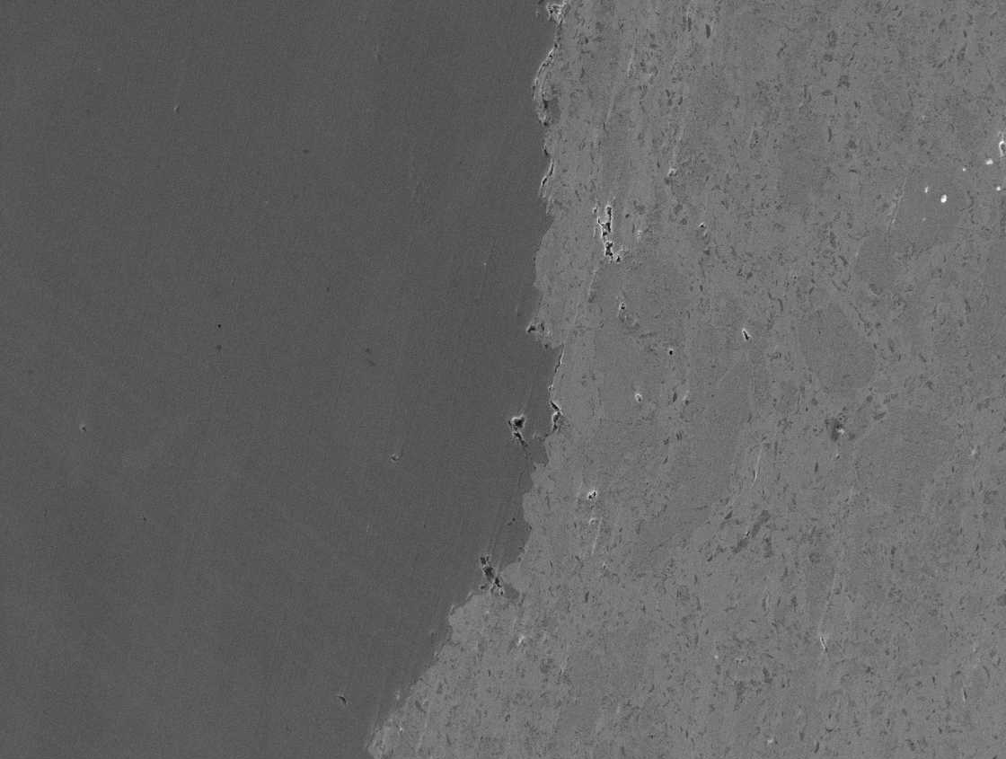

Substrate
Coating

50 μm

Fig.4 Cross section SEM image of Ag-SnO₂ coating

Plasma sprayed coating has the typical splat-like structure which is attributed to continually overlapping of countless single-layer ^{[18,19]}. If the molten drops have a higher viscosity, they will be spreading very well and a little splashed after impacting the substrate. Consequently, the single-layer with thin pancake shape and uniform thickness is formed. It would lead to a higher bonding strength between coating and substrate, a well cohesive strength for interior coating, and a higher density ^{[20, 21]}. Because Ag has a good plasticity, SnO₂ particles can be distributed in the Ag matrix uniformly. Therefore, although
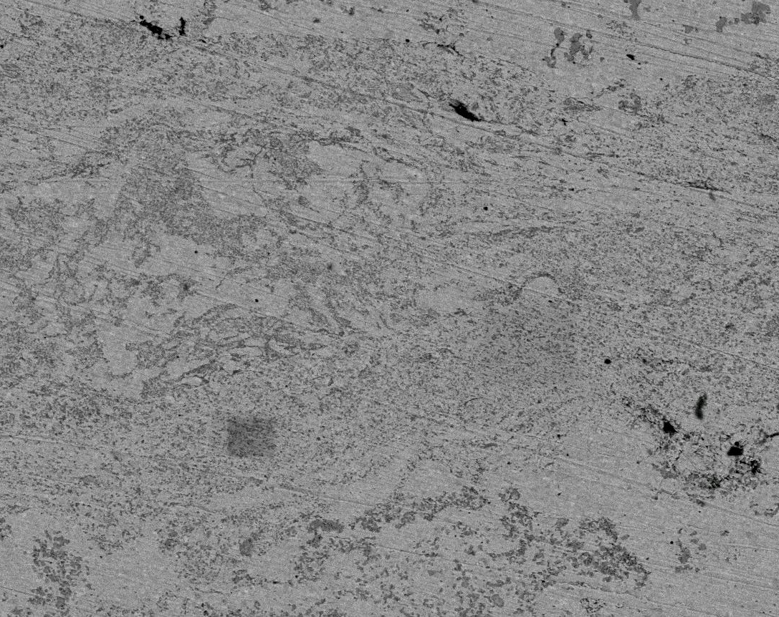
1 μm
a

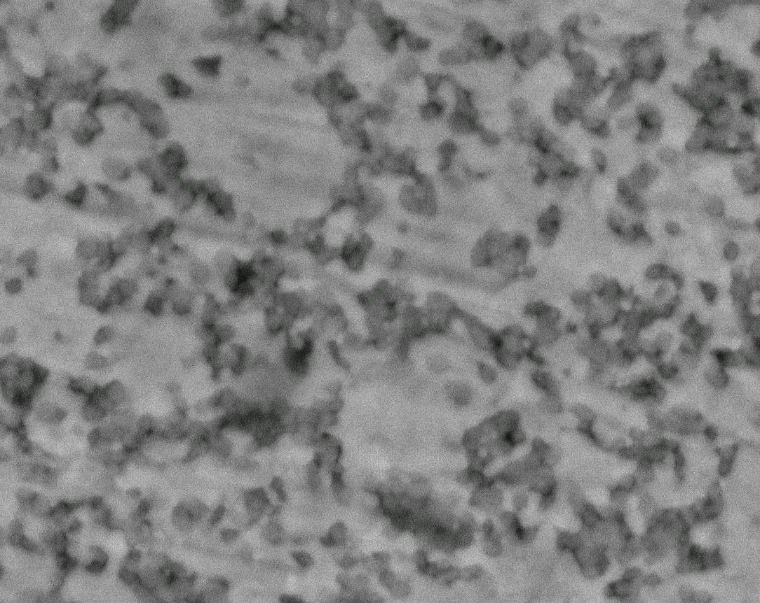
b

100 nm

Fig.5 Cross section SEM backscattered electron images of Ag-SnO₂ coating: (a) overall morphology and (b) the magnified image of the selected range denoted by the frame in Fig.5a

the impact velocity of the molten drops on the substrate is very quick and the cooling rate of the molten drops is extremely high, the coating still has large density.

2.3 Bonding strength
The bonding strength of Ag-SnO₂ coating with Cu substrate is about 17.9 MPa according to the tensile test. During the testing, all the specimens have fractured at the interface between the coating and the substrate, indicating that the cohesive strength for interior coating is higher than the bonding strength between the coating and the substrate.

2.4 Microhardness
The hardness HV_{0.2} of Ag-SnO₂ coating and Ag-SnO₂ bulk material are 1090 and 1260 MPa, respectively. The hardness is one of the indicators of the arc erosion resistance of contact materials and high hardness is beneficial to arc erosion performance of the coatings. Plasma sprayed coating has the typical lamellar structure. Because of the shadow effect, there are some holes and gaps existing in the superposition area between adjacent layers, which leads to the lower density of the coating compared to the bulk alloy ^{[22]}. Therefore, the hardness of the Ag-SnO₂ coating is also lower than that of its bulk.

2.5 Arc-erosion resistance
Arc erosion rate is an important parameter of the arc-erosion resistance of contact materials. It affects the service life and the application performance of contact materials. According to the mass loss Δm and total discharge quantity Q, the arc erosion rate of the coating and the bulk of Ag-SnO₂ calculated by formula (1) are 39.9 and 33.5 μg/C, respectively.
The surface morphologies of Ag-SnO₂ bulk material and Ag-SnO₂ coating after arc erosion test are shown in Fig.6 and Fig.7, respectively. It can be observed that they have the similar surface morphologies under the same conditions of arc erosion test. In Fig.7a, the surface of the Ag-SnO₂ coating is relatively smooth, indicating that electric ablation of sample is slightly. Meanwhile, it can be seen that the little burnt pits (which are produced by solidification of cathode spot, marked by the white arrow in Fig.7a) are distributed over all of the sample surface rather than

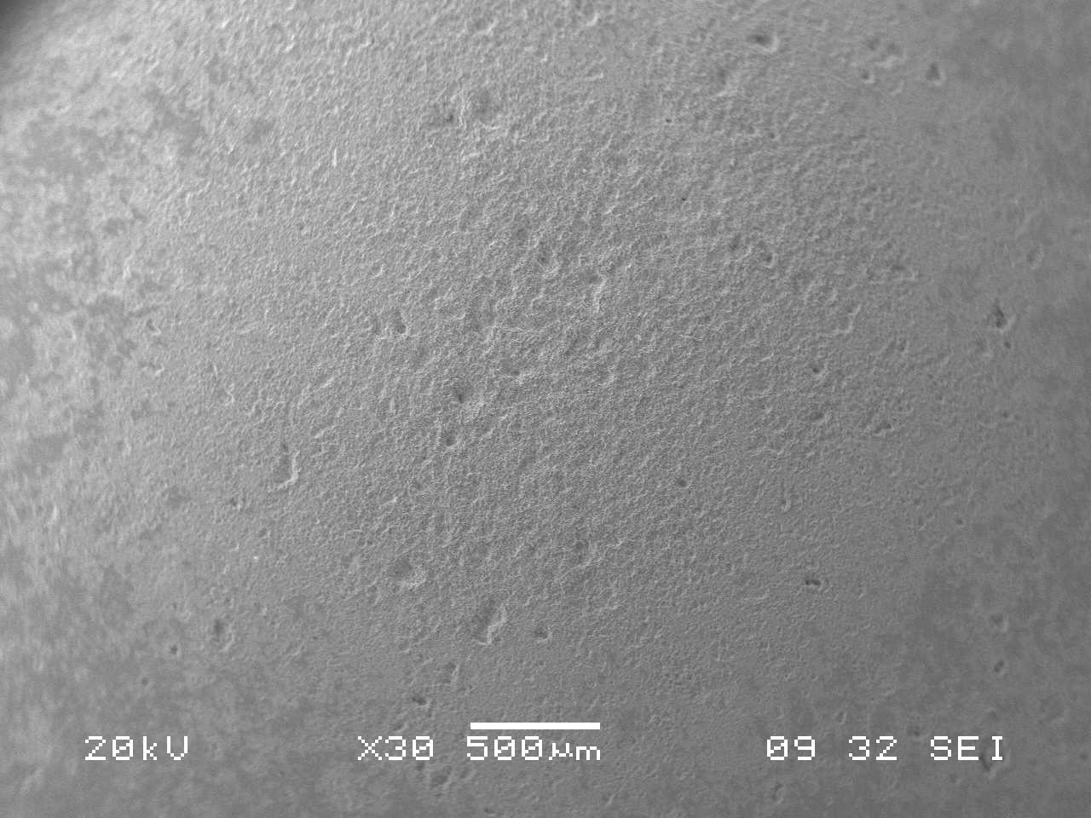
a

500 μm

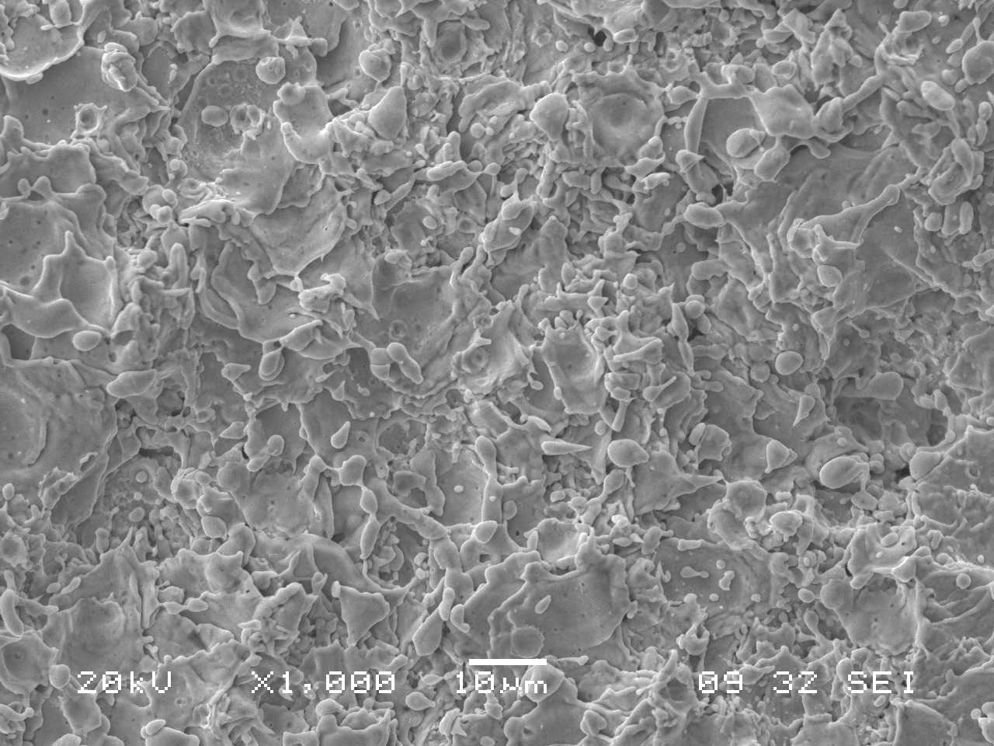
b

10 μm

Fig.6 Surface morphologies of Ag-SnO₂ bulk material after arc erosion: (a) overall morphology and (b) the magnified image of center area in Fig.6a

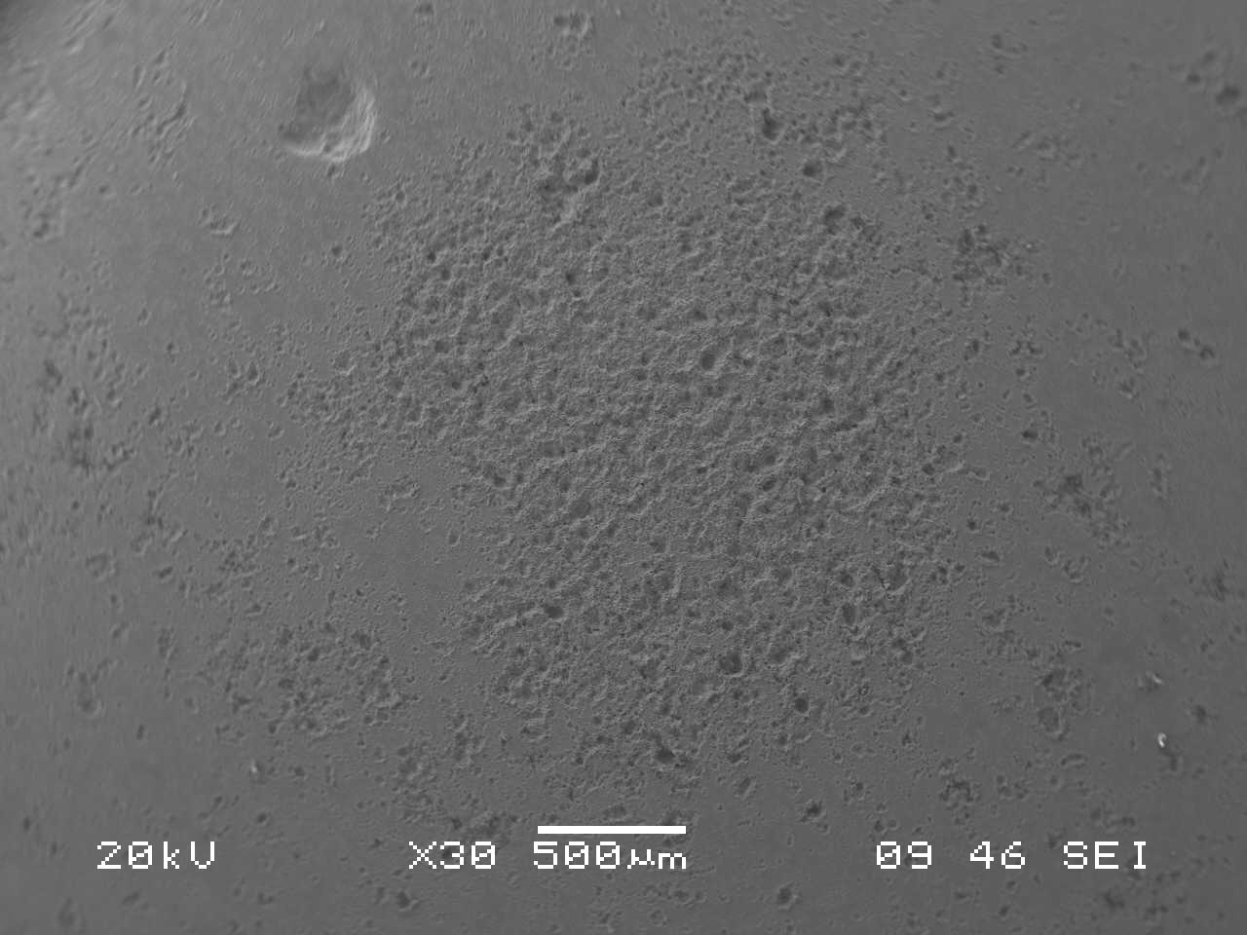
a

500 μm
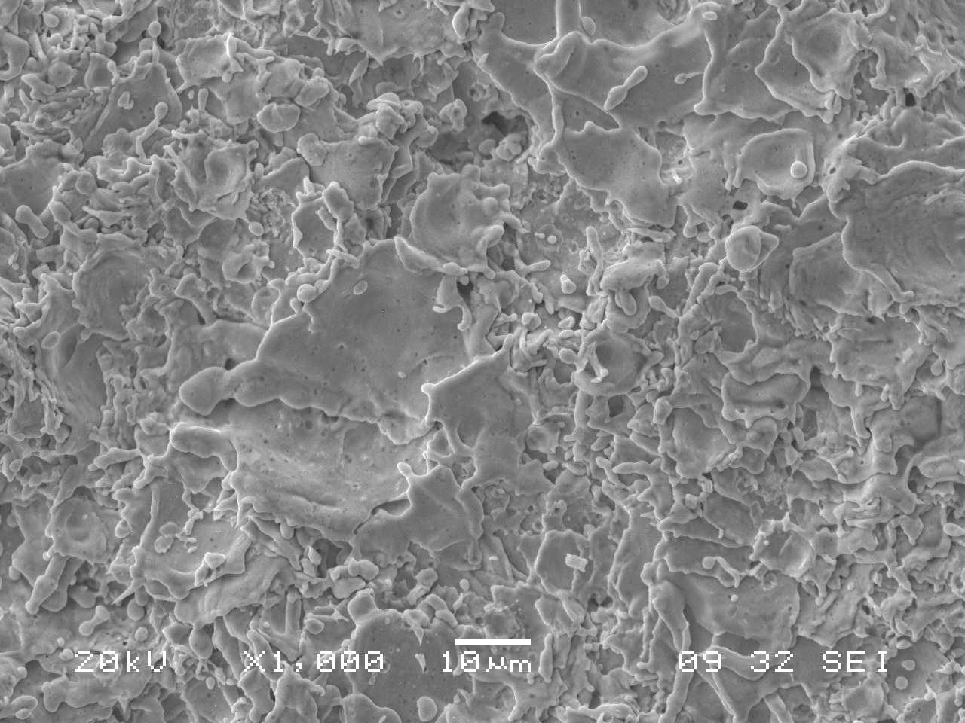
b

10 μm

Fig.7 Surface morphologies of Ag-SnO₂ coating after arc erosion: (a) overall morphology and (b) the magnified image of center area in Fig. 7a

concentrating in a certain area. Fig.7b is the magnified image of center area in Fig.7a. It can be observed that the surface melt layer of Ag-SnO₂ coating has a small size and compact structure, indicating that the liquid state silver has a low flowability and a high viscosity under arc test. This may be attributed to the homogeneous dispersion of SnO₂ nanoparticles within Ag matrix.
The second phase SnO₂ nanoparticles uniformly dispersing in Ag matrix can make contribution to more phase boundaries and more dispersed cathode spots. Furthermore, it makes arc disperse in a larger area rather than concentrating in a certain area. Consequently, the arc energy through the unit area is greatly decreased, and the probability of Ag liquid spatter is also significantly decreased. In addition, SnO₂ nanoparticles have the bigger contact area with the Ag matrix, which can enhance the adhesion between Ag liquid and SnO₂ under arcing. This can be expressed as formula (2) ^{[23]}:

W = γ_{Ag}(1 + cosδ)A (2)
where W is the adhesion work, γ_{Ag} is the surface energy of Ag liquid, δ is the wettability angle between Ag liquid and SnO₂, and A is the interfacial area of two phases. Obviously, the finer the SnO₂ particle is, the higher the viscosity of Ag liquid and the more difficult the splashing. As a result, the as sprayed coating has stronger resistance to arc erosion.

3 Conclusions
1) The as-sprayed Ag-SnO₂ coating shows a uniform and compact microstructure. SnO₂ nanoparticles are distributed in the silver matrix homogeneously with an average particle size less than 100 nm.
2) The average bonding strength of Ag-SnO₂ coating with Cu substrate is 17.9 MPa. The hardness HV_{0.2} and arc erosion rate of Ag-SnO₂ coating are 1090 MPa and 39.9 μg/C, respectively. The properties of Ag-SnO₂ coating are close to those of bulk alloy.
3) After arcing test, the cathode spots on surface of coating is dispersive, and the arc erosion of coating is slight, indicating that the Ag-SnO₂ coating has excellent arc-erosion resistance.

References
- Feng J, Chen C, Xiao B et al. Physica B[J], 2009, 404: 2461
- Verma A, Ananthraman T R. Journal of Materials Science[J], 1992, 27: 5623
- Gardener J, Mcdonnell D, Ramoni P. Proceedings of 14th International Conference on Electrical Contacts[C]. Holm: ICEC, 1995: 373
- Hauner F, Jeannot D, Ruhlicke D. Proceedings of 26th International Conference on Electrical Contacts[C]. Chicago: ICEC, 2004: 225
- Wang J B, Zhang Y, Yang M G et al. Materials Science and Engineering B[J], 2006, 131: 230
- Liu X M, Wu S L, Chu P K et al. Materials Chemistry and Physics[J], 2006, 98: 477
- Chen J C, Feng J, Xiao B et al. Journal of Materials Science & Technology[J], 2010, 26: 49
- Lorrain N, Chaffron L, Carry C et al. Materials Science and Engineering A[J], 2004, 367: 1
- Yang T Z, Du Z J, Gu Y Y et al. Transactions of Nonferrous Metals Society of China[J], 2007, 17: 434
- Gengenbach B, Mayer U, Michal R et al. Computer Hybrids Manufactory Technology[J], 1985, 8: 58
- Jeannot D, Pinard J, Ramoni P et al. Computer Hybrids Manufactory Technology[J], 1994, 17: 17
- Zhang X C, Xu B S, Xuan F Z et al. Journal of Alloys and Compounds[J], 2009, 467: 501
- Kulkarni A, Wang Z, Nakamura T. Acta Materialia[J], 2003, 51: 2457
- Fu C, Wang J B, Yang M G et al. Journal of Non-Crystalline Solids[J], 2011, 357: 1172
- Wang J B, Zhang Y, Yang M G et al. Journal of Non- Crystalline Solids in Chinese[J], 2005, 34: 1790
- Xu A B, Wang Y P, Ding B J. Journal of Materials Research [J], 2003, 17: 156 (in Chinese)
- Yang X H, Fan Z K, Liang S H et al. Journal of Materials Research [J], 2007, 21: 414 (in Chinese)
- Liu X Q, Zheng Y G, Chang X C et al. Journal of Alloys and Compounds[J], 2009, 484: 300
- Liang B, Liao H L, Ding C X. Thin Solid Films[J], 2005, 484: 225
- Yin Z J, Tao S Y, Zhou X M et al. Applied Surface Science[J], 2008, 254: 1636
- Zhu J L, Huang J H, Wang H T et al. Applied Surface Science[J], 2008, 254: 6687
- Xiang J Y, Chen S H, Huang J H et al. Acta Metallurgica Sinica [J], 2012, 48: 965 (in Chinese)
- Heringhaus F, Braumann P, Ruhlicke D. Proceedings of 20th International Conference on Electrical Contacts[C]. Stockholm: ICEC, 2000: 199

等离子喷涂Ag-SnO₂涂层的微观结构和性能

付 翀¹，侯锦丽¹，郭天福¹，王俊勃¹，丁秉钧²，郑 晶³
(1. 西安工程大学，陕西 西安 710048)
(2. 西安交通大学 金属材料强度国家重点实验室，陕西 西安 710049)
(3. 西北有色金属研究院，陕西 西安 710016)

摘 要：采用等离子喷涂技术在铜基体表面制备了Ag-SnO₂涂层，应用XRD和SEM对涂层的相结构和微观组织进行了表征，通过拉伸和硬度试验测定了涂层的力学性能，并采用电弧侵蚀试验测试了涂层的耐电弧侵蚀性能。结果表明，所得涂层结构均匀致密，涂层内纳米级SnO₂颗粒均匀分布在银基体中；涂层的力学性能和电弧侵蚀性能与块体合金接近；电弧侵蚀试验后，涂层表面阴极斑点分散，烧蚀轻微，表明所制备的Ag-SnO₂涂层具有良好的耐电弧侵蚀特性。
关键词：等离子喷涂；Ag-SnO₂；触头材料；电弧侵蚀

作者简介：付 翀，男，1980年生，博士，副教授，西安工程大学机电工程学院，陕西 西安 710048， 电话：029-82330319，E-mail: fuchong69@163.com

