Facile Hydrothermal Synthesis of MnOOH Nanorods and Their Application
Li Zhongchun^{1, 2} , Gu Aijun², Zhou Quanfa^{1, 2}

¹ Jiangsu Key Laboratory of Precious Metals Chemistry and Engineering, Changzhou 213001, China; ² Jiangsu University of Technology, Changzhou 213001, China

Abstract: Single crystal manganese oxyhydroxide (MnOOH) nanorods were prepared under the condition of no extra template or surfactant by a simple hydrothermal route using potassium permanganate (KMnO₄) as Mn source, water and N-methyl pyrrolidone (NMP) as mixed solvent. By adjusting the reaction temperature, reaction time and the volume ratio of H₂O/NMP, MnOOH nanorods with lengths up to 20 μm and square cross-sections of edge lengths in the range of 50~400 nm were be facilely prepared. The as-prepared samples were characterized by X-ray diffraction (XRD), scanning electron microscopy (SEM), transmission electron microscopy (TEM), high-resolution transmission electron microscopy (HRTEM) and Fourier transformed infrared spectroscopy (FTIR). The formation mechanism of MnOOH nanorods was preliminarily discussed based on the Ostwald's ripening process. Furthermore, Mn₂O₃ nanorods were obtained by calcination of MnOOH nanorods. Results show that the morphologies of MnOOH nanorods and Mn₂O₃ nanorods are almost the same.

Key words: manganese oxyhydroxide; Mn₂O₃; synthesis; nanorod

Manganese oxyhydroxide (MnOOH) has drawn great attention due to its potential applications in catalysts for redox reactions^{[1,2]}. Meanwhile, it can be easily transformed into several different manganese oxides, such as Mn₃O₄^{[3,4]}, MnO₂^{[5,6]}, and Mn₂O₃^{[5]}, which find potential applications in catalysis and supercapacitors^{[6-8]}. Many methods including solvothermal/hydrothermal routes^{[9-11]}, electro-chemical deposition^{[2,12]}, and solution-based routes^{[13-15]}, have been explored to synthesize the MnOOH with various morphologies, such as branched architectures^{[10,16]}, microrods or nanorods^{[3,17,18]}, nanowires^{[15,19,20]}, multi- pods^{[11,21]}, fibers^{[22,23]}, and nanowhiskers^{[24]}. Although a great deal of effort has been made and some successes have been achieved, the synthesis of MnOOH with controllable phase, shape, and size, especially the preparation of one-dimensional (1D) MnOOH in a controlled way still faces a big challenge for the material scientists. Moreover, the performance of MnOOH in many fields could be potentially enhanced by processing MnOOH into 1D nanostructure ^{[1, 2, 15]}. In the present paper, we reported the synthesis of MnOOH nanorods by a simple hydrothermal route under mild conditions based on the redox between KMnO₄ and NMP without extra surfactant or template. The NMP, a kind of water-soluble compound, is not only reactant, but also crystal growth modifier. MnOOH nanorods were achieved by simply tuning the hydrothermal reaction conditions including the volume ratio of H₂O/NMP, reaction temperature and reaction time. The experiment results showed that the volume ratio of H₂O/NMP, reaction temperature and reaction time were crucial factors in determining the morphologies of final products. The formation mechanism of MnOOH nanorods was preliminarily discussed based on the Ostwald's ripening process. Furthermore, uniform Mn₂O₃ nanorods were achieved by calcination of MnOOH nanorods at 500 °C.

1 Experiment
Potassium permanganate (KMnO₄, AR), N-methyl pyrrolidone (NMP), and other reagents were purchased from Sinopharm Chemical Reagent Co. Ltd. and used without further purification. The water used in the whole experiment was thrice-distilled water.
MnOOH nanorods were synthesized via a facile hydrothermal process as follows. 0.20 g of KMnO₄ was dissolved in the mixture of NMP and thrice-distilled water (the total volume of the mixture was 15.0 mL). After stirring vigorously, the resultant system was transferred to a 25 mL Teflon-lined pressure vessel, stainless steel autoclave. The autoclave was sealed and heated in an oven at a given temperature for different time. The reaction time was varied from 2 h to 36 h in order to optimize the morphologies of the samples. The pressure vessel was allowed to cool to room temperature naturally after the dwell time. The precipitate was collected by centrifugation and washed with water and ethanol for several times, and then the precipitate was dried in air.
MnOOH nanorods obtained from the above hydrothermal process were put into a crucible, and then, it was transferred into a muffle furnace. The temperature of muffle furnace was raised to 500 °C and held for 4 h. Finally, the black powder was collected.
XRD analyses were performed on a Bruker D8 Advance diffractometer with Cu Kα radiation. SEM images were obtained with a HITACHI-3400s. TEM images were observed on a Tecnai-12 transmission electron microscopy operating at 120 kV. HRTEM characterization was performed with a FEI Tecnai G2 F30 S-TWIN field-emission transmission electron microscopy operating at 300 kV. FTIR spectrum was obtained using a Nicolet 200 Model Fourier transformed infrared spectroscopy at ambient temperature.

2 Results and Discussion
2.1 XRD of MnOOH nanorods
A typical XRD pattern of as-prepared MnOOH nanorods is shown in Fig.1. The sharpness of the peaks implies that the sample is well crystallized. All of the reflections in Fig.1 can be readily indexed to a monoclinic phase of MnOOH with lattice constants a = 0.530 nm, b = 0.527 nm, and c = 0.530 nm, which are compatible with literature values (JCPDS No. 41-1379)^{[9,17,20]}. And no peak of impurities could be found from this pattern. The XRD result preliminarily indicates that high purity MnOOH nanorods can be obtained through the hydrothermal route based on the redox between KMnO₄ and NMP in water.
2.2 Microstructure and morphology of MnOOH nanorods
The overview morphology of as-prepared MnOOH is shown in Fig.2a, which indicates that the sample is

Fig.1 XRD pattern of MnOOH nanorods

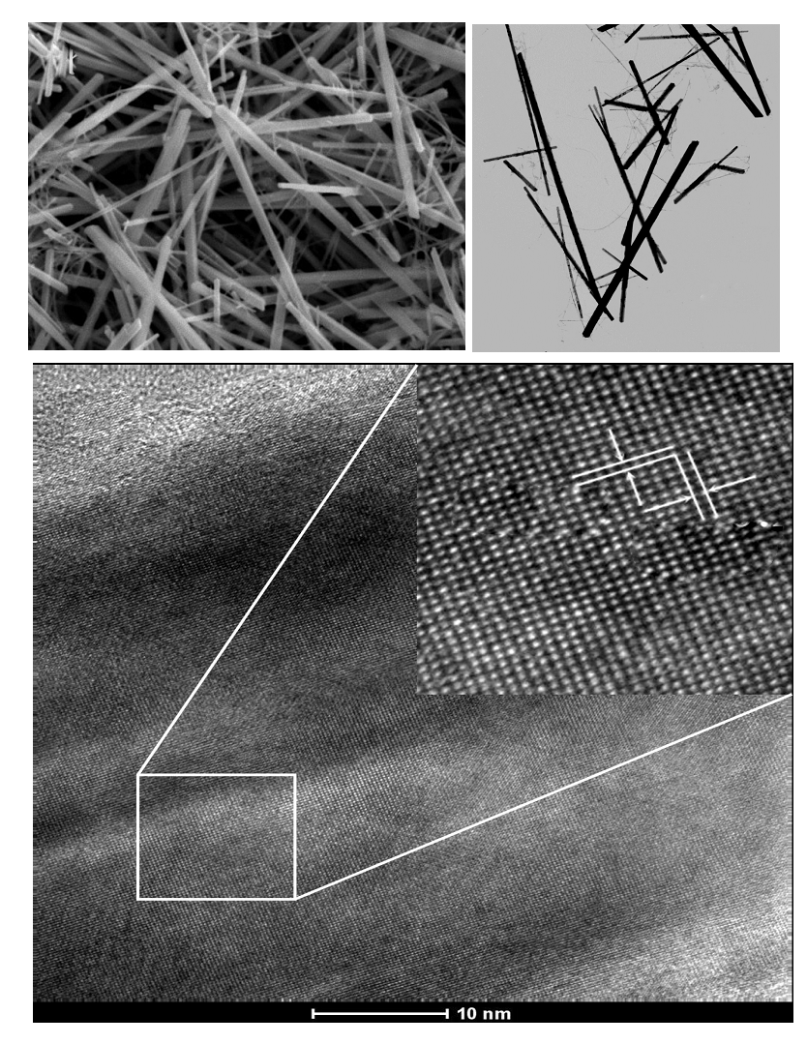
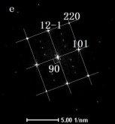
a
b
c
2 µm
2 µm
10 nm
0.225
0.287

Fig.2 SEM image (a), TEM image (b), HRTEM image and FFT pattern (c) for MnOOH nanorods synthesized at 120 °C with the volume ratio H₂O/NMP of 14.0

composed of a large quantity of MnOOH nanorods with lengths up to around 20 μm. It is interestingly observed that an individual MnOOH nanorod owns a cross-section of square shape. Fig.2b shows a typical TEM image of as-prepared MnOOH nanorods. As shown in Fig.2b, MnOOH nanorods with high aspect ratios are obtained on a large scale. Their diameter are 50~400 nm and the lengths is up to 15 μm. To further analyze the structure of MnOOH nanorods, we have obtained HRTEM image of a single nanorod as shown in Fig.2c. The inset in Fig.2c shows the enlarged view of the square region to identify the lattice planes of formed MnOOH nanorods. The lattice fringe is clearly seen in Fig.2c, indicating that the nanorod is well crystallized. The spacings of the neighboring lattice fringes are found to be 0.225 and 0.287 nm, which correspond to () and (101) planes of a monoclinic phase of MnOOH, respectively. The inset in Fig.2c at the right corner shows the corresponding fast Fourier transform (FFT) pattern. The spotted pattern taken from the reciprocal lattice peak through a two-dimensional Fourier transform indicates that the sample is single crystal in nature. Calculations indicate that the angle between the () and (101) planes is 90°, which is consistent with the results of HRTEM and FFT pattern.
2.3 FTIR spectrum of MnOOH nanorods
A representative FTIR spectrum of as-prepared MnOOH nanorods is shown in Fig.3. In the 400~4000 cm⁻¹ range, the sharp peaks at 449, 491, 594 and 642 cm⁻¹ are attributed to the vibrations of the Mn-O bonds in MnOOH ^{[25]}. The peaks at 1087, 1112 and 1154 cm⁻¹ demonstrate the existence of the OH bondings, which correspond to γ-OH, δ-2-OH and δ-1-OH^{[26]}, respectively. The broad peak around 2685 cm⁻¹ is the fundamental OH stretching related to the hydrogen bonding with an OH-O length of about 0.260 nm in the structure of manganite^{[3,20]}. The peak at 2088 cm⁻¹ could be considered as a combination band of the OH-stretching mode (f₁) at 2685 cm⁻¹ and the excited lattice mode at 594 cm⁻¹(f₂). Thus, by f = f₁－f₂, it is concluded 2685 – 594 = 2091 cm⁻¹. This value is very close to the results reported by Sharma and Zhang et al. (2098 and 2050 cm⁻¹, respectively) ^{[20, 27]}.
2.4 Influential factors on the formation of MnOOH nanorods
The nature of the nanomaterial formed by hydrothermal route depends on various factors including used solvent, reaction temperature, reaction time, effective fill level in the pressure vessel and so forth ^{[17,26,28,29]}. The factors mentioned above can be judicially chosen to get the desired architecture. The morphologies and the dimensions of the samples are found to strongly depend on the reaction parameters such as the volume ratio of H₂O/NMP, temperature and the reaction time. It is well known that NMP molecule contains a carbonyl group, which make NMP be a reducing agent, and KMnO₄ can be easily reduced to form MnOOH during the synthesis process. The reducing ability of NMP would be affected by the NMP concentration (NMP concentration is increased with the decreasing of the volume ratio of H₂O/NMP in our synthesis process.). When the reaction is carried out at 120 °C for 36 h, the morphologies of samples change from nanorods to small particles with the decrease of the volume ratio between H₂O and NMP as depicted in Fig.4. MnOOH nanorods are the major products when the volume ratio is in the range of 29.0~2.0 (Fig.4a~4c). The as-synthesized MnOOH nanorods, typically with 5~20 μm in length, have

Fig.3 FTIR spectrum of as-prepared MnOOH nanorods

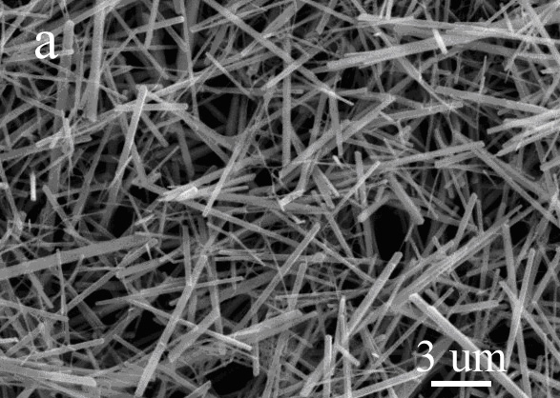
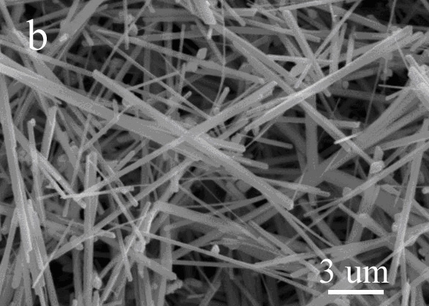
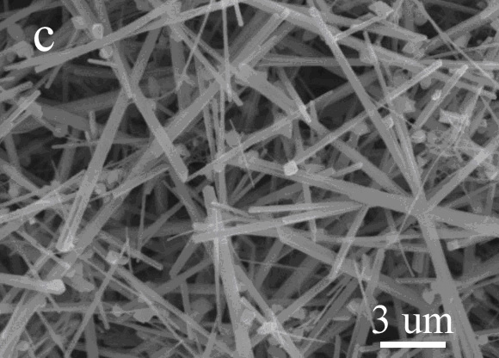
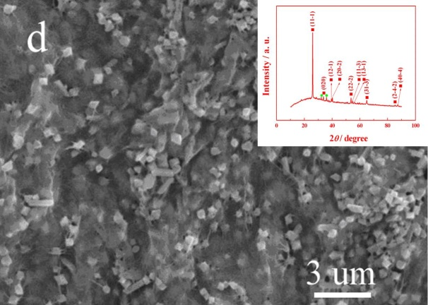
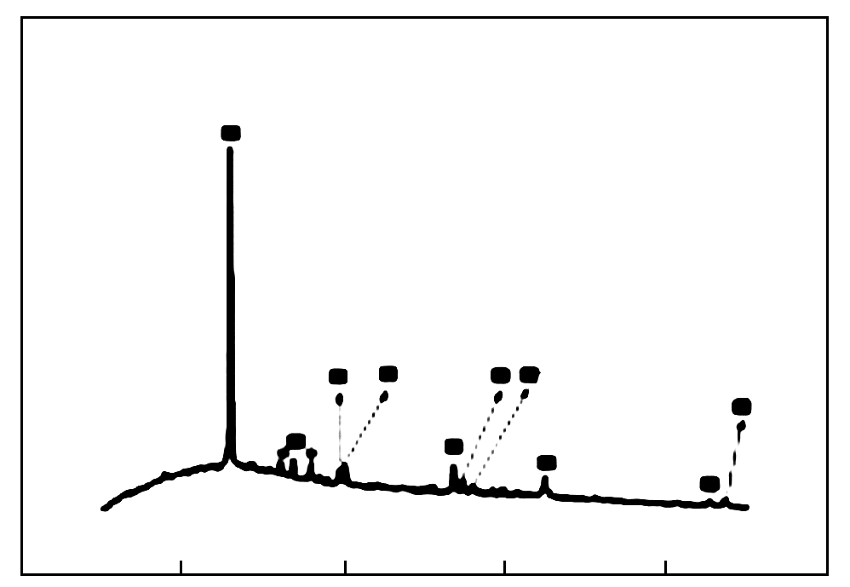
a
b
c
d
3 µm
0 20 40 60 80 100
2θ/(º)
Intensity/a.u.
(11-1)
(020)
(12-1)
(20-2)
(22-2)
(11-3)
(13-1)
(31-3)
(2-4-2)
(40-4)
e

Fig.4 SEM images of the samples obtained at 120 °C for 36 h with various volume ratios of H₂O/NMP: (a) 29.0; (b) 4.0; (c) 2.0; (d) 0.5 and its corresponding XRD pattern (e)

square cross-sections with edge lengths in the range of 50~400 nm, delivering unexpectedly high aspect ratios larger than 1000. Such a high aspect ratio of one dimension nanostructure is uncommon in solution-based synthesis. Small particles are obtained when the volume ratio of H₂O/NMP is decreased to 0.5 (Fig.4d). Fig.4e represents the XRD pattern of this sample. All of the reflections marked with squares can be readily indexed to a monoclinic phase of MnOOH (JCPDS No. 41-1379). Only two small peaks marked with dots can be assigned to the Mn₃O₄ (JCPDS No. 24-0734). From this XRD pattern, we can see that the obtained sample is mainly composed of MnOOH under the present experiment conditions. Therefore, the above results indicate that a suitable NMP concentration is needed to obtain uniform MnOOH nanorods.
Comparative experiments were carried out at other temperatures. Fig.5a shows the SEM image of the samples prepared at 100 °C. It can be observed that the sample consists of a large number of small particles and rod-like products. Only nanorods are obtained when the experiment is conducted at 120 °C (Fig.2a). When the reaction temperature is increased to 160 °C, the morphology is the mixture of nanorods and small particles as shown in Fig.5b. Fig.5c represents the corresponding XRD patterns of the samples prepared at 100 and 160 °C when the volume ratio of H₂O/NMP is 14.0. All diffraction peaks are in good agreement with the reported values of monoclinic phase of MnOOH (JCPDS No. 41-1379). No characteristic peaks due to other impurities are detected, indicating that the as-prepared samples consist of a single phase of MnOOH. So a suitable temperature is essential to the formation of MnOOH nanorods. In our synthesis process, 120 °C is chosen as the synthetic temperature according to the comparative experiment results.
In order to further understand the formation process of MnOOH nanorods, we carried out time-dependent experiments at 120 °C and the volume ratio between H₂O and NMP is 14.0 (Fig.6). At an early stage (2~12 h of hydrother-

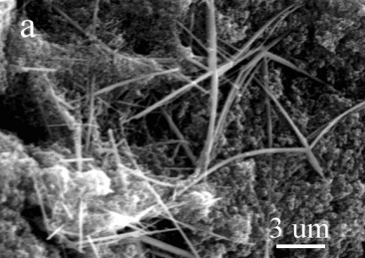
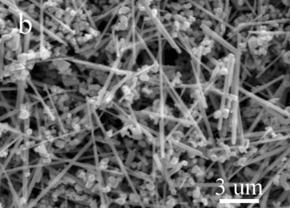
a
b

3 µm
3 µm
2θ/(º)
Fig.5 SEM images (a, b) and XRD patterns (c) of the samples (volume ratio of H₂O/NMP 14.0) obtained at various reaction temperatures: (a) 100 °C and (b) 160 °C

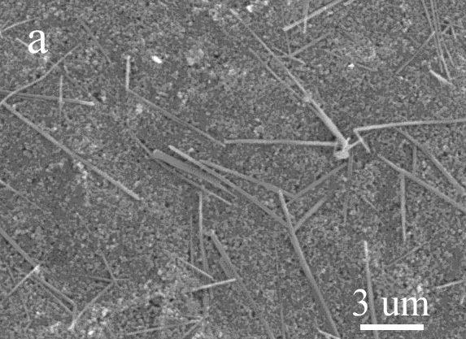
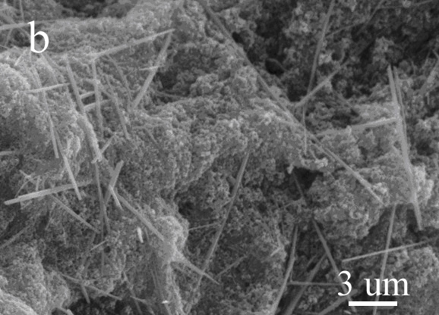
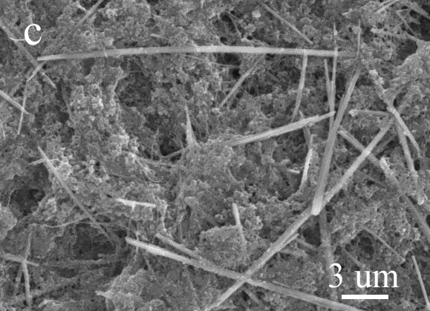
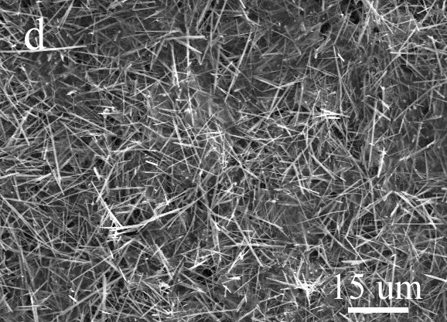
a
3 µm
b
3 µm
c
3 µm
d
15 µm

Fig.6 SEM images of samples obtained at 120 °C and different reaction time: (a) 2 h, (b) 6 h, (c) 12 h, and (d) 24 h

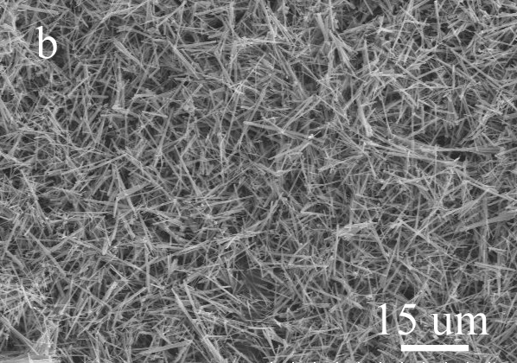
b

15 µm

Fig.7 XRD pattern of MnOOH nanorods after calcination at 500 °C (a) and SEM image of Mn₂O₃ (b)

mal reaction), the samples predominantly consist of small particles and a few rod-like architectures (Fig. 6a~6c). When the reaction time is prolonged to 24 h, the products are composed of MnOOH nanorods (Fig.6d). Uniform MnOOH nanorods could be obtained if the reaction time is raised to 36 h (Fig.2a). It could be deduced that many MnOOH nuclei form at the beginning of the reaction and as the reaction goes forward, MnOOH nanoparticles would grow to form rod-like shape products by Ostwald's ripening process^{[30]}. In this process, NMP molecules should act as not only reactant but also crystal growth modifier ^{[16]}. NMP molecules in solution would have preferential absorption ability to different crystal faces of MnOOH, which would affect the growth rates along different crystal axes during the Ostwald's ripening process and result in the growth of nanoparticles into MnOOH nanorods ^{[31]}.
2.5 Morphology-conserved transformation from MnOOH nanorods to Mn₂O₃ nanorods
Fig.7a shows the XRD pattern of the sample prepared by calcining MnOOH nanorods at 500 °C. The diffraction
peaks can be readily indexed to those of the Mn₂O₃ (JCPDS No. 41-1442). The formation process of Mn₂O₃ can be described as follows:
(1)
The morphology of the corresponding sample is shown in Fig.7b. Compared to Fig.2a, we can see that the morphology of MnOOH nanorods are well reserved in Mn₂O₃ sample, and no obvious difference is observed.

3 Conclusions
1) Single crystal MnOOH nanorods with lengths up to 20 μm and square cross-sections with edge lengths in the range of 50~400 nm can be synthesized on a large scale via a simple hydrothermal reaction between KMnO₄ and NMP.
2) The volume ratio of H₂O/NMP, reaction temperature and reaction time are crucial to the formation of MnOOH nanorods.

3) Mn₂O₃ prepared by calcination of MnOOH inherits the morphology of MnOOH nanorods.

References
- Tang Q, Gong X, Wu C et al. Catalysis Communications[J], 2009, 10: 1122
- El-Deab M S. International Journal of Electrochemical Science [J], 2009, 4: 1329
- Li F, Wu J, Qin Q et al. Journal of Alloys and Compounds[J], 2010, 492: 339
- Folch B, Larionova J, Guari Y et al. Journal of Solid State Chemistry[J], 2005, 178: 2368
- Zhou F, Zhao X, Yuan C et al. Journal of Materials Science [J], 2007, 42: 9978
- Gao L, Fei L, Zheng H. Materials Letters[J], 2007, 61: 1785
- Cheng F, Shen J, Ji W et al. ACS Applied Materials & Interfaces[J], 2009(1): 460
- Zhang W, Wang H, Yang Z et al. Colloids and Surfaces A: Physicochemical and Engineering Aspects[J], 2007, 304: 60
- Hu C C, Wu Y T, Chang K H. Chemistry of Materials[J], 2008, 20: 2890
- Li Y, Tan H, Lebedev O et al. Crystal Growth & Design[J], 2010, 10: 2969
- Jia Y, Xu J, Zhou L et al. Materials Letters[J], 2008, 62: 1336
- El-Deab M, SOhsaka T. Journal of the Electrochemical Society[J], 2008, 155: D14
- Portehault D, Cassaignon S, Baudrin E et al. Crystal Growth & Design [J], 2010, 10: 2168
- Chandra N, Bhasin S, Sharma M et al. Materials Letters[J], 2007, 61: 3728
- Cao X, Wang N, Wang L et al. Sensors and Actuators B: Chemical[J], 2010, 147: 730
- Zheng D, YinZ, Zhang W et al. Crystal Growth & Design[J], 2006, 6: 1733
- Sampanthar J T, Dou J, Joo G G et al. Nanotechnology[J], 2007, 18: 284
- Li Z, Xu J, ChenX et al. Colloid and Polymer Science[J], 2011, 289: 1643
- Zhang Z, Mu J. Solid State Communications[J], 2007, 141: 427
- Zhang Y C, Qiao T, Hu X Y et al. Journal of Crystal Growth [J], 2005, 280: 652
- Mi Y, Zhang X, Yang Z et al. Materials Letters[J], 2007, 61: 1781
- Sun X, Kong X, Wang Y et al. Materials Science and Engineering: C [J], 2006, 26: 653
- Rabiei S, Miser D, Lipscomb J et al. Journal of Materials Science[J], 2005, 40: 4995
- Sun X, Ma C, Wang Y et al. Inorganic Chemistry Communications[J], 2002, 5: 747
- Ocaña M. Colloid and Polymer Science[J], 2000, 278: 443
- Zhang W, Yang Z, Liu Y et al. Journal of Crystal Growth[J], 2004, 263: 394
- Sharma P K, Whittingham M S. Materials Letters[J], 2001, 48: 319
- Zhang Y, Liu Y, Guo F et al. Solid State Communications[J], 2005, 134: 523
- Byrappa, Kadschiri T. Progress in Crystal Growth and Characterization of Materials[J], 2007, 53: 117
- Cushing B L, Kolesnichenko V, LO'Connor C J. Chemical Reviews[J], 2004, 104: 3893
- Murphy C J. Science[J], 2002, 298: 2139

简单水热法合成MnOOH纳米棒及应用

李中春^{1, 2}，顾爱军²，周全法^{1, 2}
(1. 江苏省贵金属深加工技术及应用重点建设实验室，江苏 常州 213001)
(2. 江苏理工学院，江苏 常州 213001)

摘 要：在无模板和表面活性剂的条件下，以 KMnO₄ 为锰源，N-甲基吡咯烷酮 (NMP) 和水为混合溶剂，通过简单的水热法成功地合成了MnOOH单晶纳米棒。通过调节H₂O/NMP的体积比、反应温度、反应时间等实验条件合成了长度达20 μm，且横截面为方形的MnOOH纳米棒。用X射线衍射 (XRD)、扫描电镜 (SEM)、透射电镜 (TEM)、高分辨透射电镜 (HRTEM) 和傅里叶变换红外光谱 (FTIR) 对样品进行了表征。用Ostwald熟化理论初步讨论了 MnOOH 纳米棒的形成机理。在此基础上，通过煅烧 MnOOH 纳米棒获得了 Mn₂O₃ 纳米棒，与 MnOOH 纳米棒相比，其形貌基本没有变化。
关键词：MnOOH；Mn₂O₃；合成；纳米棒

作者简介：李中春，男，1977年生，副教授，江苏理工学院化学与环境工程学院，江苏 常州 213001，E-mail: czlizc@126.com

