Synthesis and Thermal Stability of Nanocrystalline Nickel Coatings by Direct Current Electrodeposition
Dong Nan, Zhang Caili, Li Juan, Han Peide

Key Laboratory of Interface Science and Engineering in Advanced Materials, Ministry of Education Taiyuan University of Technology, Taiyuan 030024, China

Abstract: The influences of current density and saccharin concentration on nanocrystalline nickel coatings synthesized by direct current electrodeposition were analyzed. Results show that in the current density range from 0.5 A/dm² to 1.5 A/dm², nanocrystalline nickel coatings with broad microhardness HV distribution from 4150 MPa to 6030 MPa can be synthesized by adjusting saccharin concentration. The preferred orientation in the deposits exists at 0.5 A/dm², (111), (200) double orientation texture changes to a (200) orientation texture as saccharin concentration and (200) intensity increase. The internal stresses of the samples prepared at 0.5 A/dm² decrease to nearly 0 MPa as saccharin concentration increases to 1.2 g/L. The results of DSC curves show that the grains start to grow until 600 °C and keep the thermal stability near to bulk nickel when grain sizes are in the range from 28 nm to 98 nm. However, when the grain size is 10 nm, the grains grow abnormally at 317 °C, and their thermal stability decrease sharply.

Key words: nanocrystalline nickel; electrodeposition; microhardness; thermal stability

Advanced nanostructured materials such as nanocrystalline metals have gained considerable interest because they exhibit exceptionally high strength ^{[1,2]}. There are several routes to obtain nanocrystalline coatings such as pulsed laser deposition, electrodeposition, chemical vapour deposition and thermal spray. Among them, direct current electrodeposition is a convenient and economical method to produce dense nanocrystalline, pure metal and composite materials ^{[3-6]}.
The mechanical properties of electrodeposits depend on their microstructures, which can be substantially influenced by the electroplating conditions and the composition of plating bath ^{[7-12]}. It is of great interest to understand the relationship between the grain sizes of nanocrystalline coatings and their synthesis technique parameters both from the fundamental and performance standpoints because the properties of these coatings are intrinsically size-dependent. A recent study ^{[9, 13]} has shown that a broad grain size distribution was the key factor to increase the ductility of nanocrystalline materials without losing their intrinsic high strength. Current density has a significant function on the grain sizes of electrodeposited coatings. High current density causes high overpotential and nucleation rates, which further promote grain refinement ^{[14,15]}. The grain refining via saccharin concentration increase in nickel plating bath was analyzed by Erb ^{[16]} and Yuan^{[17]}. However, the exact circumstances of production and grain refinement methods are not known by the tester because the production and mechanical analyses were not executed by the same groups. Existing studies always focus on preparing nanocrystalline nickel with a narrow grain size distribution, whereas those that prepare nanocrystalline nickel with a broad distribution remain scarce. In the present study, we determined the influence of the low current density and saccharin concentration on nanocrystalline nickel, and found the best conditions to produce this material with a broad microhardness distribution. Moreover, the thermal stability of the nanocrystalline nickel coatings was researched.

1 Experiment
All nickel coatings were synthesized via direct current electrodeposition on copper substrates by a Watts bath at 50 °C. The details of the conditions and coatings preparation procedures were described in Ref. [13]. The coatings were obtained with current densities and saccharin concentrations ranging from 0.5 A/dm² to 4.1 A/dm² and from 0.4 g/L to 5 g/L, respectively. The coatings with a thickness of approximately 120 µm are deposited under above conditions.
Microstructures of representative samples were characterized by scanning electron microscopy (SEM) and X-ray diffraction (XRD). Grain sizes were calculated from diffraction line broadening using the Scherrer equation ^{[18]}. Internal stresses were measured qualitatively via the sin²ψ method ^{[19]} by X-ray stress evaluations. Microhardness tests were performed on an HMV-2T microhardness tester with a Vickers indenter at a load of 50 g for duration of 15 s. During the hardness tests, the separation between indents was initially kept at more than three times as large as the diameter of each indent. Five measurements were averaged in order to determine the hardness of each specimen. Differential scanning calorimetry (DSC) experiments were performed in an HCT-2 differential thermal analyzer using argon as the purge gas. Measurements were performed between 50 and 700 °C at a heating rate of 10 °C/min.

2 Results and Discussion
2.1 Microstructure of the nanocrystalline Ni coatings
The macrograph and the surface morphology of the samples obtained by SEM are presented in Fig.1. These samples, which have bright and smooth surface morphologies, satisfy the surface quality requirement.
Fig.2a shows the XRD patterns of representative deposits produced at various current densities with a saccharin concentration of 0.4 g/L. The crystal structure of the samples is pure faced-centered cubic nickel and no characteristic peaks of other phases have been recorded. The strong intensity of peak at 2θ=44.6° is from Ni (111) plane together with other peak Ni (200) at approximately 2θ=52°. The peak broadening of the coating indicates grain refinement to nanoscale size. Increasing of the current density from 0.5 A/dm² to 4.1 A/dm² retains the preferred orientation, and I₍₂₀₀₎/I₍₁₁₁₎ [defined as the quotient of the intensity of (200) and (111) planes] decreases from 0.947 to 0.691. However, Fig.2b shows that the diffraction intensity of (111) texture of the deposit prepared at 0.5 A/dm² sharply decreases with increasing of saccharin concentration. I₍₁₁₁₎/I₍₂₀₀₎ changes from 1.055 to 0.047, thus indicating that
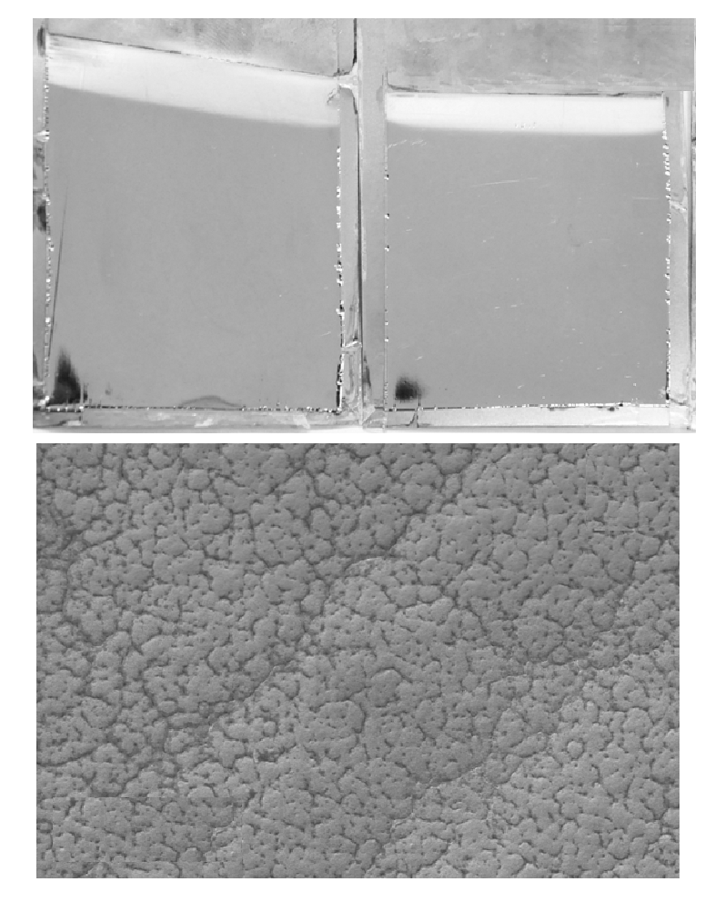
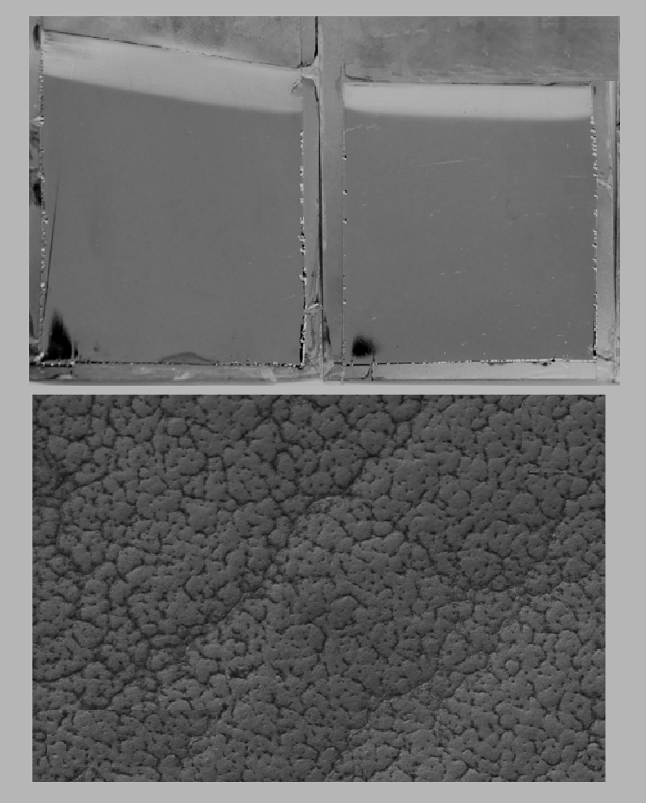
a
b
10 µm

Fig.1 Macrograph of samples prepared at 0.5 A/dm² with saccharin concentrations of 0.4 g/L and 2.0 g/L (a); surface morphology of sample prepared at 0.5 A/dm² and saccharin concentration of 2.0 g/L (b)

a

b

Fig.2 XRD patterns of nickel coatings prepared at a saccharin concentration of 0.4 g/L and different current densities (a); and different saccharin concentrations at 0.5 A/dm² (b)

the preferred orientation and the texture of the deposit are markedly influenced by saccharin concentration. This finding agrees with the study of Kerstin and Qin ^{[9,13]}. However, the broadening variation of the (200) and (111) diffraction peaks of the samples is not obvious.
The grain sizes of the samples calculated via XRD by the Scherrer equation are shown in Fig.3. With increasing of the current density from 0.5 A/dm² to 4.1 A/dm² the grain size increases slightly from 10 nm to 16 nm at a saccharin concentration of 0.4 g/L. With increasing of the saccharin concentration from 0.4 g/L to 1.6 g/L the grain size increases greatly from 10 nm to 28 nm at a current density of 0.5 A/dm². In a conclusion, the effect of saccharin concentration on grain size at low current density is more obvious than that of current density.
2.2 Microhardness of the nanocrystalline Ni coatings
The microhardnesses of the samples prepared at different deposition parameters are shown in Fig.4. This microhardness HV varies at relatively high values from 5500 MPa to 6030 MPa at a saccharin concentration of 0.4 g/L. Varying of saccharin concentration between 0.8 and 1.7 g/L yields the maximum microhardness, and then the value decreases with increasing of current density. However, increasing of saccharin concentration to 2.0 g/L (and even to 5.0 g/L) yields the minimum microhardness, which agrees with previous results ^{[20,21]}. Fig.4 also shows that microhardness HV increases from 4150 MPa to 6030 MPa with varying saccharin concentration between 0.5 and 1.5 A/dm² for a current density. Hence, nanocrystalline nickel samples with broad microhardness distribution can be prepared by changing the saccharin concentration. However, only a narrow microhardness distribution can be synthesized for current densities ranging from 1.5 A/dm² to 4.0 A/dm².
Kerstin et al. ^{[9]} showed that the electrodeposition process produces internal stresses. The magnitude and prefix of these stresses depend on the deposition parameters and the ingredients of the electrolyte. The result measured qualitatively by the sin²ψ method from XRD (Fig.2a, 2b) shows that with increasing of the current density from 0.5 A/dm² to 4.1 A/dm², the internal stresses increases from 24 MPa to 26 MPa at a saccharin concentration of 0.4 g/L. However, the stress value decreases from 24 MPa to nearly 0 MPa with the increase of saccharin concentration from 0.4 g/L to 1.2 g/L. The combination of this result and that from Kerstin shows that high saccharin contents flatten internal stresses. Moreover, when the samples perepared at a saccharin concentration of 0.4 g/L are annealed at 150 °C for 2 h, their microhardness (as shown in Fig.4 in the dashed line) is decreased sharply. This finding show that the high microhardness of the samples prepared at 0.4 g/L is caused by the aforementioned internal stresses, and that a temperature of 150 °C does not cause grain growth.
2.3 DSC analysis
Fig.5 shows the DSC curves of nickel samples with six grain sizes. Two possibilities exist for the origin of the exothermic peak
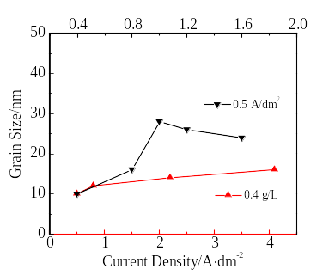
Content of Saccharin/g·L⁻¹

Fig.3 Relationships between the grain size and the current density as well as the saccharin concentration
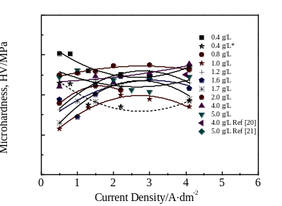
7000
6000
5000
4000
3000

Fig.4 Relationship between microhardness and current density, compared with Ref. [20, 21]


Fig.5 DSC curves of nickel samples with grain sizes of l0, 28, 46, 77 and 98 nm, and that of the bulk nickel sample prepared at 10 °C/min heating rate

in nanocrystalline metals, namely, grain growth and stress relaxation, thus indicating that stress relaxation occurs first before grain growth ^{[22]}. Heating the samples at a rate of 10 °C/min from 50 °C to 700 °C yields an obvious exothermic peak in all nanocrystalline nickel samples at approximately 60 °C based on stress relaxation. The exothermic peak associated with the abnormal grain growth is recorded at approximately 317 °C in a 10 nm nickel sample, and a large number of grains grow quickly. No exothermal effect was detected in other nickel samples with 28, 46, 77, and 98 nm grain sizes and in bulk nickel. Another exothermic peak, which corresponds to the grain growth of all nanocrystalline samples, was recorded at approximately 600 °C. In summary, the sample tends to be unstable and grains grow abnormally at 317 °C for a grain size of 10 nm. Meanwhile, when the grain sizes of the samples are in the range from 28 nm to 98 nm, the grain do not grow until 600 °C, and the thermal stabilities of them are nearly to the bulk nickel.

3 Conclusions
1) Nanocrystalline nickel with broad microhardness HV distribution 4150~6030 MPa can be prepared by adjusting the saccharin concentration at the current density ranging from 0.5 A/dm² to 1.5 A/dm².
2) A preferred orientation exists in the deposits prepared at 0.5 A/dm². This orientation changes progressively from a (111), (200) double orientation texture to a (200) orientation texture as saccharin concentration increases.
3) The thermal stabilities of the samples with grain size ranging from 28 nm to 98 nm are nearly to the bulk nickel. However, the sample grows abnormally at 317 °C and thermal stability decreases sharply when grain size is 10 nm.

References
- Jeong D H, Gonzalez F, Palumbo G et al. Scripta Materialia [J], 2001, 44: 493
- Dao M, Lu L, Asaro R J et al. Acta Mater[J], 2007, 55: 4041
- Li Y D, Jiang H, Pang L J et al. Surface and Coating Technology[J], 2007, 201: 5925
- Moti E, Shariat M H, Bahrololoom M E. Materials Chemistry and Physics[J], 2008, 111: 469
- Li Y D, Jiang H, Huang W H et al. Applied Surface Science[J], 2008, 254: 6865
- Shen Y F, Xue W Y, Wang Y D et al. Surface and Coating Technology[J], 2008, 202: 5140
- Bhardwaj M, Balani K, Balasubramaniam R et al. Surface Engineering[J], 2011, 27: 642
- Sen R J, Das S, Das K. Materials Character[J], 2011, 62: 257
- Kerstin S, Bastian P, Martin W et al. Acta Mater[J], 2013, 61: 3945
- Chung C K, Chang W T. Thin Solid Films[J], 2009, 517: 4800
- Rashidi A M, Amadeh A. Surface and Coating Technology [J], 2008, 202: 3772
- Matsui I, Takigawa Y, Uesugi T et al. Materials Transactions [J], 2011, 52: 142
- Qin L Y, Xu J Y, Lian J S et al. Surface and Coating Technology[J], 2008, 203: 143
- Winand R. Electrochimica Acta[J], 1994, 39: 1091
- Winand R. J Appl Electrochem[J], 1991, 21: 377
- Sherik El, Erb U. J Mater Sci[J], 1995, 30: 5743
- Yuan X T, Wang Y, Sun D B et al. Surface and Coating Technology[J], 2008, 202: 1895
- Natter H, Schmelzer M, Hempelmann R. J Mater Research [J], 1998, 13: 1186
- Xu K W, He J W, Zhou H J. Journal of Materials Science and Technology[J], 1993, 9: 57
- Kang J X, Zhao W Z, Zhang G F. Surface and Coating Technology[J], 2009, 203: 1816
- Hayatia M, Rashidi A M, Rezaei A. Solid State Sciences [J], 2011, 13: 163
- Detor A J, Schuh C A. J Mater Research[J], 2007, 22: 3233

直流电沉积法制备纳米晶体镍镀层及其热稳定性研究

董 楠，张彩丽，李 娟，韩培德
(太原理工大学 新材料界面科学与工程教育部重点实验室，山西 太原 030024)

摘 要：利用直流电沉积技术系统分析电流密度和镀液糖精浓度对纳米晶体镍性能的影响。结果表明, 电流密度在0.5~1.5 A/dm²时，可调节糖精浓度制备出显微硬度HV分布为415~603 MPa的纳米晶镀层。小电流密度0.5 A/dm² 时，随糖精浓度增大，镀层 (200) 面衍射强度增强，结构由 (111), (200) 双织构向 (200) 面转变，且镀层内应力降低，糖精浓度增大到1.2 g/L时，内应力降为0。镀层晶粒尺寸为28~98 nm时，直到600 ℃晶粒才开始长大，结构稳定性较好；晶粒尺寸为10 nm时，晶粒在317 ℃异常长大，其结构稳定性显著下降。
关键词：纳米晶体镍；电沉积；显微硬度；热稳定性

作者简介：董 楠，女，1988年生，博士生，太原理工大学材料科学与工程学院，山西 太原 030024，电话：0351-6018843，E-mail: dongnantyut@126.com

