Multi-wedge Cross Wedge Rolling Process of 42CrMo4 Large and Long Hollow Shaft
Peng Wenfei^{1, 2}, Zheng Shuhua², Chiu Yijui², Shu Xuedao², Zhan Lihua¹

¹ State Key Laboratory of High Performance and Complex Manufacturing, Central South University, Changsha 410083, China; ² Zhejiang Provincial Key Laboratory of Part Rolling Technology, Ningbo University, Ningbo 315211, China

Abstract: Large and long thick-walled hollow shafts are the key parts of industry equipments, which are formed by the multi-wedge cross wedge rolling (MCWR). In the present paper, first, the deflection angle equations of side-wedges applied at the multi-wedge cross wedge rolling of hollow shafts were derived, which lay important foundation for designing the MCWR mold. Second, the spreading angle's impacts on single-wedge cross wedge rolling (CWR) of thick-walled hollow shaft-part were discussed. And, compared to roll small diameter of hollow shaft, the ellipticity of the large and long thick-walled hollow shaft could be controlled, and the selection range could be extended. At the same time, it was also found that the ellipticity could also be controlled by empty top surface of the mold. At last, the FE model of double-wedge cross wedge rolling of large and long thick-walled hollow shaft was established. The forming process was simulated, and the ellipticity of symmetrical cross-section was monitored. The ellipticity of large and long thick-walled hollow shaft was controlled well. The simulated ellipticity of symmetrical cross-section is 4.98%, and the experimental ellipticity is 5.56%. The results indicate that it is feasible to produce large and long thick-walled hollow shafts with double-wedge CWR.

Key words: multi-wedge cross wedge rolling; large and long thick-walled hollow shaft; ellipticity

With the rapid development of China's high-speed railway, the demand for hollow shafts of high-speed trains increases sharply. Today, China's hollow shafts of high-speed trains are mainly from imports. Methods of forming hollow shafts have two technologies. One is free forging, and then drilling the inner hole. The other is precise forging hollow shell. But there exist many shortcomings such as waste material, energy consumption of follow-up machining and high production costs ^{[1,2]}. The latter method makes a great progress in the forming quality and material utilization. However, there still exist disadvantages such as expensive equipments, low production efficiency and high energy consumption. To solve those problems, the forming method of the multi-wedge cross wedge rolling (MCWR) of large and long hollow shaft is used in this paper.
The difficulties of the MCWR of hollow shaft are to control inner hole's ellipticity and make the transitional position smooth. Thin-wall hollow shaft weakens the ability of resisting inner hole's ellipticity, which leads to unstable rolling. Those problems can be solved by reducing the spreading angle, but it will increase the mold's length and the mill's weight. There are some researches about the cross wedge rolling (CWR) of small thin-walled hollow shaft-parts, and a few researches about the CWR of thick-walled hollow shaft parts, for example, Zhang et al ^{[3]} studied the impact rules of the process parameters on the ellipticity of thin-wall hollow shaft by the rolling experiments. Pater et al ^{[4]} presented single-wedge cross wedge rolled thin-walled hollow shaft without the mandrel, and explored the laws of the influence process parameters on the inner hole's ellipticity. Lovell et al ^{[5]}, discussed the condition of rolling thin-wall hollow shaft. Zhang et al ^{[6]} presented single-wedge CWR of hollow shaft with the mandrel, from which we can see that when the ellipticity formed by spreading angle 3° is better. Wang et al ^{[7]} studied single-wedge cross wedge rolled thick-walled hollow shaft with the mandrel. They haven't studied the MCWR of hollow shaft. The ellipticity controlled by the MCWR is more difficult than by the single-wedge CWR. Zhao et al ^{[8,9]} presented the MCWR of solid long shaft. Shu et al ^{[10]} analyzed the stress of the MCWR of solid railway shaft. In addition, Li and Shu et al ^{[11, 12]} tried to reduce scale to explore the deformation rules of solid train shafts. Based on the above analyses, the multi-wedge cross wedge rolling of solid long shaft, all of middle long equivalent diameter shaft-segments are formed by two wedges synchronously. The deformation of transitional position between main wedge and side wedge is difficult to make smooth. However, their results have some questions in rolling large and long thick-walled hollow shaft, because the hollow shaft is just rolled by single-wedge. The multi-wedge cross wedge rolling is just used to form solid long shaft, and there exist a lot of difficulties.
If the thick-walled hollow shafts are scaled down, they will become small thin-walled ones, whose deformation rules and means of controlling ellipticity are consistent with thin-walled hollow parts. The present paper derived the deflection angle formulas of the MCWR of large and long hollow shaft, discussed the impact of spreading angle and empty mold's top surface on the inner hole's ellipticity, and created a non-scaled down FE model. The paper also studied the forming process, monitored the ellipticity in symmetrical cross-section, and the feasibility of rolling large and long thick-walled hollow shaft. The results lay the foundation for studying the multi-wedge cross wedge rolling of hollow shaft of high-speed train.

1 Hollow Shaft and MCWR Technology
The production of hollow shaft of high-speed train is a typical large and long thick-walled hollow shaft with outer diameter 198 mm and inner hole diameter 70mm. The geometry of hollow train shaft is shown in Fig.1.
MCWR is that the molds fixed on the mill rollers rotate in the same direction, and drive the billet rotation in an opposite direction. Under the function of mold, the billet produces plastic deformation, such as radial compressed and axial extended deformation. Meanwhile, the billet is rolled with different shape and length. The MCWR is an advanced, near net and precise technology of forming long shaft with many advantages, such as remarkable saving mold's size, reducing equipment weight, high efficiency, saving materials and reducing costs^{[13]}. The MCWR mold is shown in Fig.2.

2 Deflection Angle
For the multi-wedge cross wedge rolling of hollow train shaft, it is important but difficult to choose right deflection angles of the side wedges. The deflection angle directly determines the forming qualities of steps. If the deflection angle is too small, blocking metal's axial flow, the billet will bend, as shown in Fig.3a. If it is too large, the spiral incision deformation defects would be generated, as shown in Fig.3b.

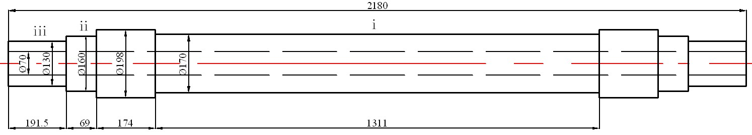
Φ70
Φ130
Φ160
Φ198
Φ170
174
69
191.5
iii
ii
1311
2180
i

Fig.1 Geometry of the large and long thick-walled hollow shaft

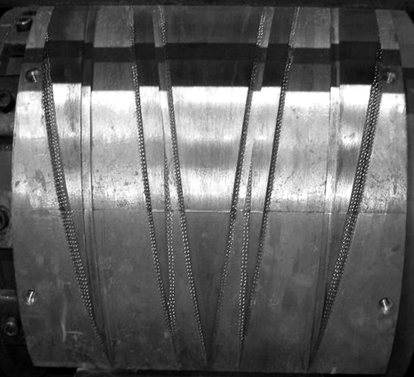
Main wedge
Side wedges

Fig.2 Mold of multi-wedge cross wedge rolling
Fig.4a introduces the deformation stages, and Fig.4b shows the process parameters of single-wedge CWR.
To study cross wedge rolling of long hollow shaft, the coupling relationship of the multi-wedge synchronization cross wedge rolling should be studied first, and the coupling relationship schematic diagram is shown in Fig.5,
and the mold curve is calculated.
The deflection angle of the multi-wedge cross wedge rolling of long hollow shaft is calculated as Eq.(1), and the double-wedge and three-wedge cross wedge rolling of deflection angle formulas are shown as Eq.(2) to Eq.(6).
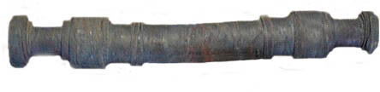
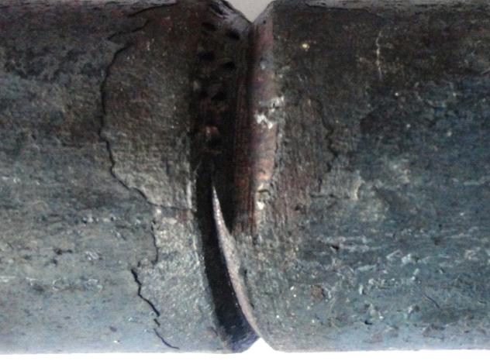
¦¤
a
b

Fig.3 Deformation defects produced by unreasonable deflection angles: (a) bend defect of small deflection angle; (b) spiral incision defect of large deflection angle

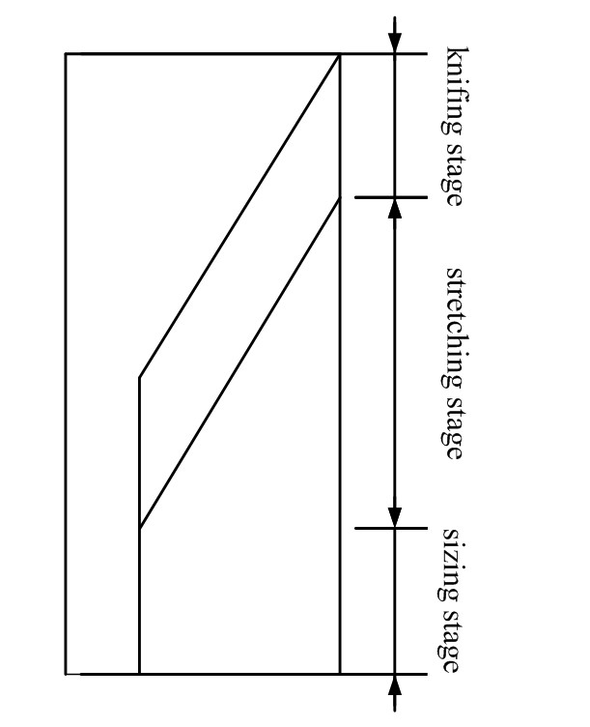
a
b
Knifing
stage

Stretching
stage

Sizing
stage

Fig.4 Mold diagram of single wedge: (a) 2-D mold and (b) 3-D mold

a
A
B
E
F

C D
G H
b

Fig.5 Multi-wedge schematic diagram: (a) three deformation zones; (b) the relationship of deflection angle and spreading angles

(1) where θ presents deflection angle, t presents the axial displacement of metal (or shaft ends) and τ presents the length of billet along the mold's surface.
(1) The deflection angle of double-wedge CWR
(2)
(2) The deflection angle of three-wedge CWR
a: 1-wedge and 2-wedge wedging at the same time:
(3)
b: 1-wedge wedging and 2-wedge spreading:
(4)
c: 1-wedge spreading and 2-wedge wedging:
(5)
d: 1-wedge and 2-wedge spreading at the same time:
(6)
In Eqs.(3)~(6), α₁ is the forming angle of main wedge, α₂ is the forming angle of side wedge, β₁ is the spreading angle of main wedge, β₂ is the spreading angle of side wedge, d₀ is the diameter of rolled part, d₁ is the diameter of main wedge rolled of shaft section, d₂ is the diameter of side wedge rolled of shaft section, and d₀ is the diameter of the inner hole.

3 Experiment Study
3.1 Experiment of three-wedge CWR
The hollow shaft is formed at the reduction scale size 1:5. When the MCWR of long shaft-parts, the middle equivalent diameter shaft segment (i) is mainly formed by the main wedge and side wedges synchronously, as shown in Fig.6a. To introduce the rolling process clearly, the FE simulation results are borrowed, as shown in Fig.6b. Firstly, the side-wedges form two gradient steps (Fig.6b), making the billet produce two transitional sections. Secondly, the main wedge rolls two gradient steps. This method brings the difficulty of forming the transitional position between the main-wedge and side-wedge. It is difficult to make the transitional sections smooth.
3.2 Experiments of double-wedge CWR
According to the geometry of hollow shaft, the deflection angle formulas, and empting top surface of mold, the main process parameters are selected in Table 1.
According to the process parameters list, the mold of the double-wedge cross wedge rolling could be designed and the mold is shown in Fig.7.
The ellipticity is concentric inner and outer wall to form oval rings and the ring has uniform wall thickness. The maximum size of the elliptical diameter D_{max} and the minimum D_{min}, are shown in Fig.8.
The ellipticity e can be expressed as:
(7)
After rolling the large and long hollow shaft-parts by double-wedge CWR, the ellipticity e is 5.56% (see Fig.9).

4 Results and Discussion
4.1 Finite element (FE) simulation
The finite element model is composed of upper die,

Table 1 Process parameters selection table of the mold
Process parameter | Value | Process parameter | Value
The forming angle of  1-wedge α₁/(º) | 45 | Area reduction,  Ψ₁/% | 26.3
The spreading angle of  1-wedge β₁/(º) | 8.5 | Area reduction,  Ψ₂/% | 34.7
The forming angle of  1-wedge α₂/(º) | 48 | Area reduction,  Ψ₃/% | 56.9
The spreading angle of  2-wedge β₂/(º) | 6 | Rolling temperature,  T/ºC | 950
The deflection angle θ₂₁ of 2-wedge at wedging section/(º) | 0.65 | The diameter of the roller,  D/mm | 1650
The deflection angleθ₂₂ of  2-wedge at spreading section/(º) | 2.5 | The rotation speed of the roller, n/r·min⁻¹ | 9.55
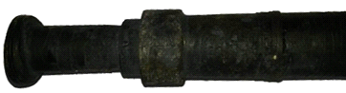
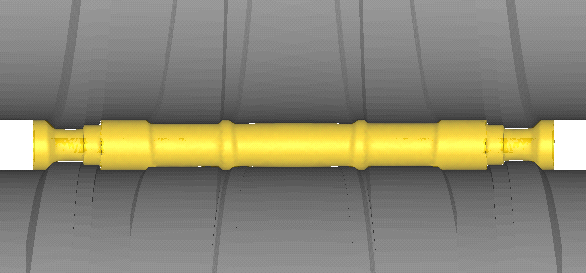
Unsmooth transitional position
Main wedge
Side wedge
Side wedge
Gradient steps at
transition section
Long and equivalent diameter shaft
-
section
a
b

Fig.6 Forming quality of transitional position: (a) unsmooth transition section; (b) the process of three-wedge cross wedge rolling

3
2
1

1-main wedge (1-wedge), 2-side wedge, 3-empty mold's top surface

Fig.7 Stretching mold of double-wedge cross wedge rolling

lower die, workpiece, mandrel, front and back guide plates. Fig.10 shows the FE model of double-wedge cross wedge rolling of large and long thick-wall hollow shafts.
The material is 42CrMo4, whose material constitutive curves are shown in Fig.11. Because the large and long thick-wall hollow shaft is large, and the rolling process is done in a short time, the rolling process is done at a constant temperature.

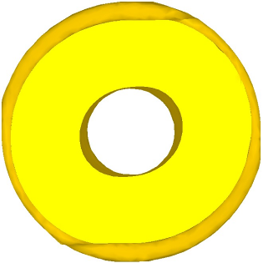
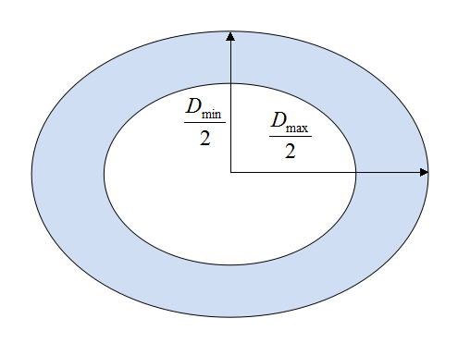
a
b
a
b

Fig.8 Cross-section ellipticity schematic diagram: (a) simulated ellipticity and (b) ellipticity diagram

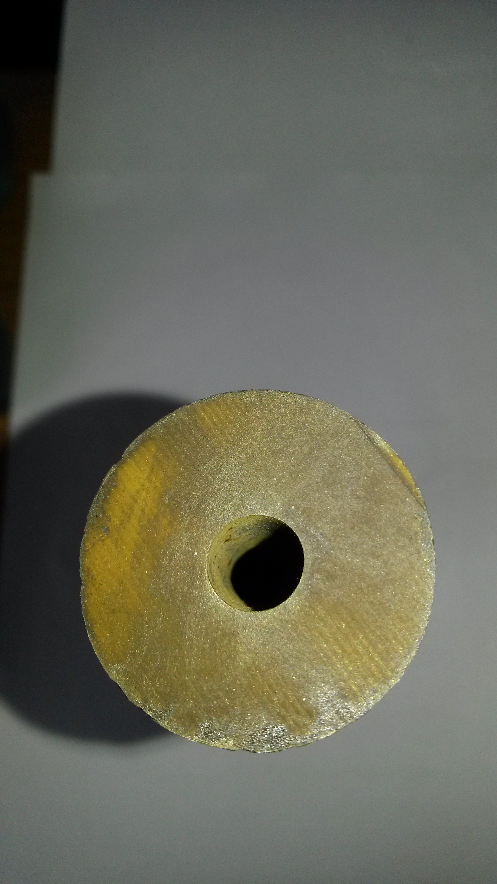

Fig.9 Ellipticity of the rolled part
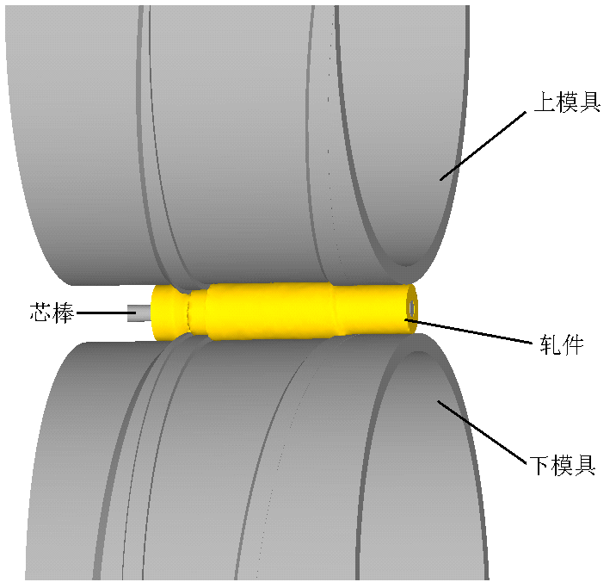
Mandrel
Upper die
Workpiece
Lower die

Fig.10 FE model of cross wedge rolled large and long thick-walled hollow shaft

4.2 Forming quality of transitional section
Left side in Fig.12 shows the process of double-wedge CWR of large and long thick-wall hollow shaft, and the right side shows the change of the ellipticity in symmetrical cross-section. Compared with references of two wedges rolling the long equivalent shaft segment ^{[11,12]}, Fig.12 shows that 1-wedge forms the long equivalent i segment, while 2-wedge forms the ii, iii segments.
Fig.12b is the deformation of 1-wedge and 2-wedge knifing stage at the same time. Fig.12c shows that the shape stepped by 2-wedge is perpendicular to the axis of the rolled part. There is no blocked material and the spiral incision defect, which indicates the selected deflection angle of 2-wedge is appropriate. The middle long equivalent shaft-segment is rolled by 1-wedge, which doesn't produce transition position. It also avoids metal fold and stress concentration while the gradient steps are pushed down. Thus, the forming quality of single-wedge (1-wedge) forming the long equivalent diameter shaft-segment is significantly enhanced.
4.3 Ellipticity analysis
The easiest ellipticity cross-section of the hollow shaft is symmetrical cross-section. After the completion of the

Fig.11 42CrMo4 material constitutive curves at 950 °C



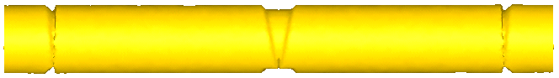
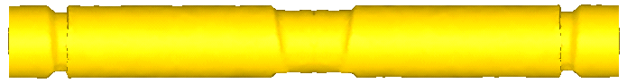
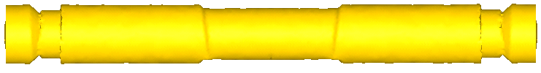
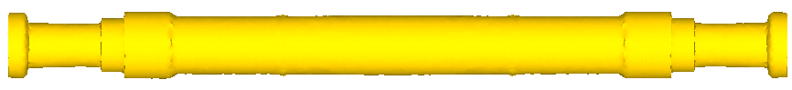



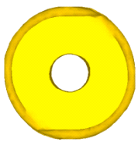


(a) workpiece
(b) 1-wedge and 2 wedge knifing

(c) 1-wedge stretching and 2 wedge knifing

(d) 1-wedge stretching and 2 wedge stretching

(e) 1-wedge stretching and 2 wedge knifing ⅲ shaft-segment

(f) 1-wedge and 2-wedge stretching and then rolling completed

Fig.12 Forming process of the double-wedge CWR

rolling process, the variation curve of the ellipticity as the rolling time is plotted in Fig.13. From Fig.13, we can see that the double-wedge CWR of high-speed railway hollow shafts makes good forming quality of controlling the ellipticity. To form large and long thick-walled hollow shaft, it is useful to analyze why good results can be achieved.
According Fig.13, the ellipticity trend in the symmetrical cross-section is “increase-decrease-no change” with time. The reason is that while 1-wedge knifing, the metal mainly produces transverse deformation, and the ellipticity increases, corresponding to the rising stage of the curve in Fig.13. With the rolling proceeding, the mold's top surface is emptied, which weakens the function of the mold acting on the hollow shaft. The ellipticity decreases, corresponding to the downward stage of the curve. With the ellipticity unchanging, the final ellipticity e is 4.98%. It indicates that the ellipticity of the double-wedge CWR of the hollow train shaft is acceptant.
Based on the above analysis, the double-wedge CWR of large and long thick-walled hollow shaft is feasible by moderately increasing spreading angle.

Fig.13 Ellipticity at symmetrical cross-section
4.3.1 Influence of the spreading angle on the ellipticity
The spreading angle directly determines the mold's length of the CWR. Under the premise of meeting the requirement of forming quality, mold with a larger spreading angle is favorable.
According to the characteristics of thick-walled hollow shafts, the FE model of the single-wedge cross wedge symmetrically rolling of thick-walled hollow shaft with the mandrel is established, and the rolling process is also simulated by FE software DERORM-3D. Table 2 shows the main process parameters. The paper studied the spreading angle's impact on the ellipticity by changing the spreading angle.
Fig.14 shows the results of 6 groups of conditions by the FE simulation. It is found that the ellipticity increases with the growing of the spreading angle. Therefore, we should minimize the spreading angle. But reducing of the spreading angle will bring a significant increase of the die's length and the mill's weight. In other words, on the premise of controlling the ellipticity, we should select the larger spreading angle.
According to Fig.14, when the cross wedge rolling of thick-walled hollow shaft without empting mold's top surface, and with the spreading angle of 8°, there is no flattening instability, and the ellipticity is 5.107%. It is indicated that the ellipticity could be controlled well with the spreading angle being 8°, which breaks through the limitation of 3°~4° of the single-wedge cross wedge rolling

Table 2 Process parameters selection table of rolling thick-walled hollow shaft-parts
Process parameter | Value | Process parameter | Value
Spreading angle,  Β/(°) | 3, 4, 5, 6,  7, 8 | Workpiece diameter,  d₀/mm | 40
Forming angle,  α/(°) | 35 | Inner hole diameter,  d₁/mm | 10
Area reduction,  Ψ/% | 61.6 | Rolling temperature,  T/°C | 950

Fig.14 Influence law of spreading angles on ellipticity
of thin-walled hollow shaft, and can greatly reduce the mold's length. Therefore, the larger spreading angle could be tried in the forming process of rolling thick-walled hollow shaft parts.
4.3.2 Influence of mold's top surface on the ellipticity
This paper tries to control the ellipticity with empting the mold's top surface, which means that the top surface of mold is mechanized into groove. CWR molds with empting and without empting are shown in Fig.15.
To verify emptied mold being useful, one group of die has emptying top surface, while the other die has no emptying. After FE simulation analysis, Fig.16 shows the influence rules.
Form Fig.16 we can see that there is only little influence of the molds with and without emptying mold’s top surface on the ellipticity at the knifing stage, because there is the same mold's structure at the knifing stage. At stretching stage, the deformation area is far away from symmetric cross-section, the ellipticity decreases. The ellipticity formed by empting mold is significantly lower than that by no emptying mold. After rolling process going into the sizing stage, the top surface of emptying mold hardly produces rolling force, which makes the ellipticity unchanged, basically less than 2%. But when the mold is not emptied, the ellipticity is ~6%, which is three times of

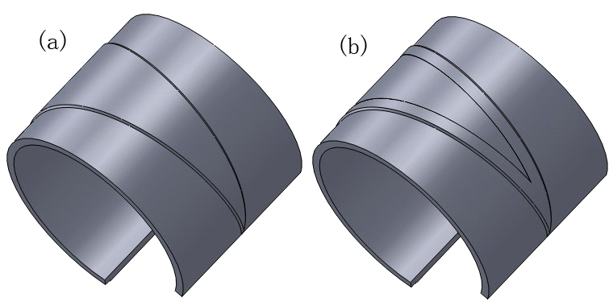
Empty top surface
a
b

Fig.15 Molds of cross wedge rolling: (a) without empty and (b) with empty

Fig.16 Ellipticity influence curves of die with and without empty (forming angle α = 42°, spreading angle β = 6°, area reduction Ψ = 26.3%)
emptied mold's ellipticity. The emptied mold avoids harmful contact in the rolling process, which could effectively reduce the ellipticity of the hollow shaft.

5 Conclusions
1) When rolling the large and long thick-walled hollow shaft, the selection range of the spreading angle can be extended, and the ellipticity can be controlled well. It breaks through the limit of spreading angle usually selecting 3°~ 4° of the cross wedge rolled thin-walled hollow parts. One wedge forming the long equivalent hollow shaft segment can avoid transition section, making the shaft segment smooth.
2) The deflection angle formulas of the multi-wedge cross wedge rolling of the hollow shaft-parts are derived, which lays the foundation for rolling the long hollow shaft.
3) The method of empting mold's top surface is useful to reduce the ellipticity.
4) The double-wedge cross wedge rolling of large and long thick-walled hollow shafts is feasible with the moderate increasing of spreading angle, right deflection angle and emptying mold's top surface.

References
- Guang Dawei. Thesis for Doctorate[D]. Dalian: Dalian Jiaotong University, 2010 (in Chinese)
- Li Jiguang. Thesis for Doctorate[D], Taiyuan: Taiyuan University of Science and Technology, 2007 (in Chinese)
- Zhang Kangsheng, Wang Baoyu, Liu Jinping at al. Forging & Stamping Technology[J], 2000, 2: 34
- Bartnicki J, Pater Z. Journal of Materials Processing Technology[J], 2005, 164-165: 1154
- Urankar S, Lovell M, Morrow C at al. Journal of Materials Processing Technology[J], 2006, 177: 545
- Ding Wei, Zhang Kangsheng, Yang Cuiping at all. Journal of Plasticity Engineering[J], 2010, 3: 27 (in Chinese)
- Jiang Yang, Wang Baoyu, Hu Zhenghuan at al. Journal of Plasticity Engineering[J], 2012, 19: 21 (in Chinese)
- Zhao Jing, Shu Xuedao, Hu Zhenghuan. Chinese Mechanical Engineering[J], 2008, 19: 1108
- Zhao Jing, Shu Xuedao, Hu Zhenghuan. Chinese Journal of Mechanical Engineering[J], 2008, 44: 209
- Shu Xuedao, Li Chuanmin, Hu Zhenghuan. Iron and Steel Research[J], 2011, 23: 12 (in Chinese)
- Li Chuanmin, Shu Xuedao, Hu Zhenghuan. Chinese Mechanical Engineering[J], 2006, 17: 2017
- Li Chuanmin, Shu Xuedao, Hu Zhenghuan. Metallurgical Equipment[J], 2006, 160: 5
- Zhao Jing, Lu Liqun, Hu Zhenghuan. Transactions of Chinese Society for Agricultural Machinery[J], 2008, 39: 184

多楔楔横轧42CrMo4大型空心长轴类零件分析

彭文飞^{1,2}，郑书华²，邱亦睿²，束学道²，湛利华¹
(1. 中南大学 高性能复杂制造国家重点实验室，湖南 长沙 410083)
(2. 宁波大学 浙江省零件轧制成形研究重点实验室，浙江 宁波 315211)

摘 要：大型厚壁空心长轴类零件是工业装备中的关键零部件，本研究采用多楔楔横轧成形该类零件。首先，推导多楔楔横轧长轴空心件的侧楔偏转角公式，为多楔楔横轧模具的设计奠定了基础。然后，研究展宽角对单楔楔横轧厚壁空心件的影响规律，发现相对于轧制小直径空心轴，展宽角的选择范围可以扩大，内孔椭圆度也能得到控制。同时发现模具的顶面脱空也能控制内孔椭圆度。最后，建立双楔楔横轧轧制大型厚壁空心长轴类零件的有限元模型，模拟了成形过程，监测对称面的内孔椭圆度，有限元计算的内孔椭圆度为4.98%，轧制实验值为5.56%。结果表明：双楔楔横轧大型厚壁空心长轴类零件是可行的。
关键词：多楔楔横轧；大型厚壁空心长轴；椭圆度

作者简介：彭文飞，男，1983年生，博士后，讲师，中南大学机电工程学院，湖南 长沙 410083，E-mail: pengwenfei@nbu.edu.cn

