Preparation of Pb(Zr_{0.95}Ti_{0.05})O₃ Nano-powder and Its Structural Stability of Perovskite
Hu Yanhua, Yao Haiyun, Yu Zhanjun, Wang Yuzhuo

Inner Mongolia University of Technology, Hohhot 010051, China

Abstract: Pb(Zr_{0.95}Ti_{0.05})O₃ (PZT95/5 for short) anti-ferroelectric nano-powder was prepared by a sol-gel method, and the effects of calcination temperature on the structural stability of perovskite for PZT(95/5) was investigated. Based on the results of TGA-DSC, the calcination temperature range of dried gel was identified as from 550 °C to 750 °C. XRD results illustrate that the peak intensity of the main crystalline phase increases gradually, while that of the impurity phase decreases, eventually disappears with the increasing of the calcination temperature T₁. When calcined at 750 °C, single phase of perovskite for PZT (piezoelectric transition) (95/5) is formed. SEM observation shows that with the increasing of T₁, the powder synthesized becomes finer and more uniform progressively. And when calcined at 750 °C, the average particle size of PZT(95/5) nano-powder is about 100 nm.

Key words: Pb(Zr_{0.95},Ti_{0.05})O₃; sol-gel method; perovskite; structural stability

Anti-ferroelectric materials could be widely applied in high-energy storage capacitors and electromechanical systems for their special performance, such as huge strain, energy storage and release accompanied by field-induced anti- ferroelectric-ferroelectric phase transition ^{[1]}. More than 40 kinds of anti-ferroelectric materials have been found currently, among which PZT (piezoelectric transition)-based anti-ferroelectric material becomes the focus of academic research community ^{[2,3]}. Generally, the traditional methods used to prepare the PZT- based anti-ferroelectric powder include a sol-gel method ^{[4]}, a co-precipitation method ^{[5]}, a hydrothermal method ^{[6]}, a thermal chemical vapor phase reaction method ^{[7]}, a laser-induced chemical vapor deposition method ^{[8]}, a plasma vapor synthesis method ^{[9]}, etc. As these methods are used to prepare PZT-based anti-ferroelectric materials, it is so difficult to obtain a complete perovskite phase ^{[10]} for the relatively high content of impurities. In the present paper, the sol-gel method was used to prepare PZT(95/5) antiferroelectric nano-powder, and the effect of calcination temperature on the structural stability of perovskite of PZT(95/5) was further analyzed.
1 Experiment
When Pb(Zr_{0.95}Ti_{0.05})O₃ anti-ferroelectric nano-powder was prepared by the sol-gel method, lead acetate [(CH₂COO)₂Pb·3H₂O], isopropyl titanium [Ti{OCH(CH₃)₂}₄], and zirconium n-propoxide [Zr(OC₃H₇)₄] were selected as main raw material, lactic acid [C₃H₆O₃] as stabilizer, glycol [CH₂(OH)CH₂(OH)] as chelating agent, and acetic acid [CH₃COOH] and deionized water [H₂O] as solvent.
Fig.1 shows the flow chart of PZT(95/5) nano-powder preparation. If the total volume of the solution is 100 mL, and its concentration is 0.4 mol/L, therefore, the amount of experimental material is 0.04 mol. Firstly, 16.68 g (CH₂COO)₂Pb·3H₂O (10% excess, to offset the volatilization of lead acetate) was added in CH₃COOH solvent at a specific ratio. Secondly, the solution was mixed at 90 °C, stirred for 30 min and cooled to room temperature. Thirdly, 11.8 mL Zr(OC₃H₇)₄ and 5.8 mL H₂O were mixed in the proportion of 30:1 and rapidly added in acetate solution. At the same time, 0.7 mL Ti{OCH(CH₃)₂}₄ was dropped into the solution slowly, under stirring at room temperature for 30 min, and the precursor solution was obtained. CH₂(OH)CH₂(OH) (per 10 g of lead acetate requires 1 mL) and C₃H₆O₃ were added in the precursor solution in proportion by mixing for 30 min. The
Main material, stabilizer, chelating agent, solvent
Sol-gel method

Dried gel

Differential thermal analysis

Calcined at different temperatures

PZT95/5 nano-powder

XRD, SEM tests

Fig.1 Flow chart of PZT(95/5) nano-powder preparation

solution was finally adjusted to 0.4 mol/L with CH₃COOH, then aged naturally dried at 100 °C for 24 h, ground and screened (45 µm), and dried powder was obtained.
The phase transition point was determined according to the TGA and DSC curves, and the calcination temperature range of dried powder was ascertained. Then the dried powder was calcined at different temperatures followed by grinding and screening; then PZT(95/5) nano-powder was obtained.
The morphology of dried powder was observed by SEM and the size of the powder was measured. The results of XRD were used to discuss the effects of the calcination temperatures on the phase stability of PZT(95/5) anti-ferroelectric powder.
2 Results and Discussion
2.1 Tests of thermal analysis
The thermal analysis results of PZT(95/5) dried powder is shown in Fig.2. When the dried powder is heated between 30 and 200 °C, with the increasing of the heating temperature T₁, for the release of water blocked in the three dimensions structure of gel and the gradual decomposition of acetic acid group, the weight of powder decreases and the heat absorption of endothermic peak increases. When heated between 200 °C and 500 °C, because of the residual lead acetate and hydroxyl

Fig.2 DSC and TGA curves of PZT(95/5) dried powder
group, such as Zr⁴⁺, Ti⁴⁺ being decomposing gradually with the increasing of T₁, the weight of powder decreases significantly. Upon increasing T₁ to 750 °C, single perovskite phase is obtained and the weight of the powder remains constant. Based on the results of thermal analysis, the calcination temperature range is identified as from 550 °C to 750 °C.

2.2 Influence of calcination temperature on micro- morphology and phase stability of PZT(95/5)
The dried powder was calcined for 2 h at 550, 600, 650 and 750 °C, then ground and screened. The micro-morphology of PZT(95/5) powder was observed by SEM, the stability of phase structures and the diversification of phase transition were discussed with XRD and SEM results. The experimental results are shown in Fig.3.
Fig.3a shows XRD pattern and SEM image of the PZT (95/5) powder calcined at 550 °C. The diffraction peaks of the main crystalline phase appear, but there are also some miscellaneous peaks (mainly pyrochlore phase) ^{[11]} and its intensity is quite equal to that of the main crystalline phase. Therefore, it is difficult to synthesize antiferroelectric with single perovskite phase when calcined at 550 °C. There are two reasons for it. The first one is that it is easy to form a more stable impurity phase compared to the perovskite at low calcination temperature. The second is for the removal of hydroxyl, alkyl groups, organic solvent and water adsorbed in the dried gel. At the same time, the atomic motion of the dried powder is not active at low temperature, so that a part of the raw material in the matrix and the intermediate produced in the chemical reaction process are not completely decomposed, which affect the diffraction peak of the main phase. Meanwhile, due to the reduction of the three-dimensional structure aperture, the grain size of PZT(95/5) also becomes smaller.
Fig.3b and 3c show XRD and SEM results of the PZT (95/5) powders calcined at 600 and 650 °C, respectively. Compared with Fig.3a, with the increasing of calcination temperature, the intensity of the main crystalline phase peak increases gradually and becomes more acute, while that of the impurities peaks decrease. The intensities of the main phase peak and the impurity peak change obviously from 550 °C to 600 °C, while almost do not change from 600 °C to 650 °C. It means that the grain size is becoming finer in this process and the average sizes are 200~300 nm (see Fig.3b₁ and 3c₁).
In Fig.3d, when calcined at 750 °C, the intensity of main phase peak become stronger, and the impurity peak almost disappears completely. All the peaks of the main crystalline phase are exactly equivalent to that of the standard perovskite phase (Fig.4). Thus, single perovskite structure of PZT(95/5) is obtained. When observed under SEM, the grain sizes become more uniform and the average size of PZT(95/5) nano-powder is about 100 nm (see Fig.3d₁). Owing to calcining at 750 °C, some of the stable existing impurities at low temperature are decomposed easily at high temperature.
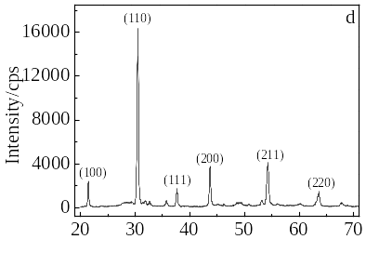
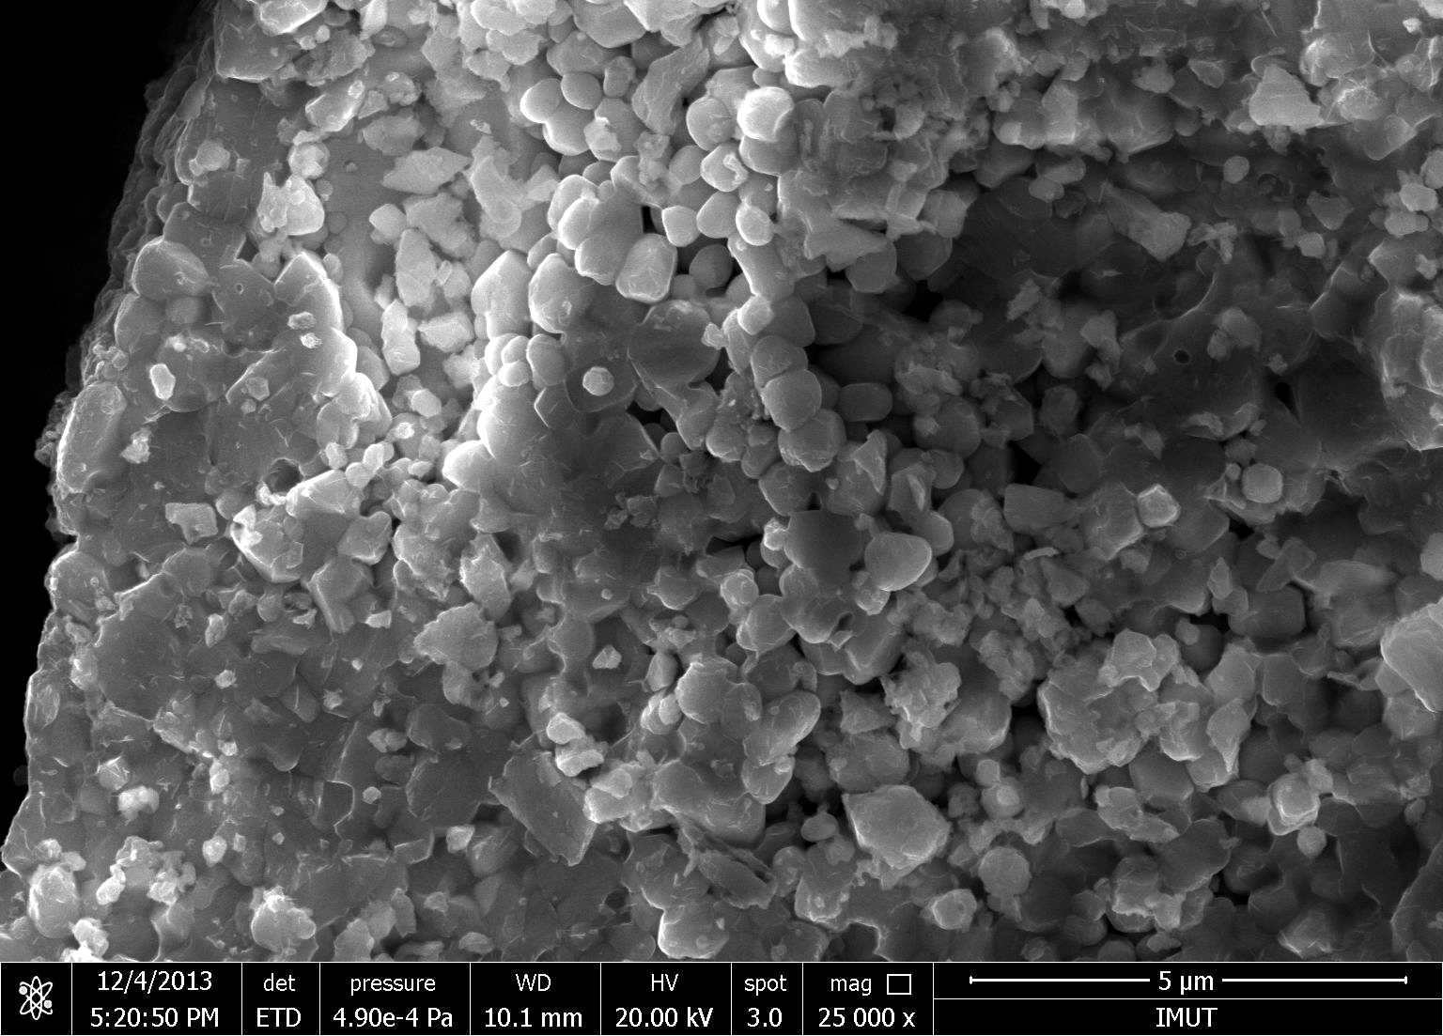
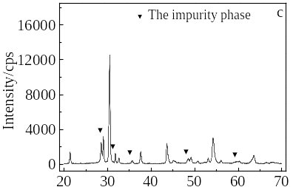
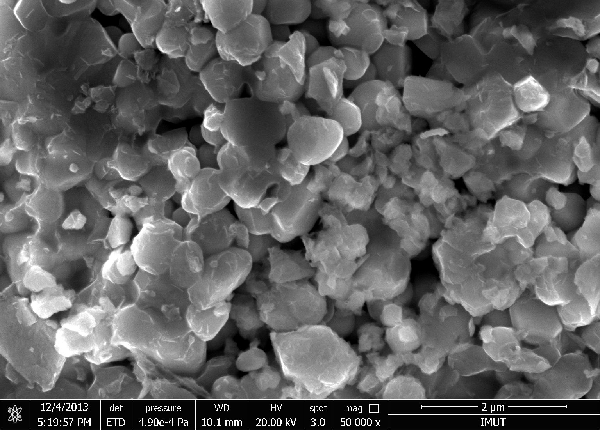

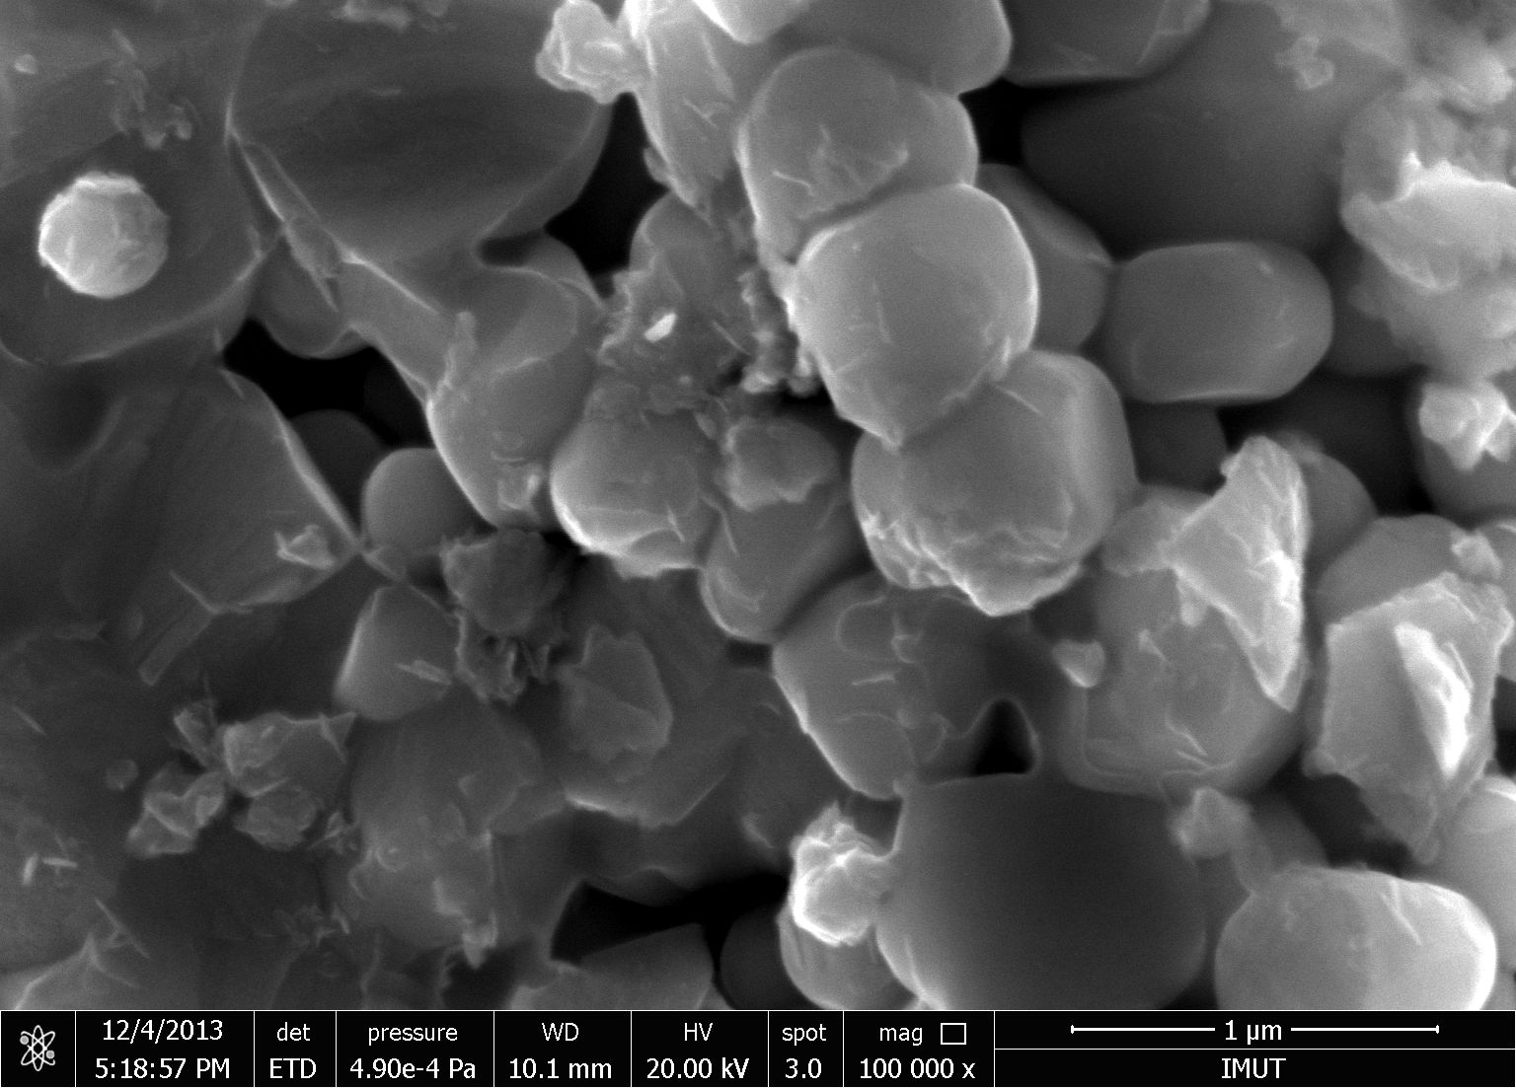
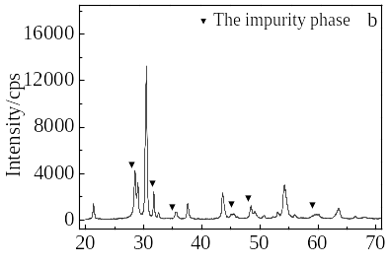
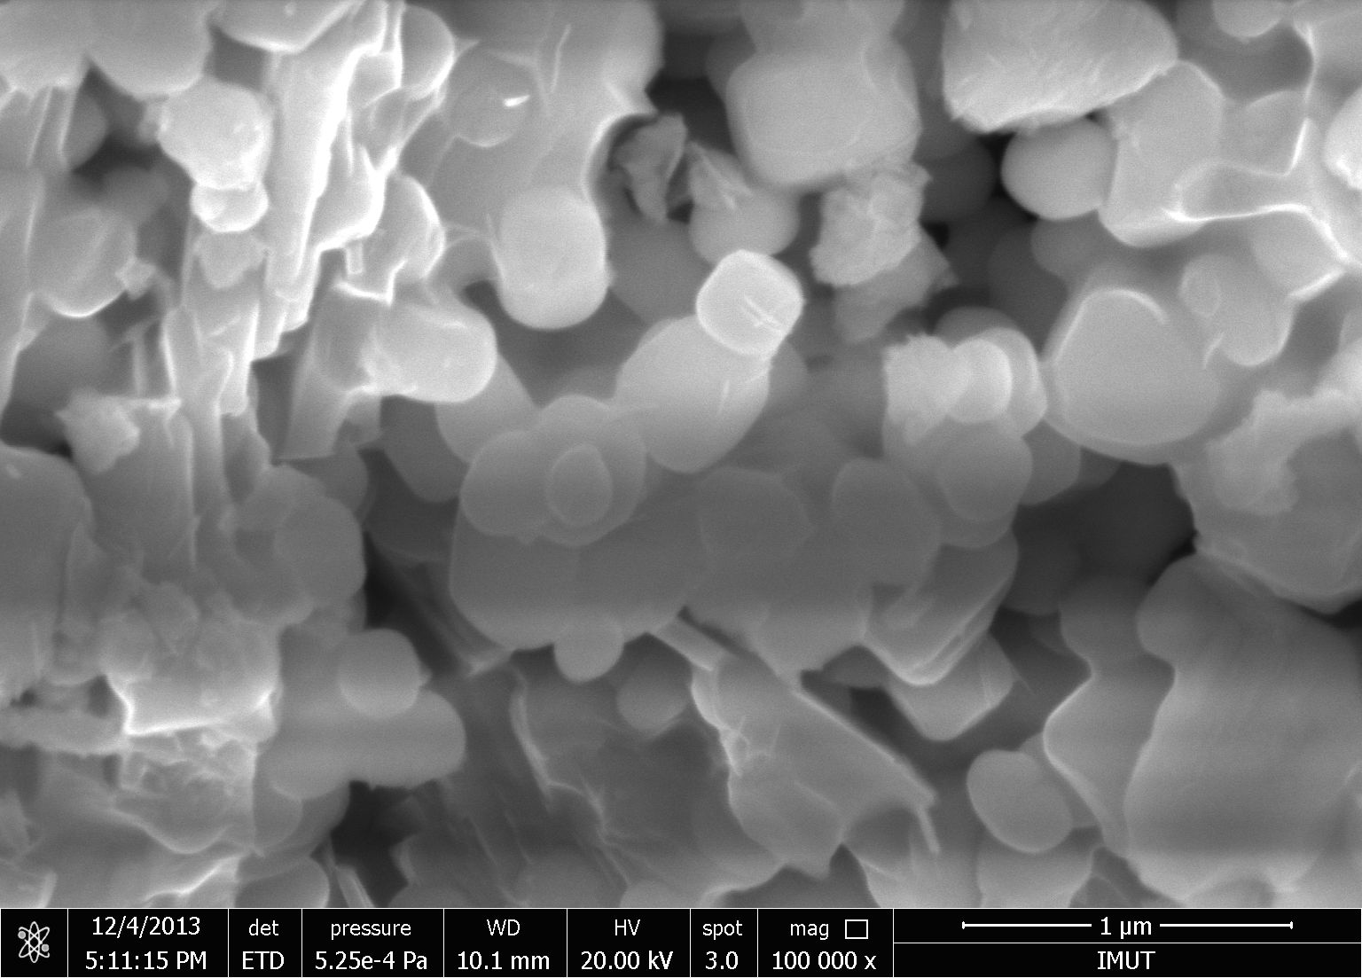
1 μm
1 μm
1 μm
1 μm
2θ/(°)
a₁
b₁
c₁
d₁

Fig.3 XRD patterns (a~d) and SEM images (a₁~d₁) of PZT (95/5) powders calcined at different temperatures:
(a) 550 °C, (b) 600 °C, (c) 650 °C, and (d) 750 °C

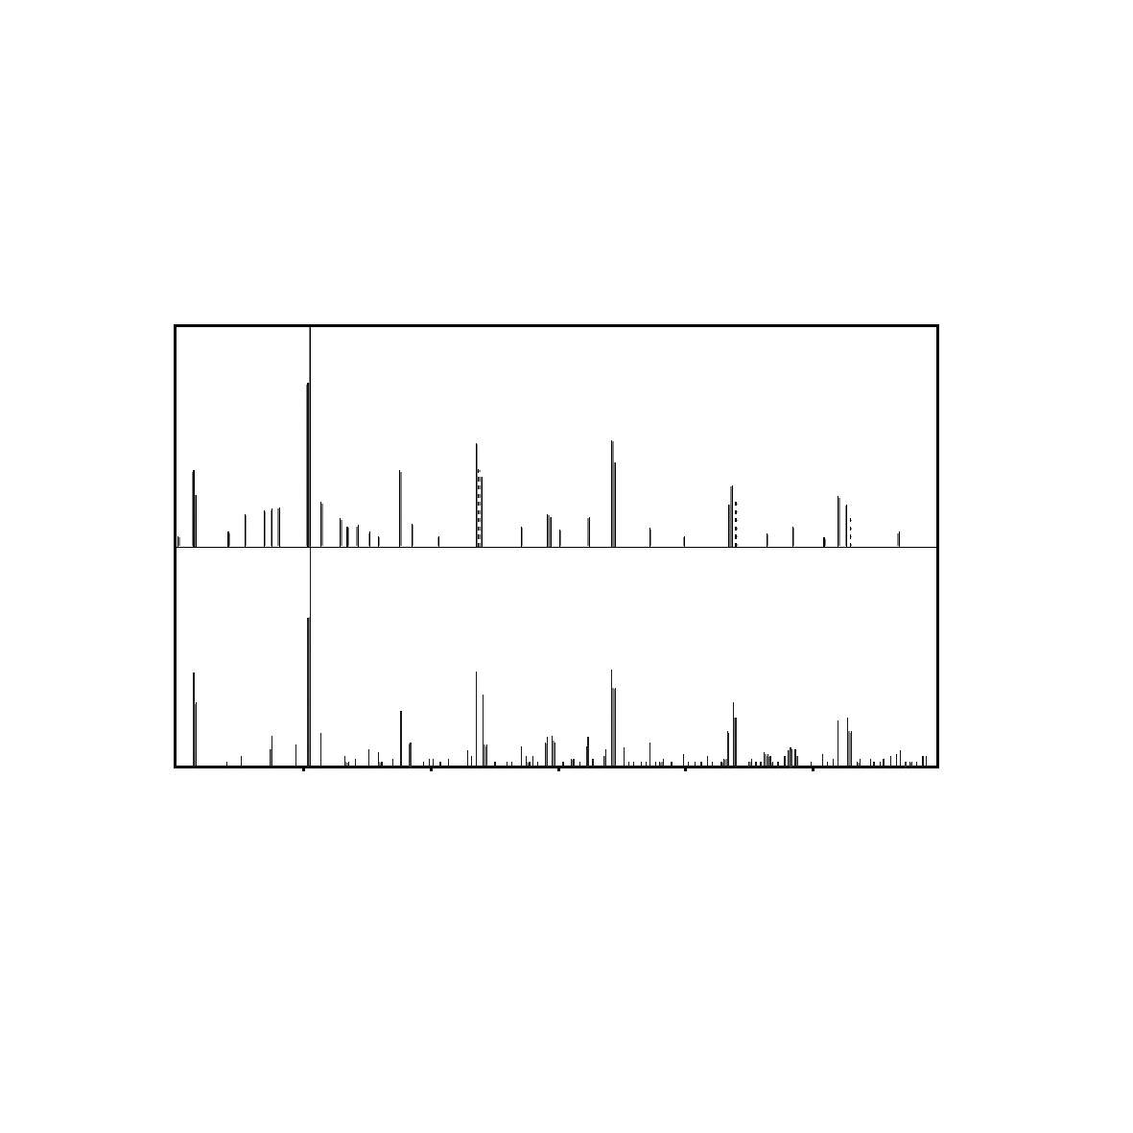
20 30 40 50 60 70 80
2θ/(°)
Intensity/a.u.
Experimental results
Standard perovskite phase

Fig.4 Comparison of experimental results with standard perovskite phase
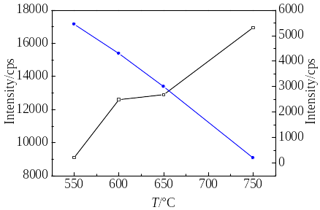
The main crystalline phase
The impurity phase

Fig.5 Relationship between PZT(95/5) powder diffraction peak intensity and calcination temperatures

Fig.6 Relationship between PZT(95/5) powder particle size and calcination temperature

In conclusion, with the increasing of calcination temperature T₁, the diffraction peak intensity (diffraction intensity of (110) as reference) increases gradually while that of the impurity phase decreases and finally disappears (as shown in Fig.5). Simultaneously, the grain size of PZT(95/5) powder (based on the analysis results of nano-particle size analyzer) is becoming finer (Fig.6)
3 Conclusions
1) When lead acetate, isopropyl titanium, and zirconium n-propoxide are selected as main raw materials, lactic acid as stabilizer, glycol as chelating agent, and acetic acid and deionized water as solvents, PZT(95/5) nano-powder can be prepared by a sol-gel method.
2) The calcination temperature range of PZT(95/5) dried gel is from 550 °C to 750 °C.
3) With the increasing of the calcination temperature T₁, the strength of the main crystalline phase for PZT(95/5) nano-powder increases gradually, while that of the impurity phase decreases and disappears eventually.
4) When calcined at 750 °C, single phase of perovskite for PZT(95/5) is formed.
5) With the increasing of T₁, powder synthesized becomes finer and more uniform progressively. And when calcined at 750 °C, the average particle size of PZT (95/5) nano-powder is about 100 nm.

References
- Zhang H L, Chen X, Cao F et al. J Am Ceram Soc[J], 2010, 93: 4015
- Hochbaum A I, Chen R, Delgado R D et al. Nature[J], 2008, 451: 163
- Wang Y, Deng Y. Chin Mater Process[J], 2011, 30 (9): 51
- Duan Z X, Zhao Q l, Liu H M et al. J Funct Mater Devi[J], 2009, 15: 275
- Zhang D Q, Wang S J, Sun H S et al. J Sol-Gel Sci Technol[J], 2007, 41: 157
- Song Y, Jiang L F, Qi W X et al. J Funct Mater[J], 2012, 12: 1605
- Wang Youwen, Xu Yuqing, Yao Hongnian. Journal of Inorganic Materials[J],1992, 2: 18 (in Chinese)
- Yao Y, Zhai J, Chen H. J Appl Phys [J], 2004, 95: 6341
- Luo P, Ehtg N I, Chwartzaj S et al. Mater Sci Eng[J], 1995, A 204: 59
- Chen M, Yao X, Zhang L Y. J Eur Ceram Soc[J], 2001, 21: 1159
- Zhong H SH, Li Q, Song F B et al. J Wuhan Univ Tech[J], 2003, 25: 1

Pb(Zr_{0.95}Ti_{0.05})O₃纳米粉的合成及其钙钛矿结构的稳定性

胡艳华，姚海云，余占军，王玉卓
(内蒙古工业大学, 内蒙古 呼和浩特 010051)

摘 要：采用溶胶-凝胶技术合成了Pb（Zr_{0.95}Ti_{0.05}）O₃纳米粉，并探讨了煅烧温度对PZT(95/5)钙钛矿相结构稳定性的影响。据TGA-DSC的实验结果，确定了干凝胶粉的煅烧温度范围为550~750 ℃。XRD实验结果表明，随着煅烧温度的升高，粉体主晶相的强度逐渐升高，杂质相的峰高逐渐减弱直至消失。当在750 ℃煅烧时，粉体结构为单一的钙钛矿相。利用SEM观察发现，随着煅烧温度的升高，所合成的粉体粒度逐渐变小、均匀。当在750 ℃煅烧时，单一钙钛矿结构的粉体的平均粒度为100 nm。
关键词：锆钛酸铅；溶胶-凝胶法；钙钛矿；结构稳定性

作者简介：胡艳华，女，1977年生，博士，副教授，内蒙古工业大学材料科学与工程学院，内蒙古 呼和浩特 010051，电话：0471-6575752，E-mail: 1149024450@qq.com

