Ti-Nb-Cu Stress Buffer Layer for TiC Cermet/304 Stainless Steel Diffusion Bonding
Li Jia, Sheng Guangmin, Huang Li

Chongqing University, Chongqing 400044, China

Abstract: Vacuum diffusion bonding of TiC cermet/304 stainless steel (304SS) was conducted and Ti-Nb-Cu multi-interlayer was used to achieve active bonding and residual stress relieving. Detailed microstructure characterization and mechanical property assessment were carried out to evaluate the bonding technology. It is found that an obvious transition zone is formed at the interfaces, and the interfacial products are (Ti, Nb), remnant Nb, remnant Cu and Cu(s.s). The shear strength of TiC/Ti-Nb-Cu/304SS joint can be up to 84.6 MPa when it is bonded at 925 °C for 20 min under a pressure of 8 MPa. Failure occurs in TiC cermet near the interface in a brittle manner. The results indicate that Ti/Nb/Cu interlayer can effectively reduce the harmful effects of intermetallic compounds on the joint performance, and the Nb interlayer plays a major role in the relief of the residual stress.

Key words: diffusion; TiC cermet; Ti-Nb-Cu interlayer; microstructure; mechanical property

TiC cermet is a promising candidate material for structural and high added-value functional applications owing to its excellent combination of desirable properties, such as wear resistance in bearing and axle bush in high temperature components of engines ^{[1,2]}. However, the intensive application of TiC is restricted, primarily due to its poor workability originated from the inherent brittleness. To overcome this shortcoming of TiC cermet, a promising method is to combine it with metallic structure, generally steel or metallic alloys.
However, the effective and successful connection between cermets and metals faces two key challenges, i. e. the relative chemical inertness of TiC cermet and the mismatch of the thermal expansion coefficient (CTE) between TiC and the metal part ^{[3-5]}. The mismatch can result in high residual thermal stresses, which originate from the joining temperature during cooling, and consequently form mechanical weak joint, making this factor be a major problem upon joining dissimilar materials such as cermets and metals ^{[6,7]}. Accordingly, for successful bonding of cermet to metal, residual stress relief methods such as applying soft interlayer should be taken into consideration.
Due to the significant mismatch in physical properties, fusion welding is infeasible in joining of cermet to metallic parts and solid state joining techniques such as diffusion bonding and active brazing are generally preferred. The diffusion bonding as a solid state bonding technique has been demonstrated to be one of the workable methods of bonding ceramics to metals which can be used for preparation of heat resistant joint in much lower temperature than conventional connection methods and has emerged as a near net shape forming processing to increase the use of ceramic materials ^{[8,9]}. The service temperature of the joint by diffusion bonding is also much higher. In addition, appropriate intermediate material has been shown to be a significant player to relieve the residual stress and to prevent the formation of intermetallic compound (IMC) in the diffusion bonded joints. In recent years, various elements, such as Ti, Ni, and Cu, have been selected for interlayer to improve the performance of joint ^{[10-12]}. Now multi-interlayer is also being used in diffusion bonding. However, the performance of bonding joints is severely deteriorated due to the formation of IMC which is resulted from the interaction of elements in multi-interlayer. W. Q. Huang ^{[13]} investigated the effect of Ti/Cu/Ti on constitutional phases and performances in the TiC-Al₂O₃/W18Cr4V bonding joint. Y. Min et al ^{[14]} studied the effect of Nb/Cu/Ni on the microstructure, interfacial reactions and mechanical properties for Si₃N₄ and Inconel 600 joint. Almost all the studies showed that the cracks occurred easily at the boundary of parent materials and alloys if the constitution had lots of hard IMC.
Therefore, considering the residual stress and IMC, the combination of the interlayer is very important for ceramic bonding. As a suitable candidate, Ti is the most attractive active element for almost all the structure ceramics. The active Ti can spread on the surface of ceramics to solve the relative chemical inertness. Nb is to be our main object for its high activity and that can form infinite solid solution with Ti. The expansion coefficient of Nb (7.2×10⁻⁶ K⁻¹) is very close to that of TiC (7.74×10⁻⁶ K⁻¹) and it plays a major role to buffer residual thermal stress. Cu with good ductility will not form IMCs when it is used to bonding steels ^{[15]}.
The present work is to study the diffusion bonding of TiC/304 stainless steel (304SS) with Ti/Nb/Cu interlayer to relieve residual stress, to inhibit the IMC and improve mechanical properties. Detailed characterization was conducted to reveal the interfacial micro-structural evolution and the mechanical properties of the bonding joints were analyzed by tensile shear tests to evaluate interconnect reliability.
1 Experiments
Materials used were TiC cermet, 304SS and Ti/Nb/Cu multi-interlayer. The microstructures of TiC cermet and 304SS are shown in Fig.1 and their compositions are summarized in Table 1. TiC cermet plate made by hot pressure sintering (HPS), was cut into specimens with 3 mm×4 mm×8 mm and 304SS plate was cut into specimens with 3 mm×10 mm×30 mm. Multi-interlayer of Ti/Nb/Cu with 400 µm thickness was employed to relieve the residual stress. Table 2 gives the room temperature thermo-physical properties of Ti, Nb, Cu and the parent materials.
Before diffusion bonding, the parent specimens and interlayers were ground and polished, and then cleaned with

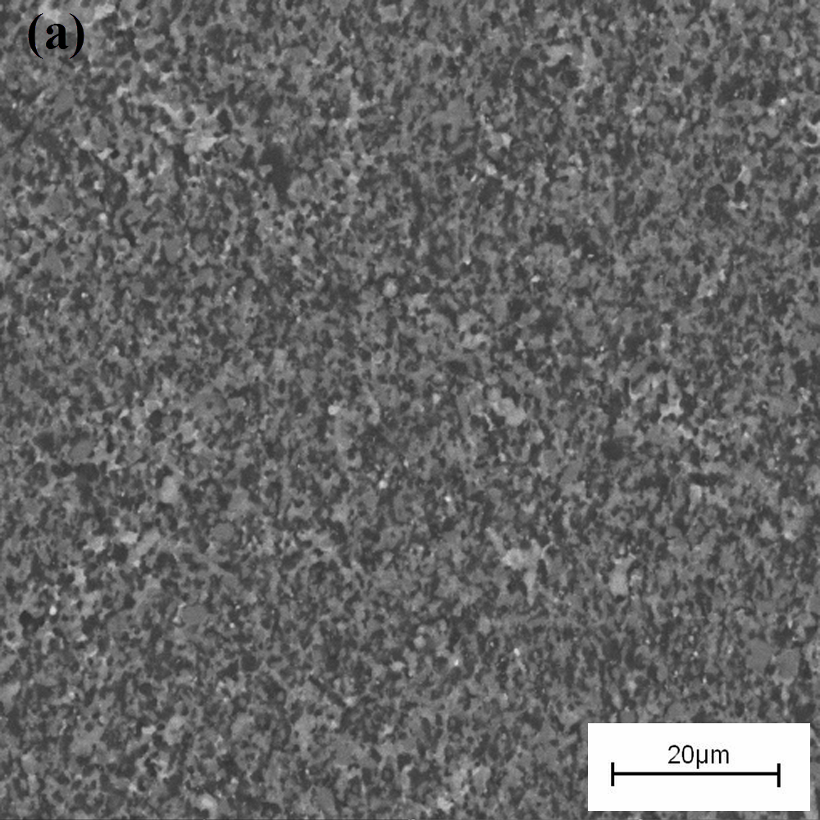
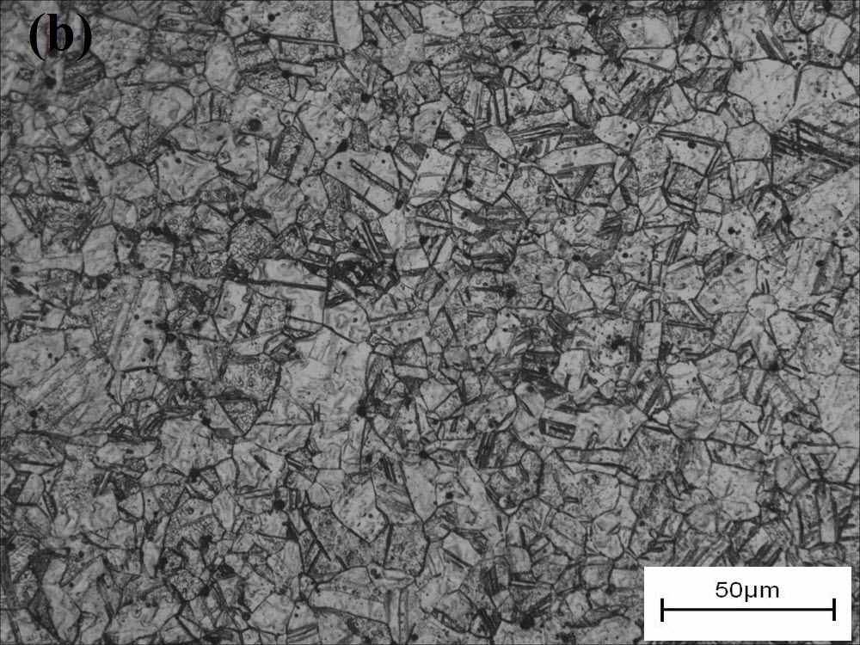
a
b
20 μm
50 μm

Fig.1 OM images of microstructures of base materials: (a) TiC cermet and (b) 304SS
Table 1 Compositions of TiC cermet and 304SS
Material | Composition content/wt%
TiC | Ti 55.98~60.49 + C 15.99~19.60 + Ni 1.40~4.33 +  Mo 3.38~9.54 + W 8.43~3.94 + Al 3.17~17.91
304SS | C 0.12 + Mn 1.35 + S 0.030 + P 0.035 + Cr 18.67 +  Ni 8.43 + Fe balance

Table 2 Room temperature thermo-physical properties of Ti, Nb, Cu and the parent materials
Material | Melting  point/K | Thermal expansion  coefﬁcient/×10⁻⁶ K⁻¹ | Young’s modulus/  GPa
Ti | 1913~1943 | 9.4 | 115
Nb | 2468 | 7.2 | 105
Cu | 1338~1355 | 16.92 | 125
TiC | 3160 | 7.74 | -
304SS | 1399~1455 | 16.4 | -

acetone. The vacuum diffusion bonding equipment (A Gleeble 1500D thermal mechanical simulator) was used to bond the specimens. The test specimens were overlapped and placed into a vacuum chamber. The assembly sequence of specimens was TiC-Ti-Nb-Cu-304SS. Technological parameters used in the test were: the heating temperature T=875~925 °C, the pressure P=8 MPa, and the holding time t=20 min. A uniaxial compressive load of 8 MPa was applied along the longitudinal direction of the specimen.
The test of micro-hardness distribution along the joint was conducted at a load of 500 g for a duration of 10 s. Shear strength tests were performed by an Instron-1186 universal testing machine to assess the shear strength of the brazed joints. The specimens were compressed by the testing machine with a constant speed of 0.5 mm/min. The assembly of shear strength tests of the brazed sample is shown in Fig.2. Selected specimens were longitudinally sectioned. The microstructure of the joint and the fracture morphology were tested by scanning electron microscope (SEM, TESCAN VEGA II) with back- scattered mode (SEM-BSE). Chemical concentration profile across the joints was determined using energy dispersive spectroscope (EDS) and X-ray diffraction (XRD).

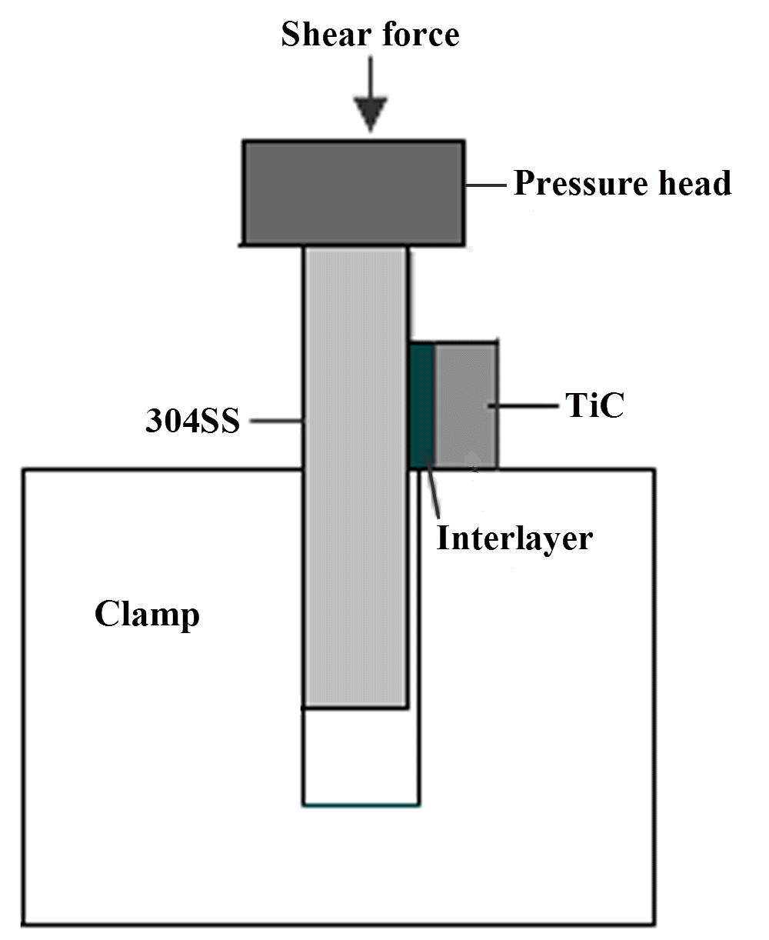

Fig.2 Schematic diagram of shear strength tests of TiC/Ti/Nb/Cu/ 304SS joint
2 Results and Discussion
2.1 Microstructure characterization
A strategy to investigate the plastic behavior of the interlayer is the microstructure analysis which allows for the estimation of qualitative information about mechanical properties of the interlayer in the as-bonded state.
The representative SEM image of the interfacial microstructure characteristics for TiC/Ti/Nb/Cu/304SS bonded at 925 °C for 20 min is shown in Fig.3a. The higher amplification microstructures for both TiC cermet/interlayer and 304SS/interlayer interface are shown in Fig.3b and Fig.3c, respectively. It is shown that the interface is continuous and free of defects. The boundary of TiC is flat and straight; the interface is uneven and bump on the 304SS side, which indicate that the Ti/Nb/Cu multi-interlayer is well combined with TiC cermet and 304SS.
A transition layer with various microstructure morphologies exists between the base materials and the interlayer due to the mutual diffusion and the metallurgic reaction of the atoms at the TiC/304SS interface. The microstructures of the four regions are distinguished with A, B, C and D. The corresponding EDS spectrum is shown in Fig.4. Line scans were conducted perpendicular to the interface. The various microstructure morphologies of the joint are labeled with ①, ②, ③, ④ and ⑤. Table 3 gives the average chemical compositions of each point of the TiC cermet/steel joint.
The hybrid region A near the TiC with dark-gray and black products is the reaction zone for TiC and Ti/Nb. The compositions (wt%) of black region ① are Ti (83.65), C (14.04), Nb (1.30), Fe (0.12), Al (0.89) and that of the dark-gray part ② are Ti (67.87), C (1.03), Nb (30.72), Fe (0.38). The black parts are mainly TiC particles, (αTi) and the dark-gray parts are mainly (βTi, Nb). It is shown that some TiC particles move from the TiC cermet into the interlayer. The severe diffusion reaction happens between Ti from TiC cermet and the components from Ti/Nb. Because Ti has different diffusion rates relative to Nb, which causes unbalanced solute transfer, and then complementary concentration profile between Ti and Nb is formed.

Region B is a non-homogeneous lumpy region, where the similar dark-gray ② is also found. The compositions (wt%) of pale gray ③ are Nb (88.34), Ti (8.58), a small amount of Fe (1.16), Cr (0.42) and Al (1.50). No matter dark-gray ② or pale gray ③, Ti and Nb are the major constitute, although formation concentration values of Ti, Nb are complementary ebbs and flows. Ti and Nb form infinite (Ti, Nb) solid solution which can effectively promote the good metallurgical bonding between TiC cermet and steel.
Region C is a completely wide remnant Nb. The rest of high ductile Nb in reaction zone plays an important role in slowing the residual stress of the joint and then improving joint properties. The spread of Ti through Nb is restricted with the increase of Nb content from TiC interface. Nb becomes the barrier of element diffusion, hindering the Ti passes through the interface and inhibiting the production of Cu-Ti IMCs.
Region D mainly relies on Cu. The point ④ is in the Cu-Nb system. The Cu-Nb system is such a system where the strong effect of compositional impurities in modifying the nature and the extent of the distribution of coexisting phases is observed. There is the terminal solid solution (Cu) in point ④ with limited solubility of Nb (0.12 wt%). The point ⑤ is mainly contains Cu (75.46wt%), Fe (13.45wt%), Cr (10.40wt%) and Al (0.69wt%). The spreads of Fe, Cr exhibit similar trend. When referred to Cu, owing to its face-centered cubic structure, the spreads of Fe, Cr through Cu are restricted. Therefore, the Fe (13.45%) and Cr (6.40%) mainly exist in the form of fcc Cu-rich solid solutions (shortened form Cu (s.s)).
Thus, these regions are (αTi), (βTi, Nb), remnant Nb, remnant Cu and Cu (s.s), respectively, from ① to ⑤. All of these solid solutions and remnant ductile interlayer in the interface form a tough continuous transition zone and no brittle IMC at all, which avoid the deterioration of joint performance.
2.2 Micro-hardness assessment
In order to study the influence of different microstructure in diffusion transition zone on the performance of the joint, a micro-sclerometer was adopted to determine the micro-hardness of the joint. The micro-hardness was measured with a load of

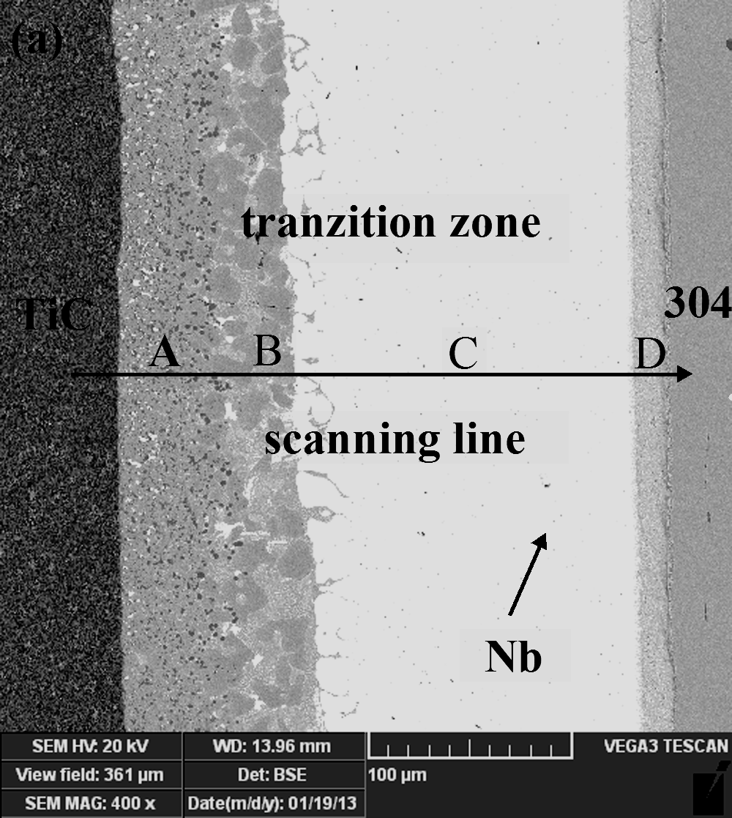
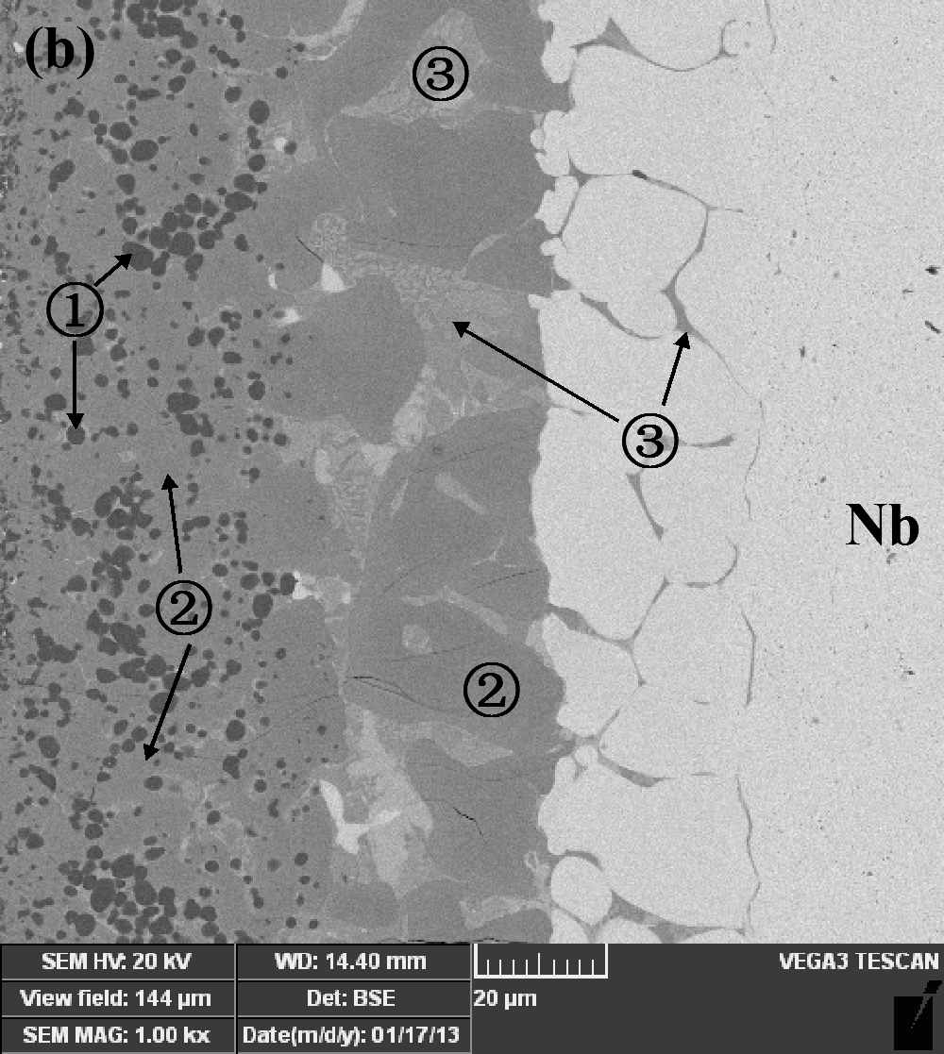
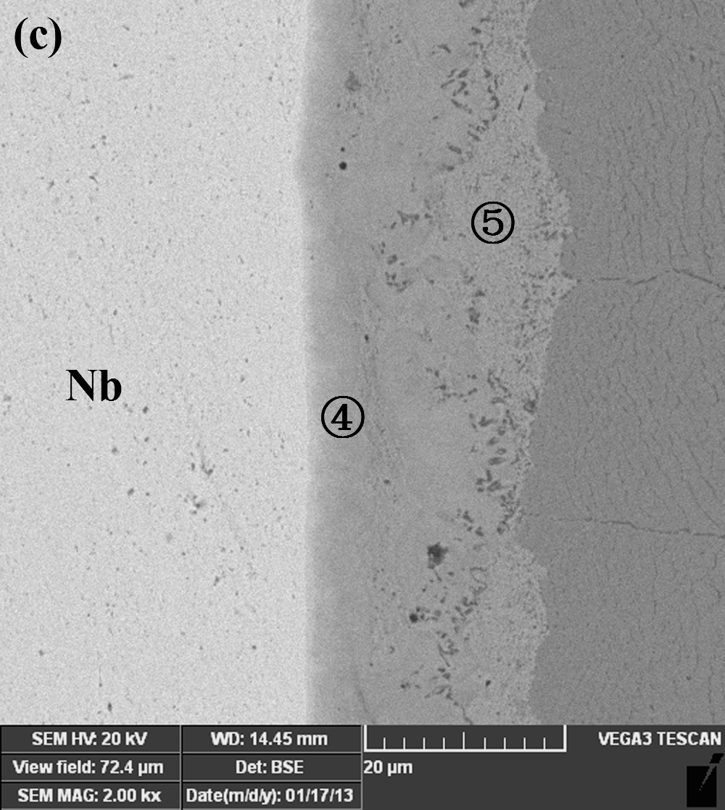
a
b
c
Transition zone
Scanning zone

Fig.3 Back-scattered electron image of TiC cermet/steel joint bonded with Ti/Nb/Cu at 925 °C for 20 min (a), TiC/Ti/Nb/ Cu interface (b),
and Ti/Nb/Cu/steel interface (c)

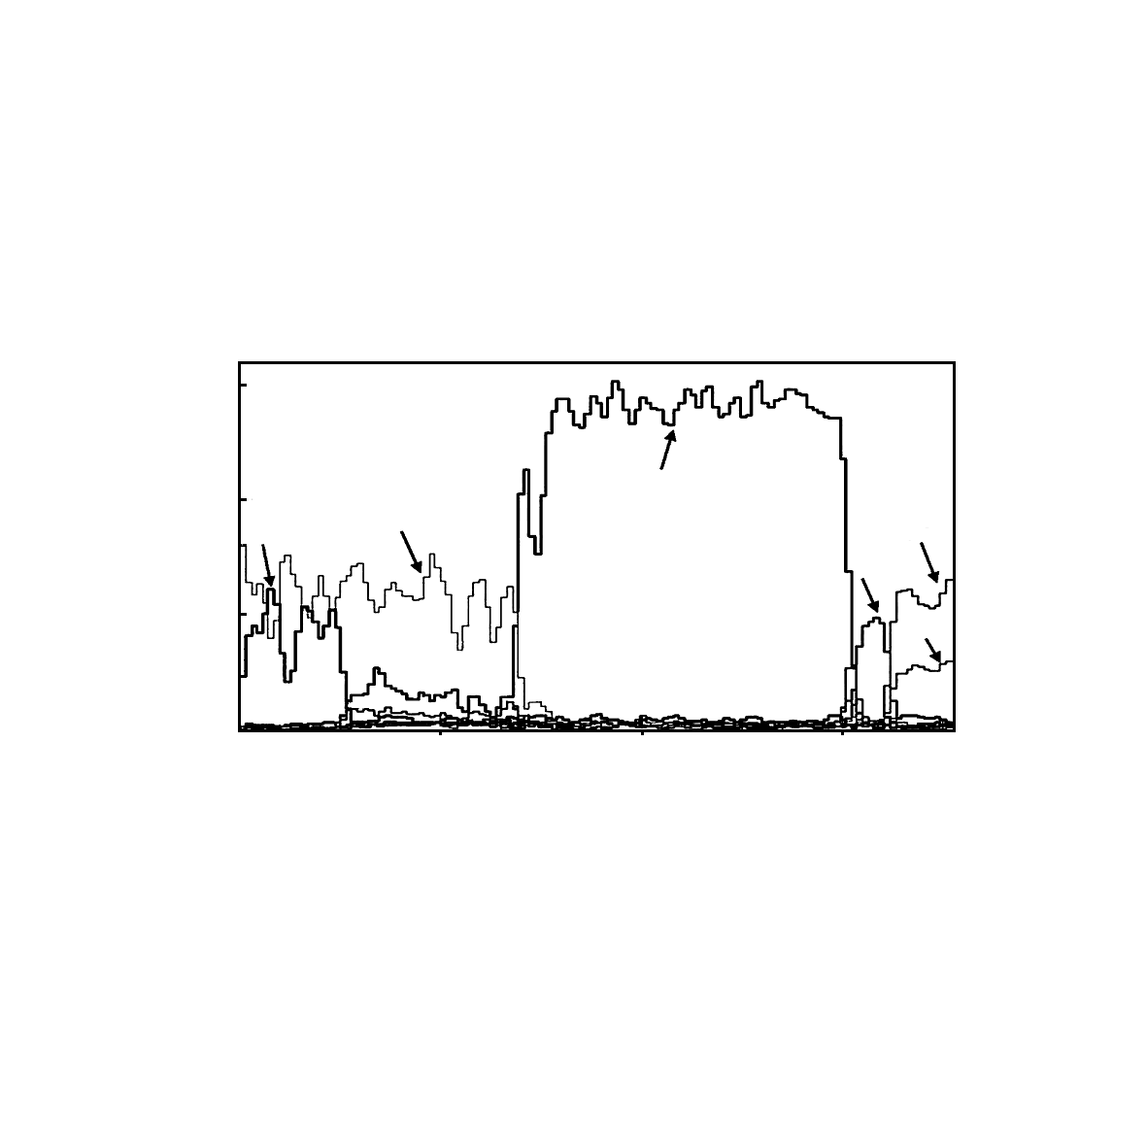
0 100 200 300
Distance/μm
300
200
100
0
Intensity/cps
Al
Ti
Nb
Cu
Fe
Cr

Fig.4 Corresponding major elements content distribution in back- scattered electron image

Table 3 Chemical composition of marked regions in Fig.3 (wt%)
Region | Ti | C | Nb | Cu | Fe | Cr | Al
① | 83.65 | 14.04 | 1.30 | - | 0.12 | - | 0.89
② | 67.87 | 1.03 | 30.72 | - | 0.38 | - | -
③ | 8.58 | - | 88.34 | - | 1.16 | 0.42 | 1.50
④ | - | - | 0.12 | 94.22 | 5.15 | 0.51 | -
⑤ | - | - | - | 75.46 | 13.45 | 10.40 | 0.69

Table 4 Micro-hardness (HV) distribution along the joint
bonded zone in Fig.3a at 925 °C (MPa)
TiC | Transition region |  |  |  | 304SS
TiC | A | B | C | D | 304SS
20506 | 5589 | 4887 | 5238 | 5365 | 1847

500 g and a load time of 10 s and the results are shown in Table 4. It can be seen that the micro-hardness HV of TiC matrix is about 20 506 MPa and that of 304SS is 1800~1900 MPa after the diffusion bonding. The results show that the microhardness of diffusion transition zone falls. The softer microhardness distribution can provide sufficient ductility in the diffusion transition zone to avoid cracking at the reaction zone.
The hardness value and thickness of the reaction layer can affect the residual stress which significantly determines the shear strength of the brazed joint ^{[16]}. From the microstructure point of view, the compositions of regions B and C are (βTi, Nb) and single Nb, respectively. So the Nb is the major component of regions B and C. The thickness of region B is about 30 µm and that of region C is about 150 µm up to two-thirds of the transition zone. In addition, the hardness values of regions B and C with Nb are lower than those of A and D, which make the residual stress of these regions decrease. Therefore, the Nb plays a major role in the relief of the residual stress.
2.3 Fracture and XRD analysis
The stress in the ceramic are at maximum in the region near the joint interface, and this can lead to component fracture therein, sometimes under very low, or even zero loads. To correctly predict residual stresses, it is essential to know the mechanical properties of the materials. Therefore, the joints are bonded adopting different technological parameters with Ti/Nb/Cu interlayer.
Fig.5 shows the axial shear loading-displacement curve for the bonded sample in Fig.1. Apparently, the maximum loading value reaches 2.031 kN, and the bonded acreage of the sample is about 24 mm². The bonding strength is as high as about 84.6 MPa determined by the formula σ = F/S (σ is the strength, MPa; F is the loading, kN; S is bonded acreage). The TiC cermet/304SS joint is destroyed at the maximum load and then the load decreases suddenly. This means that the fracture of the TiC cermet/304SS joint is a brittle fracture.
There are obvious torn traces from the interface reaction layer to TiC cermet after shearing test, which show the obvious cleavage stage in a typical fracture pattern of ceramics. The SEM image in Fig.6a for fracture surface exhibits coarse and dark veins and does not show metallic shine. The corresponding EDS spectrum in Fig.6b states that the strong peaks are Ti, Al, W and Ni. The composition of fracture surface is the same as TiC matrix. It demonstrates that the cleavage step morphology is caused by TiC cermet fracture. In order to analyse the phases in the TiC/304 joint shown in Fig.7, X-ray diffraction analysis was carried out using Cu Kα radiation on profiles across the bonds. Fig.7a represents the fracture surface near TiC side and Fig.7b represents the fracture surface near 304SS side. As shown in both sides, the composition of TiC matrix are detected. In addition, these basic components, (Ti, Nb) and NbTi₄ are identified from X-ray diffraction due to the float of TiC and the reaction of Ti and Nb. It further confirms that the failure mostly occurs within TiC cermet near the interface.
The stresses based on the research of Zdaniewski’s literature can explain this crack mechanism ^{[17]}. The stresses may result in the crack formation at the gaps either due to the thermal expansion mismatch and subsequent differences in thermal contraction in cooling or are induced by the applied loads during indentation. Because the CTE of 304SS is higher than that of TiC ceramic, the tensile residual stress σ_{x} parallel of the interface is always the largest within the joint, and suddenly reduced to 0 in the free surface. In the present work, a uniaxial compressive load of 8 MPa is applied along the longitudinal

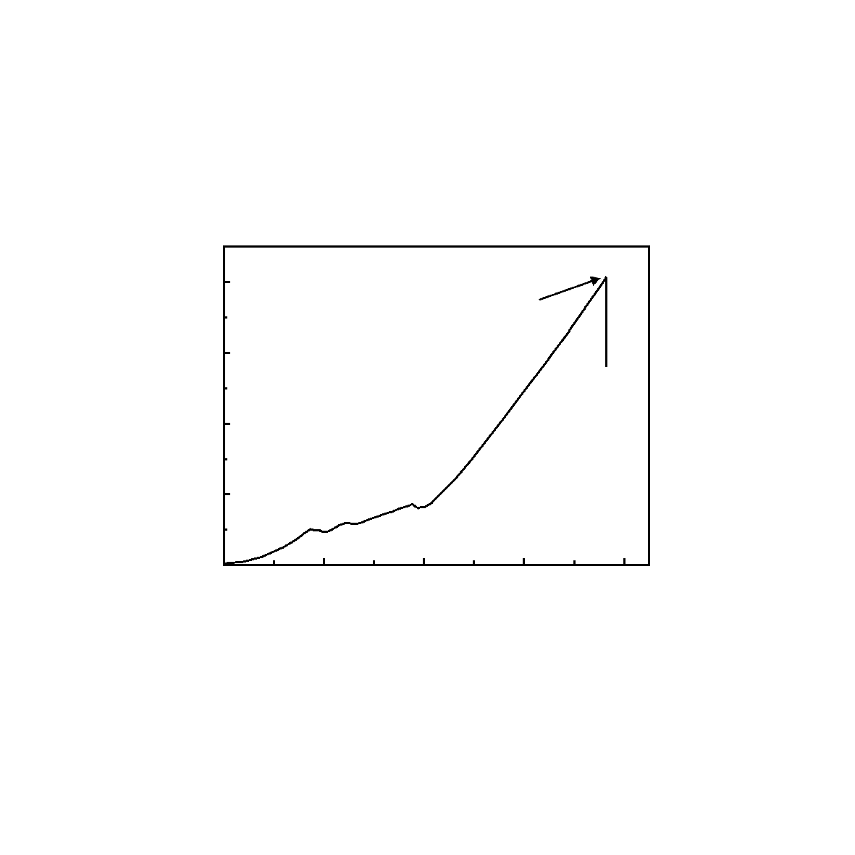
0.0 0.1 0.2 0.3 0.4
Displacement/mm
2.0
1.5
1.0
0.5
Load/kN
Brittle fracture

Fig.5 Relationship between load and displacement in shear strength measurement
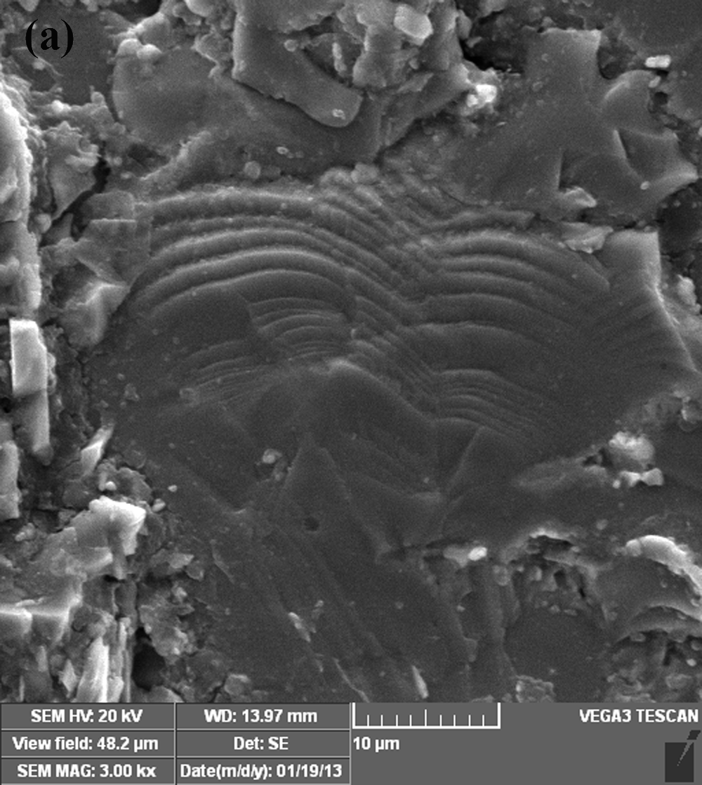
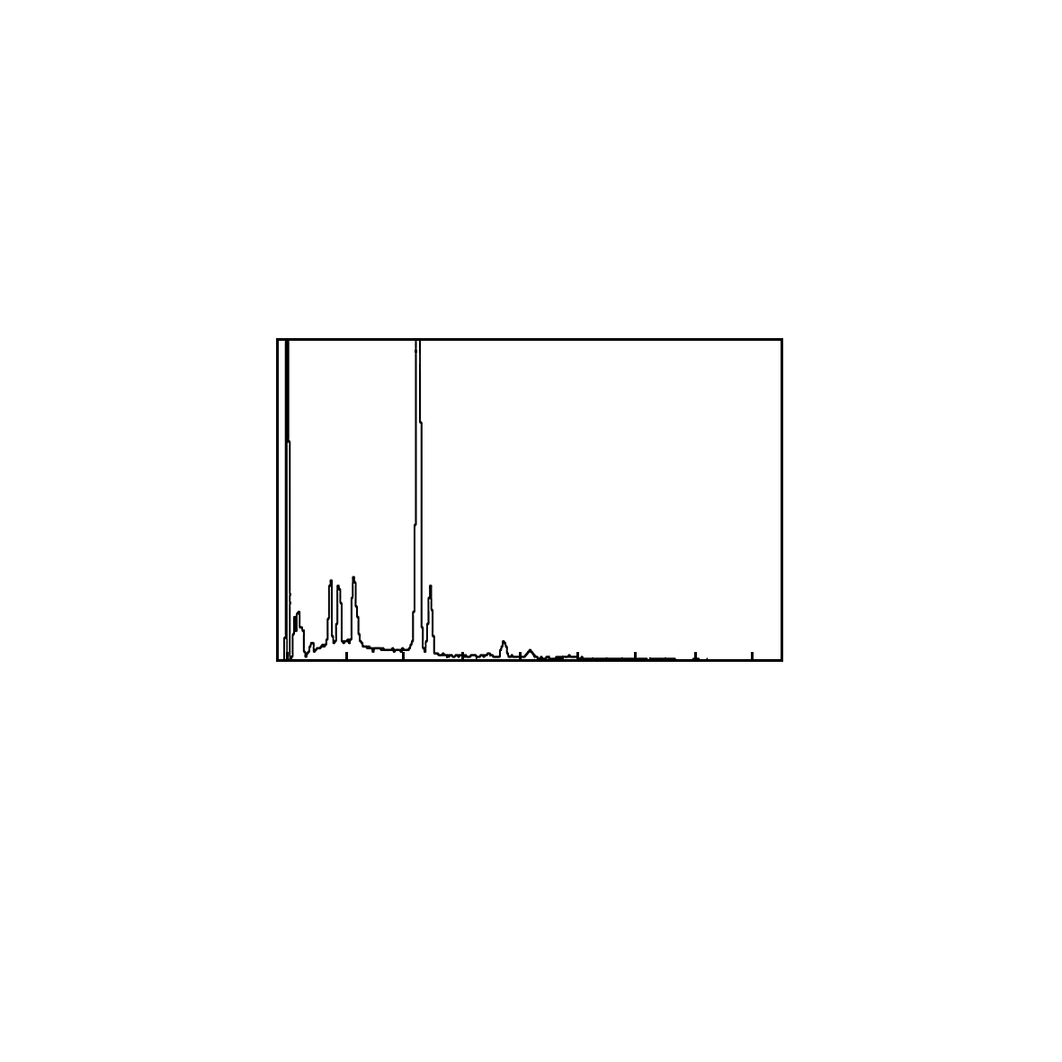
a
0 2 4 6 8 10 12 14 16
Energy/keV
Intensity/a.u.
C
Ti
Al
W
Mo
Ti
W
Ni
Ni
W
W
W
b

Fig.6 SEM fracture morphology (a) and EDS spectrum (b) of the
sample

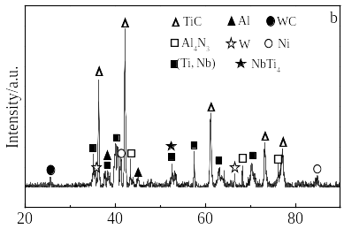
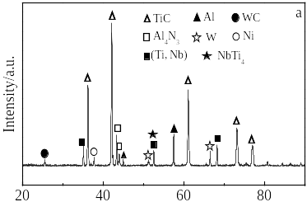
2θ/(°)

Fig.7 XRD patterns of near TiC cermet (a) and near 304SS (b)
direction of sample in the process of bonding which result in the compressive stress σ_{y} perpendicular to the interface by lateral contraction of the ceramic and steel ^{[18]}. Therefore, the crack is inevitable, especially the nature of brittleness in TiC. But now things change. The formation of tough (Ti, Nb) solid solution and the float of TiC particles in the boundary relieve the CTE mismatch which inhibit the origin of cracks to a certain extent. Ti and Nb play an important role in continuous ductile transition from TiC matrix to reaction interface. The stress distribution, the interlayer effect and the loading conditions can explain the fracture process in which the cracks begin from the (Ti, Nb) to the TiC ceramic and finally lead to fracture. Because the hardness value of (Ti, Nb) in region B mentioned in Table 4 is the lowest among all the reaction products, the shear strength of the joint whose fracture starts from (Ti, Nb) region is the highest.
3 Conclusions
1) There exist a transition zone including (Ti, Nb), remnant Nb, remnant Cu and Cu (s.s) regions within TiC cermet/ Ti/Nb/Cu/304SS joint. Under the action of these solid solutions, the maximum shear strength of the joint can be up to 84.6 MPa when it is boned at 925 °C for 20 min under a pressure of 8 MPa.
2) There are not brittle phases in the interfacial transition zone while high hardness exists. The fracture of TiC/304SS diffusion bonding interface is proved to exhibit the brittle cleavage fracture features. Fracture occurs within TiC cermet near the interface instead of reaction zone.

References
- Miao Hezhou, Lin Xuping, Qi Longhao. Rare Metal Materials and Engineering[J], 2008, 37(1): 14 (in Chinese)
- Sun Kangning, Yin Yansheng, Li Aimin. Intermetallics/Ceramic Matrix Composite[M]. Beijing: China Machine Press, 2002 (in Chinese)
- Dilermando T, Maurizio F, Gert D O. Materials Science and Engineering A[J], 2002, 337(1-2): 287
- Shen X Q, Li Y J, Putchkov U A et al. Computational Materials Science[J], 2009, 45(2): 407
- Ye Dameng, Xiong Weihao. Rare Metal Materials and Engineering[J], 2008, 37(7): 1281 (in Chinese)
- Kliauga A M, Travessa D, Ferrante M. Materials Characterization[J], 2001, 46(1): 65
- Jadoon A K, Ralph B, Hornsby P R. Journal of Materials Processing Technology[J], 2004, 152(3): 257
- Hattali M L, Mesrati N, Tréheux D. Journal of the European Ceramic Society[J], 2012, 4: 717
- Cao J, Song X G, Li C et al. Materials Characterization[J], 2013, 81: 85
- Travessa D, Ferrante M, Den O G. Materials Science and Engineering[J], 2002, 337: 287
- Wang J, Li Y J, Yin Y S. Bulletin of Materials Science[J], 2006, 29(2): 155
- Marks R A, Sugar J D, Glaeser A M. Journal of Materials Science[J], 2001, 36: 5609
- Huang W Q, Li Y J, Wang J et al. Kovove Materialy-Metallic Materials[J], 2010, 48: 227
- Min Y, Zou Z D, Song S L et al. Key Engineering Materials[J], 2005, 297-300: 2435
- Kundu S, Ghosh M, Laik A et al. Materials Science and Engineering A[J], 2005, 407(1): 154
- Zhang L X, Feng J C, He P. Materials Science and Engineering A [J], 2006, 428(1): 24
- Zdaniewski W A, Conway J C, Kirchner H P. Journal of the American Ceramic Society[J], 1987, 70: 110
- Podgornik B, Leskovšek V, Kovačič M et al. Materials and Manufacturing Processes[J], 2011, 26: 1097

Cu作缓冲层的TiC金属陶瓷/304不锈钢扩散连接

李 佳，盛光敏，黄 利
(重庆大学，重庆 400044)

摘 要：对TiC金属陶瓷和304不锈钢进行真空扩散连接实验，并采用Ti/Nb/Cu中间层以实现活性连接并缓解接头残余应力的目的。对焊后接头进行详细的组织分析和力学性能测试来评估焊接工艺。分析发现在TiC金属陶瓷和304不锈钢之间形成明显的转变过渡区，界面反应产物为（Ti, Nb）、剩余Nb、剩余Cu以及 Cu (s.s)。连接温度925 ℃，保温时间20 min，压力8 MPa下得到的接头剪切强度达84.6 MPa，此时脆性断裂发生在靠近界面处的陶瓷内部。结果表明，中间层Ti/Nb/Cu的合理选择能很好的降低金属间化合物对接头性能的有害作用，而且Nb对接头残余应力的改善起到关键作用，有效的提高了接头强度。
关键词：扩散；TiC陶瓷；Ti-Nb-Cu中间层；微观组织；力学性能

作者简介：李 佳，女，1990年生，博士，重庆大学材料科学与工程学院，重庆 400044，电话：023-65103045，E-mail: 810934362@qq.com

