Bonding Process and Application Properties of an Al-Ni Layer Composite Sheet for Lithium-ion Battery Packaging
Yu Kun^{1, 2}, Xiong Hanqing^{1, 2}, Dai Yilong², Teng Fei², Fan Sufeng², Qiao Xueyan²,
Wen Li²

¹ Central South University, Changsha 410083, China; ² Yantai Nanshan University, Yantai 265713, China

Abstract: The cold roll bonding process of an Al-Ni layer composite sheet applied as a brazing solder for the welding of nickel and aluminum structures in the lithium-ion battery packaging was investigated. The effects of roll bonding and annealing treatment on the application properties and the interface compounds of Al-Ni composite sheet were also studied. The results show that the appropriate rolling reduction to bond and produce Al-Ni layer composite sheet is between 50% and 60% deformation degree. During the annealing process, the first formed Al₃Ni phase in the interface of Al and Ni is beneficial to the bonding of such two metals, but the sequently formed Al₃Ni₂ phase results in cracks and separation of the Al-Ni layers. The roll-bonded Al-Ni layer composite sheet acquires good bending endurance, stable weldability and suitable electrical resistivity upon annealing at 698 K to 748 K for 1 h.

Key words: Al-Ni layer composite; roll bonding; interface

Layer metal composites can provide customizable materials for specific applications requiring particular properties of different metals ^{[1]}. For example, the Al-Ni bi-layer composite sheet can be used as a brazing solder for the ultrasonic welding of nickel and aluminum structures for lithium-ion battery packaging. The main application properties, such as appropriate mechanical properties, stable weldability and low electrical resistivity, require the Al-Ni bi-layer composite to provide a reliable bonding between the individual aluminum layer and nickel layer. Roll bonding is a usual method available to fabricate Al-Ni bi-layer composite sheet because its thickness is only 0.1~0.2 mm^{[2,3]}. The rolling process parameters are important to the bonding reliability. Meanwhile, it is well known that the intermetallic phases formed between aluminum layer and nickel layer by solid state reaction during the roll bonding and sequent heat treatment have great effects on the application properties of Al-Ni layer composite sheet ^{[4]}. Some previous investigations were done to study the intermetallic phase formation between nickel and aluminum alloys ^{[5,6]}. The solid state reactions in Al/Ni alternate sheets were studied in Ref.[7] and the growth kinetics of the new compounds were obtained by the study of sputtering Al/Ni multi-layer samples or some mechanical ball milling of Al and Ni powders ^{[8-10]}. These studies focused on the nucleation and the growth of new compounds between Al and Ni but seldom provided the relationship between the new intermetallic phases and the application properties of Al-Ni layer composite sheet. So, in the present investigation, the parameters of roll boding and the heat treatment of manufacturing the Al-Ni layer composite sheet were studied. In particular, the effects of microstructures on the application properties of the Al-Ni layer composite sheet were discussed.
1 Experiment
The Al-Ni layer composite sheets were obtained by superimposing rolling the sheets of 0.22 mm pure Ni and 0.10 mm pure Al. The pure Ni and pure Al sheets were cleaned by scratch brushing and acetone before folding them together. Then the bi-layer metals were rolled to bond at the ambient temperature by a Φ90 mm/Φ300 mm×350 mm rolling mill to obtain the bonded composite sheets with thickness of 0.20, 0.15 and 0.10 mm, respectively. So the calculated rolling reductions were about 38%, 53% and 69% correspondingly. The rolled Al-Ni sheets were annealed at different temperatures from 598 K to 823 K for 1 h to evaluate the bonding effect and to analyze the phase formation between Al and Ni.
The microstructure evolution and the phase formation of the rolled and annealed Al-Ni layer composite sheets were observed by a Polyvar-MET optical microscopy (OM) and a FEI Quonta-200 scanning electron microscopy (SEM) with energy-dispersive X-ray spectroscopy (EDX). The hardness of Ni layer and Al layer was tested by SHIMADZU HSV-1000 micro-hardness tester. A 180° bending test of Al-Ni composite sheet was performed as shown in Fig.1a to evaluate the local exfoliation of Ni or Al layers after bonding. The tensile strength was tested by CSS-41000 electronic stretcher system to measure the junction force of a weld zone after ultrasonic welding of Al-Ni layer composite sheet with a 0.5 mm pure aluminum plate contacted in the aluminum layer side (Fig.1b). The Al-Ni layer composite sheet and the pure aluminum plate were bent at the measurement point to L typeface at the edge of a weld zone, the edge was pulled, and the hauling force making a joint exfoliate was measured and taken as junction force. The electric resistivity of Al-Ni layer composite sheet was tested by Kelvin double bridge methods. All the experimental tests were performed three times per each sample to acquire the average values.
2 Results and Discussion
2.1 Cold roll bonding of Al-Ni layer composite sheet
Roll bonding is a solid state welding process in which bi-layer metals are stacked together and rolled to cause enough deformation to produce solid state welds ^{[11]}. Since the bonded surfaces of the Al and Ni sheets are cleaned by the scratch brushing and acetone, the applied sufficient pressure can form the bond of such two metals. It is well established that a threshold deformation degree must be achieved to obtain a relative firm and reliable bonding.
Three different rolling reductions were performed to bond the Al and Ni sheets together as shown in Fig.2 to obtain a suitable roll bonding deformation degree. It is obvious that the Al layer and Ni layer separate after rolling with the reduction of 38% (Fig.2a) but they will join well with the reduction over 50% (Fig.2b). The plastic deformation degree over 50% is required for the Al-Ni composite sheets to provide enough pressure to make Al and Ni meshing each other. But the sheet distorts seriously under a reduction over 60% because of the difference of plastic deformation behavior of Al and Ni. Such warpage or waviness shape (Fig.2c) is unacceptable to fabricate the Al-Ni composite sheets. Therefore, controlling of a suitable rolling reduction about 50%~60% is the most important step to produce the Al-Ni bi-layer composite.
On the other hand, the mechanism of the interfacial bonding of such two metals at this rolling state is only a mechanical meshing, but not a metallurgical bonding. The interface microstructure of the rolled Al-Ni composite sheet is shown in Fig.3. The EDX analysis of the interface of Al and Ni shows that there is no reaction occurrence between Al and Ni during the rolling process. The microstructure of Al and Ni interface forms a jagged, interlocking pattern which is beneficial to bonding of these two metals.

a
b
Welding point
Al-Ni sheet
Pure Al sheet

Fig.1 Schematic diagram of testing the Al-Ni composite sheet: (a) bending test of Al-Ni sheets and (b) welding junction force test of Al-Ni with Al sheet

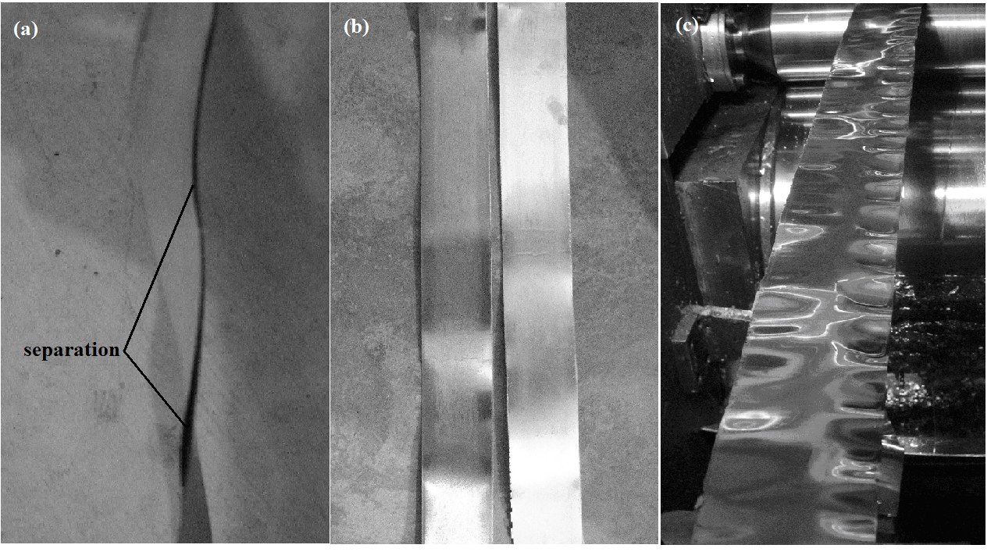
Separation
Al
Ni
Al
Ni
a
b
c
25 μm

Fig.2 Cold roll bonding of Al-Ni bilayer composite sheet with different reductions: (a) 38%, (b) 53%, and (c) 69%

The successful roll bonding is so important that it deter- mines the sequent solid state reactions and the metallurgical bonding of Al-Ni interface ^{[7]}. A perfect mechanical meshing of Al and Ni interface can result in a following metallurgical reaction between them. In general, the metallurgical bonding process is inhibited by the mobility of the atoms of the two metals ^{[12]}. This obstacle of low mobility can be overcome by high compressive and shear stresses at the contact zones between Al and Ni layers during the high plastic deformation degree of the rolling process. Usually, the plastic deformation degrees of Ni layer and Al layer during the rolling process are seriously different because the yield strength of Al is much lower than that of Ni. The yield strength of Al layer is about 35 MPa while that of Ni about is 220 MPa ^{[13]}.
So there is a serious stress concentration on the interface of Al and Ni layers. Such heterogeneous distribution of shear stress is also an activation force to accelerate the Al and Ni atoms diffusion which deduces a metallurgical bonding during the sequent heat treatment of the bi-layer composite. But if the concentration of stress on the interfacial boundary between the Al and Ni layers overwhelms the ultimate strength of metals, the cracks would begin to develop in the hardened boundary resulting in the defects as shown in Fig.2c. The Vicker’s hardness HV of Ni layer after roll bonding is 2140 MPa, and that of Al layer is 780 MPa. One reason for such great hardness difference is the intrinsic hardness difference between Al and Ni. But the other more important reason is that the work hardening effect of nickel is more obvious than that of aluminum during the roll bonding process. Therefore, a proper rolling process is important to ensure the bonding of Al and Ni during the rolling deformation with less deformation defects. The appropriate roll bonding deformation degree of Al and Ni of this experiment is about 50% to 60%.
2.2 Annealing of rolled Al-Ni composite sheet
Solid state reactions in the rolled Al-Ni composite sheet become activated during annealing process ^{[7]}. When Al and Ni are bonded and annealed at high temperatures, they react and form intermetallic compounds. The bi-layer metal structure sample has a perfect geometry to study the nucleation of the first intermediate phase and the sequencing of phase transfor-

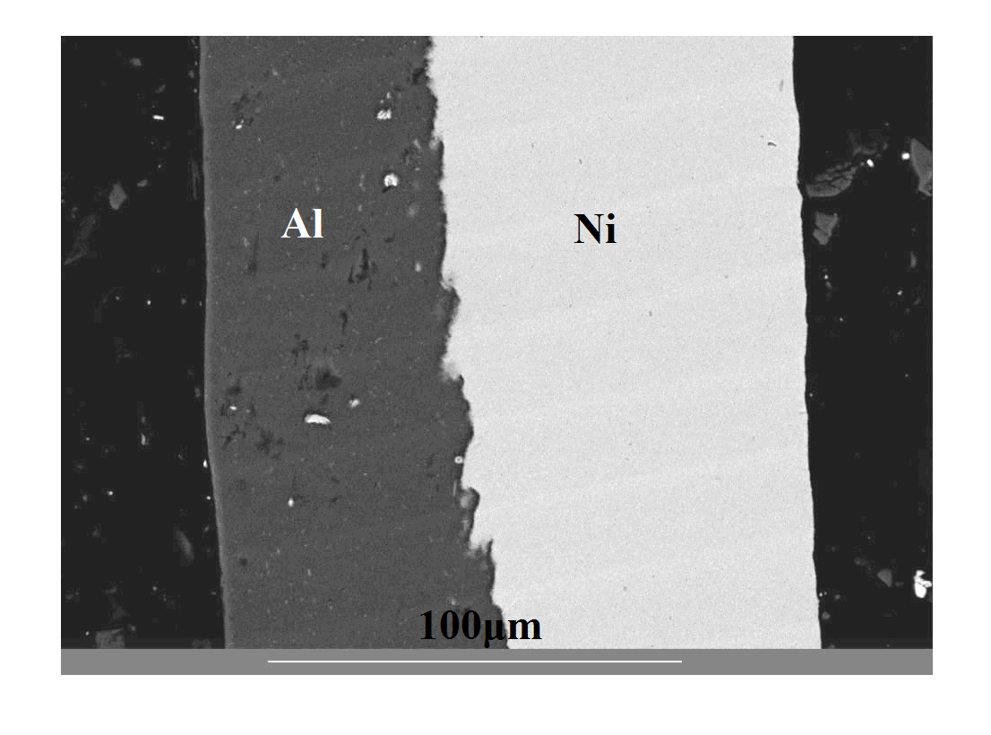
50 μm

Fig.3 Morphology of the interface of rolled Al-Ni composite sheet
mation. The finite supply of the reactants in such bi-layer composite sheet samples produce fewer coexisting phases than annealing bulk diffusion couples ^{[14]}. So, the formation of different phases in the interface of Al and Ni are shown by the interfacial boundary of Al-Ni composite sheet after different temperatures annealing. It is known that the reactions producing the intermetallics are the results of the interaction between diffusion, phase nucleation and growth. The phase formation sequencing depends on the temperature, reaction time, composition gradients, interfacial surface energies, Gibbs free energies and other phases already present. At a low annealing temperature of 598 K, the start of reactions occurs on the interface. The nucleation of intermetallics compounds can be identified by spot EDX analyses as shown in Fig.4a and 4b.
It is very important to identify the first phase to form because this phase can strongly influence the interfacial subsequent phase evolution and the bonding effect of Al and Ni. The first formed phase measured by spot EDX has a composition of 74.21at%Al and 25.79at%Ni, so the phase can be identified as Al₃Ni according to the Al-Ni phase diagram ^{[13]}. The growth of Al₃Ni phase forms a layer pattern at a high annealing temperature of 698 K (Fig.5a). The Al₃Ni intermetallic compound layer on the interface of Al and Ni is important for the bonding properties of the two layers.
Once the Al₃Ni interlayer is fully developed on the interface, the bonding mechanism of Al and Ni layers changes from mechanical meshing to metallurgical bonding. With a detailed observation of the interlayer of Al₃Ni phase (Fig.5b), the

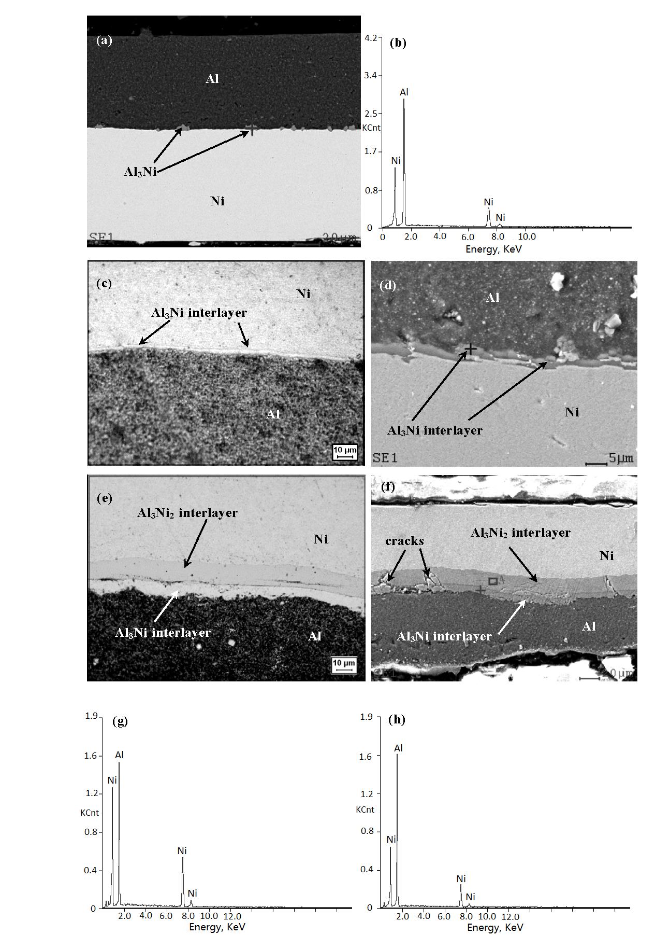
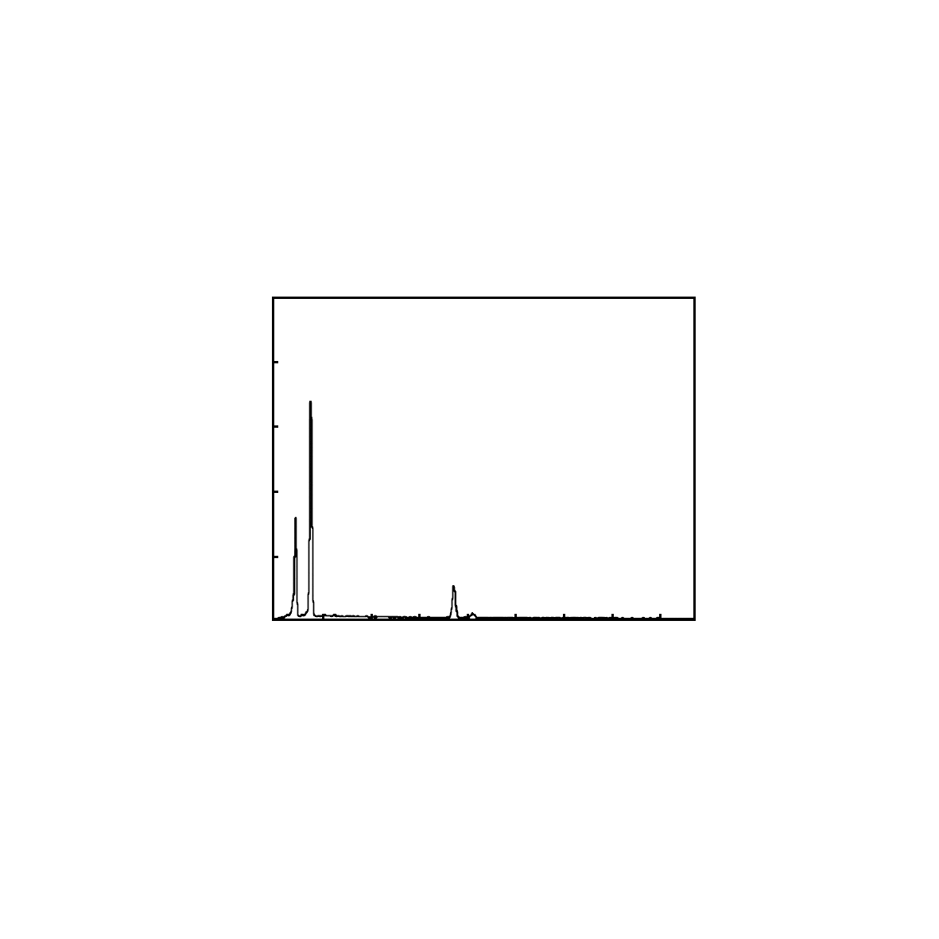
a
20 μm
0 4.0 8.0
Energy/keV
b
4.2
3.4
2.5
1.7
0.8
0
Intensity/×10³ cps
Ni
Al
Ni
Ni

Fig.4 SEM morphology of the intermetallic compounds (a) and EDX spectrum of the new phase Al₃Ni on the interface of Al-Ni annealed at 598 K (b)

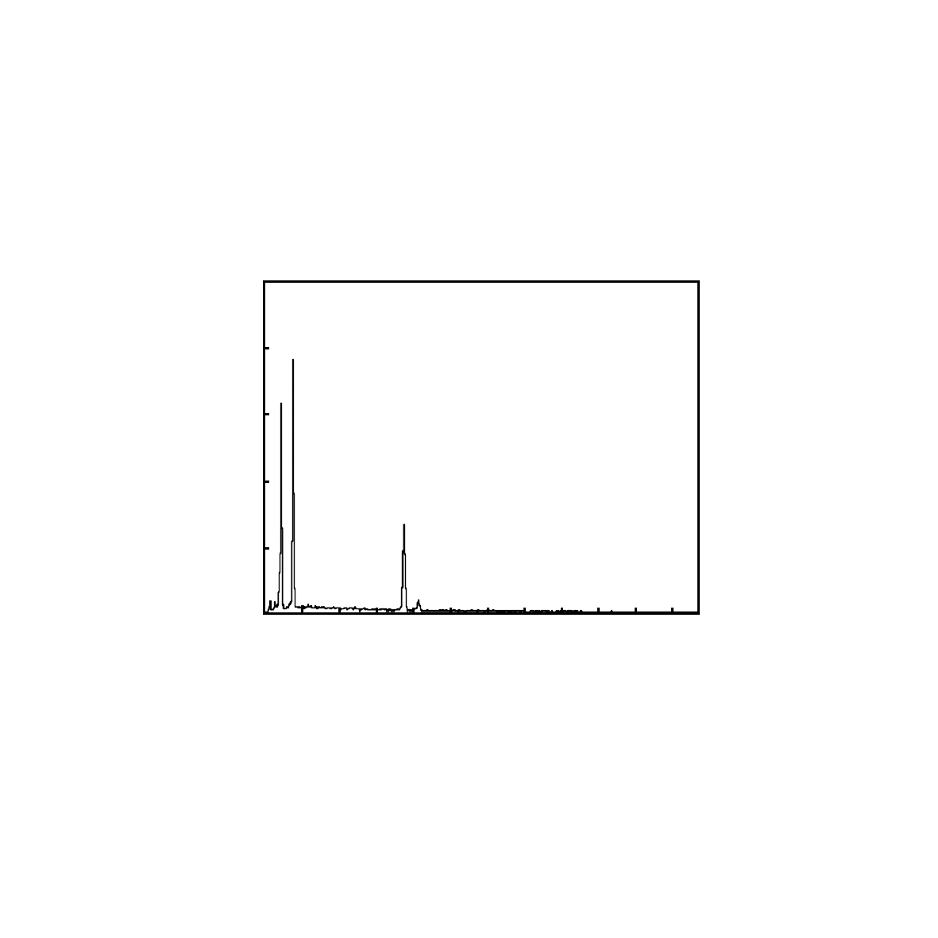
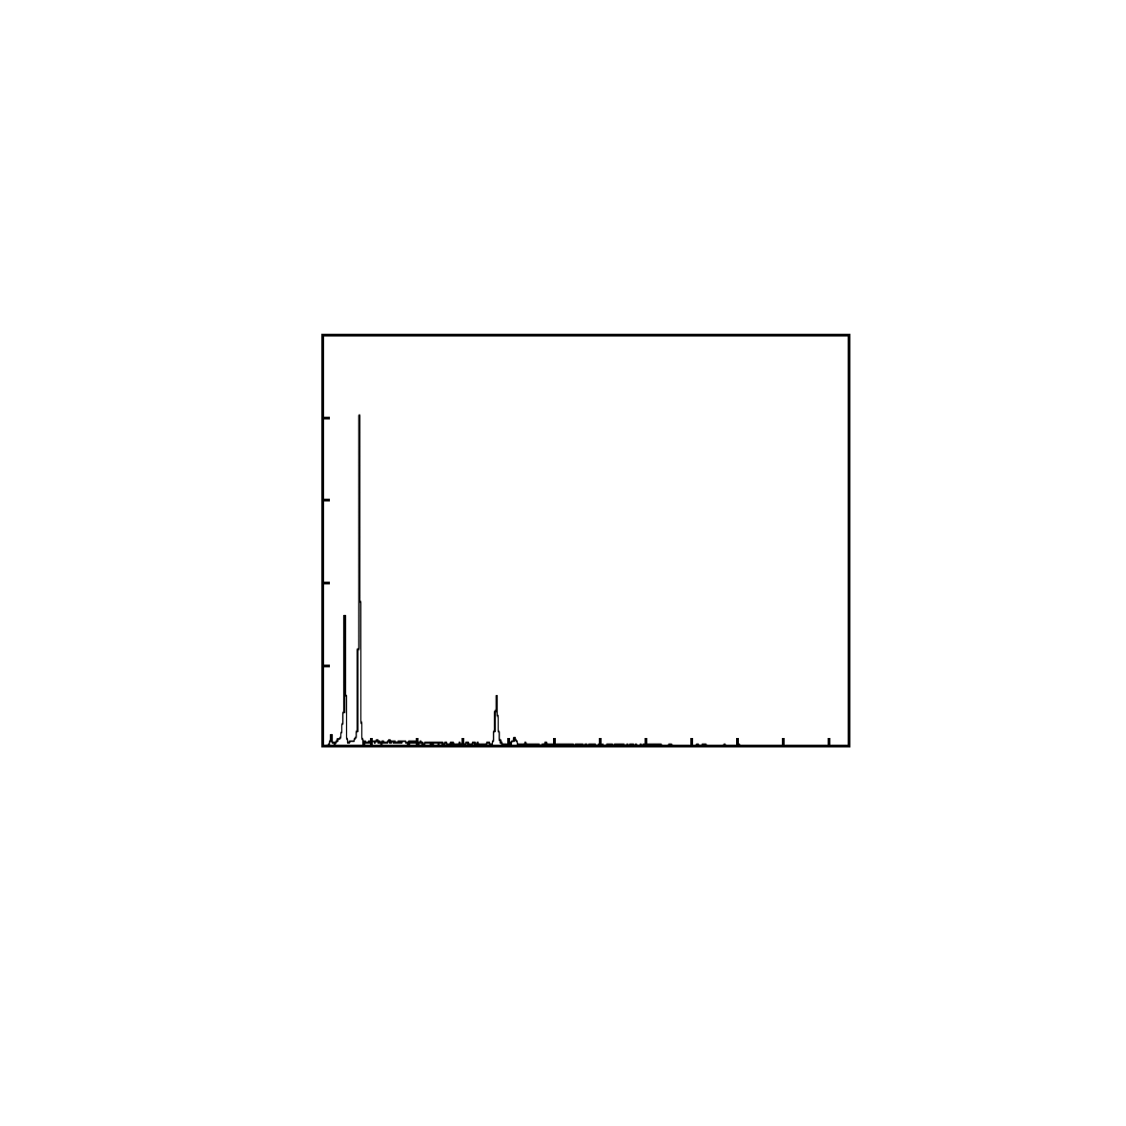
a
b
d
e
Cracks
10 μm
5 μm
10 μm
20 μm
1.9
1.6
1.2
0.8
0.4
0
Intensity/×10³ cps
2.0 6.0 10.0
c
f
Ni
Al
Ni
Ni
2.0 6.0 10.0
Energy/keV
1.9
1.6
1.2
0.8
0.4
0
Intensity/×10³ cps
Ni
Al
Ni
Ni

Fig.5 Morphologies and compositions of the intermetallic compounds on the interface of Al-Ni : (a) OM microstructure of Al-Ni annealed at 698 K, (b) SEM image of Al-Ni annealed at 723 K, (c) EDX spectrum of Al₃Ni₂ interlayer; (d) OM microstructure of Al-Ni annealed at 763 K, (e) SEM image of Al-Ni annealed at 763 K, (f) EDX spectrum of Al₃Ni interlayer

Al₃Ni phase also shows a jagged, interlocking pattern like the morphology of mechanical meshing state. The thickness of Al₃Ni phase interlayer is about 2~3 μm at 698 K and increases to 6~8 μm at the annealing temperature to 763 K. With the increasing of temperature to 763 K, another compound Al₃Ni₂ will nucleate and grow quickly at the Al₃Ni/Ni interfaces (Fig.5c~5f). The interlayer thickness of newly formed Al₃Ni₂ phase between the Al₃Ni/Ni interfaces is over 10 μm (Fig.5d). The different phase interlayer will lead to a mismatch on the interface of Al and Ni. Such mismatch between different phases results in many cracks in the interlayer and leads to the separation of Al and Ni layers (Fig.5e). Therefore, controlling of the category and the thickness of interlayer phases is important to the bonding effect of Al and Ni layers during the annealing process. An appropriate annealing temperature based on the application property tests should be chosen to obtain a firmly fixed bonding effect of Al-Ni composite sheet.
2.3 Application properties of Al-Ni composite sheet
The application properties of 180° bending times of the annealed Al-Ni composite, hauling force of Al-Ni bi-layer with 0.5 mm aluminum plate and the electric resistivity were measured to evaluate the bonding effect of Al-Ni composite sheet. One ordinary but effective method is the 180° bending for the bi-layer composite to calculate how many times it can endure before the separation occurs. The bending results of Al-Ni composite sheets at different states are shown in Table 1. More than 5 times are acceptable for the Al-Ni composite sheet when it is annealed from 698 K to 763 K. Neither the temperature below 673 K nor over 763 K is suitable for the annealing of Al-Ni composite sheet because of the different interfacial structures at different states. At the rolling state or annealing at low temperature, the mechanical meshing of Al and Ni bi-layer composite sheet can not endure the bending, resulting in the separation of the two metals. At the high annealing temperature over 763 K, the formation of the brittle Al₃Ni₂ phase will weaken the bonding effect of Al layer and Ni layer.
It is important for a joint that stable weld bonding is acquired for lithium-ion battery packaging. It is considered that the minimum junction force should exceed 49 N for industrial applications. The composite sheets after heat treatment at different temperatures were welded with the aluminum plate and the hauling force was measured. The results with the hauling force over 49 N in Table 1 show that the appropriate temperature range for annealing of Al-Ni composite sheet is from 598 K to 748 K.
The electric resistivity of Al-Ni composite sheet is also an important parameter to evaluate the bonding effect of the two metals. The separation of Ni layer with Al layer is the worst problem to Al-Ni composite sheet which is used as the welding brazing solder. A slight separation of Al and Ni layer will result in an obvious increasing of the electric resistivity of the composite. The electrical resistivities of Al-Ni composite sheets after annealing at different temperatures are shown in Table 1. The Al-Ni composite sheets with a low resistivity value with 0.043~0.049×10⁻⁶Ω/m are annealed from 598 K to

Table 1 Application properties of Al/Ni composite sheet at different states
Tests | Rolling state | Annealed for 1 h at different temperatures/K
Tests | Rolling state | 598 | 673 | 698 | 723 | 748 | 763 | 773 | 798 | 823
180° bending times to fail | 1 | 1 | 2 | 8 | 10 | 10 | 5 | 3 | 3 | 1
Hauling force/N | 10.78 | 55.86 | 58.8 | 53.90 | 50.96 | 51.94 | 45.08 | 41.16 | 27.44 | 25.48
Resistivity/×10⁻⁶ Ω·m⁻¹ | 0.103 | 0.049 | 0.049 | 0.044 | 0.043 | 0.043 | 0.043 | 0.058 | 0.089 | 0.084

763 K. Compared with all the parameters above for annealing of Al-Ni composite sheets, the optimal annealing process is from 698 K to 748 K for 1 h.
2.4 Solid state reactions in Al-Ni composite sheet
When Al and Ni are put in contact and annealed at high temperature, they react and form intermetallic compounds. It is well known that the forming of new phase in solid state is established by diffusion. Initially, the Al and Ni atoms only diffuse through (Al) and (Ni) rich solid solutions. According to the Ni-Al phase diagram, the solid solubility of Ni in (Al) is very limited. It is reported that the solid solubility decreases from 0.11at% Ni at the eutectic temperature to 0.01at%Ni at 773 K. (Ni) dissolves Al in solid solution up to a maximum of 21.1at% at the Ni-rich eutectic temperature and more than 8at% Al at 773 K ^{[12,14]}. Meanwhile, the known activation energy for the diffusion of Al in Ni is 270.16 kJ/mol. And the value for the diffusion of Ni in Al is about 145.53 kJ/mol. The activation energy for the diffusion of Ni in Al is very similar to that for self-diffusion of Al in Al (142.19 kJ/mol) ^{[14]}. So the activation energy for diffusion of Al in Ni is almost twice as large as the value for Ni in Al. Therefore, Ni should diffuse faster in Al than Al diffusion in Ni. Thus, the Ni concentration in Al and the low solid solubility of Ni in (Al) result in the formation of Al₃Ni intermetallic phase initially. Once the Al₃Ni interlayer is fully developed and with the temperature increasing, the Al₃Ni₂ phase will nucleate and grow on the Al₃Ni/Ni interface (Fig.5c, 5f). In annealing experiment, the solid state reaction of Al-Ni bilayer composite and the sequence of new phase transformation can be established as Al+ Ni→Al₃Ni + Ni (598 K<T<763 K) and Al₃Ni + Ni→Al₃Ni₂ (T>763 K) ^{[13,14]}. Due to the importance of the initial Al₃Ni phase formation and to better understand the initial phase selection and subsequent phase sequencing, it is useful to consider the relative thermodynamic phase stability and the free-energy changes for various reactions. It is well known that the initial interdiffusion forms a solid solution. The free-energy changes between the solid solution and the various intermediate phases were calculated by phase equilibria assessment. The free-energy change of Al₃Ni from solid solution is about 0.99~1.05 kJ/cm³ less than that of the formation of Al₃Ni₂ phases from 598 K to 753 K ^{[10]}. Therefore, based on the thermodynamic analysis of diffusion and phase formation, the Al₃Ni phase is the initial phase formed on the interface at the low annealing temperatures.
The Al₃Ni phase has an orthorhombic structure with parameters a = 0.6611 nm, b = 0.7366 nm, and c = 0.4812 nm. The Vickers hardness is 7~7.7 GPa at 300 K and it changes insignificantly upon heating up to 600 K, and then decreases linearly to 2 GPa at 850 K. The Al₃Ni₂ phase has hexagonal lattice with parameters a = 0.4036 nm, c = 0.490 nm. The Vickers hardness exceeds 11 GPa at 300 K and 5 GPa at 850 K ^{[12]}. These parameters show that both the lattice mismatch and the hardness of Al₃Ni phase are less than those of Al₃Ni₂ phase. Since Al and Ni have both face-centered cubic structure, the interfacial bonding of Al₃Ni will be better than that of Al₃Ni₂. Both the great mismatch on the interface and the high hardness of the Al₃Ni₂ phase will result in the crack as shown in Fig.5d. Therefore, controlling of the formation of Al₃Ni phase and restraining of the formation of Al₂Ni₃ phase are important during annealing.
3 Conclusions
1) The appropriate roll bonding deformation degree to produce Al-Ni composite sheet is about 50% to 60%. The interfacial bonding of such two metals at the rolling state is only a mechanical meshing but not a metallurgical bonding. The interface of Al and Ni forms a jagged, interlocking pattern but no reaction occurs between them.
2) The first formed phase is Al₃Ni during the annealing process. Another Al₃Ni₂ phase nucleates and grows quickly at the Al₃Ni/Ni interfaces with the increasing of temperature. The bonding mechanism changes from mechanical meshing to metallurgical bonding with the formation of such phases. The thin thickness of Al₃Ni interface is beneficial to the bonding of Al and Ni but the thick, brittle and mismatched Al₃Ni₂ phase will lead to the separation in the interface.
3) The roll bonded Al-Ni composite sheet can acquire appropriate application properties including good bending, stable weldability and suitable electrical resistivity under annealing from 698 K to 748 K for 1 h.

References
- Li L, Nagai K, Yin F X. Science and Technology of Advanced Materials[J], 2008, 9: 1
- Tayyeb M, Eghbali B. Materials Science and Engineering A[J], 2013, 559: 759
- Luo J G, Acoff V L. Materials Science and Engineering A[J], 2004, 379: 164
- Gajanan P C, Viola A. Composites Science and Technology[J], 2009, 69: 1667
- Sauvage X, Dinda G P, Wilde G. Scripta Materialia[J], 2007, 56: 181
- Min G H, Lee J M, Kang et al. Materials Letters[J], 2006, 60: 3255
- Mozaffari A, Danesh M H, Janghorban K. Journal of Alloys and Compounds[J], 2010, 489: 103
- Sieber H, Park J S, Weissmüller J et al. Acta Materials[J], 2001, 49: 1139
- Morsi K. Materials Science and Engineering A[J], 2001, 299: 1
- Ke L M, Huang C P, Li X et al. Journal of Alloys and Compounds[J], 2010, 503: 494
- Blobaum K J, Van Heerden D, Gavens A J et al. Acta Materials[J], 2003, 51: 3871
- Eizadjou M, Danesh Manesh H, Janghorban H. Materials & Design[J], 2008, 29: 909
- German Randall M, Suri Pavan, Park Seong Jin. Journal of Materials Science[J], 2009, 44(1): 1
- Noro J, Ramos A S, Vieira M T. Intermetallics[J], 2008, 16: 1061

锂离子电池封装用Al-Ni层状材料的复合过程及应用特性研究

余 琨^{1, 2}，熊汉青^{1, 2}，戴翌龙²，滕 飞²，范素峰²，乔雪岩²，文 利²
(1. 中南大学，湖南 长沙 410083)
(2. 烟台南山学院，山东 烟台 265713)

摘 要：采用冷轧复合工艺制备了用于锂离子电池封装用的层状Al-Ni双金属复合带材。针对轧制复合工艺和热处理退火工艺对Al-Ni双金属复合带材界面化合物种类、结构及其应用特性进行了研究。结果表明：合适的轧制变形量是实现Al层和Ni层复合的关键因素，在本实验中复合轧制的变形量应控制在50%~60%之间。在后续退火工艺中，Al层和Ni层界面上首先形成的是Al₃Ni相，该相有利于Al层和Ni层实现牢固的冶金结合。随着退火时间的延长，随后会形成较脆性的Al₃Ni₂相，该相以层状形式存在两层金属中间，容易造成Al层和Ni层金属的剥离，因此通过退火工艺控制界面化合物形成的类型和结构十分重要。实验发现，在698~748 K温度范围内退火1 h的轧制复合Al-Ni双金属复合带材，具有好的抗折弯效果、稳定的焊接性能和合适的电阻值，可以作为锂电池封装材料来进行使用。
关键词：Al-Ni层状复合材料；轧制复合；界面

作者简介：余 琨，男，1974年生，博士，教授，中南大学材料科学与工程学院，湖南 长沙 410083，电话：0731-88879341，E-mail: yukunarticle@163.com

