Study on the rheological model of semi-solid Al₂Y/AZ91 magnesium matrix composites slurry prepared by ultrasonic vibration

Huang Wenxian^{1, 2,3}, Yan Hong^{1, 2},
¹ Department of Materials Processing Engineering, School of Mechanical Electrical Engineering, Nanchang University, Jiangxi Nanchang 330031,China ; ² Key Laboratory of Light Alloy Preparation & Processing in Nanchang City，Nanchang 330031,China; ³ Department of Civil Engineering, School of Architectural Engineering, Jinggangshan University, Jiangxi Ji′an 343009,China

Abstract: Semi-solid Al₂Y/AZ91 magnesium matrix composites slurry was prepared by ultrasonic vibration, and the apparent viscosity of semi-solid slurry was measured as well. According to the experimental results, with the increase th of volume fraction of Al₂Y the apparent viscosity of semi-solid Al₂Y/AZ91 magnesium matrix composites slurry increases, the relationship between apparent viscosity and solid fraction varies according to the exponential law, under the same experimental conditions, the apparent viscosity decreases with the increase of ultrasonic power. Based on the experimental data fitting, the rheological model of semi-solid Al₂Y/AZ91 magnesium matrix composites prepared by ultrasonic vibration was established.
Key words: ultrasonic vibration; magnesium matrix composites; semi-solid slurry; rheological model

1 Introduction
Great progress has been achieved in the semi-solid slurry preparation and forming^{[1-3]}. The preparation methods of semi-solid slurry mainly include mechanical stirring, electromagnetic stirring, ultrasonic vibration and low superheatpouring process with a shear field process^{[4-6]}, the application of ultrasonic vibration in the semi-solid slurry preparation has drawn more and more attention, compared with other methods, ultrasonic vibration has many advantages such as grain refinement, preparation of non-dendritic grain in a short period of time and no pollution to molten metal^{[7-8]}. Many researchers studied the semi-solid slurry prepared by ultrasonic vibration, Zhu et al prepared semi-solid A356 alloy slurry with grian shape coefficient of 0.6 and average grain diameter of 70μm by indirect ultrasonic vibration^{[9]}. Dai et al prepared semi-solid Zl201aluminum alloy slurry by indirect ultrasonic vibration method, and studied the effect of ultrasonic technological parameters on the average grain diameter and shape factor^{[10]}. By now, researchers mainly study the effect of ultrasonic technological parameters on the microstructure of semi-solid slurry and the evolution mechanism of non-dendritic grains during the solidification via ultrasonic vibration, there are few studies on the effect of ultrasonic vibration on the rheological properties and forming performance of semi-solid slurry. In this work, the effect of ultrasonic vibration on the rheological properties of semi-solid slurry of Al₂Y/AZ91 magnesium matrix composites has been investigated. According to the results of fitting of the experimental data, the rheological model of semi-solid Al₂Y/AZ91 magnesium matrix composites prepared by ultrasonic vibration was established, which establishes foundation for the numerical simulation of rheological forming of Al₂Y/AZ91 magnesium matrix composites.

2 Experimental procedure
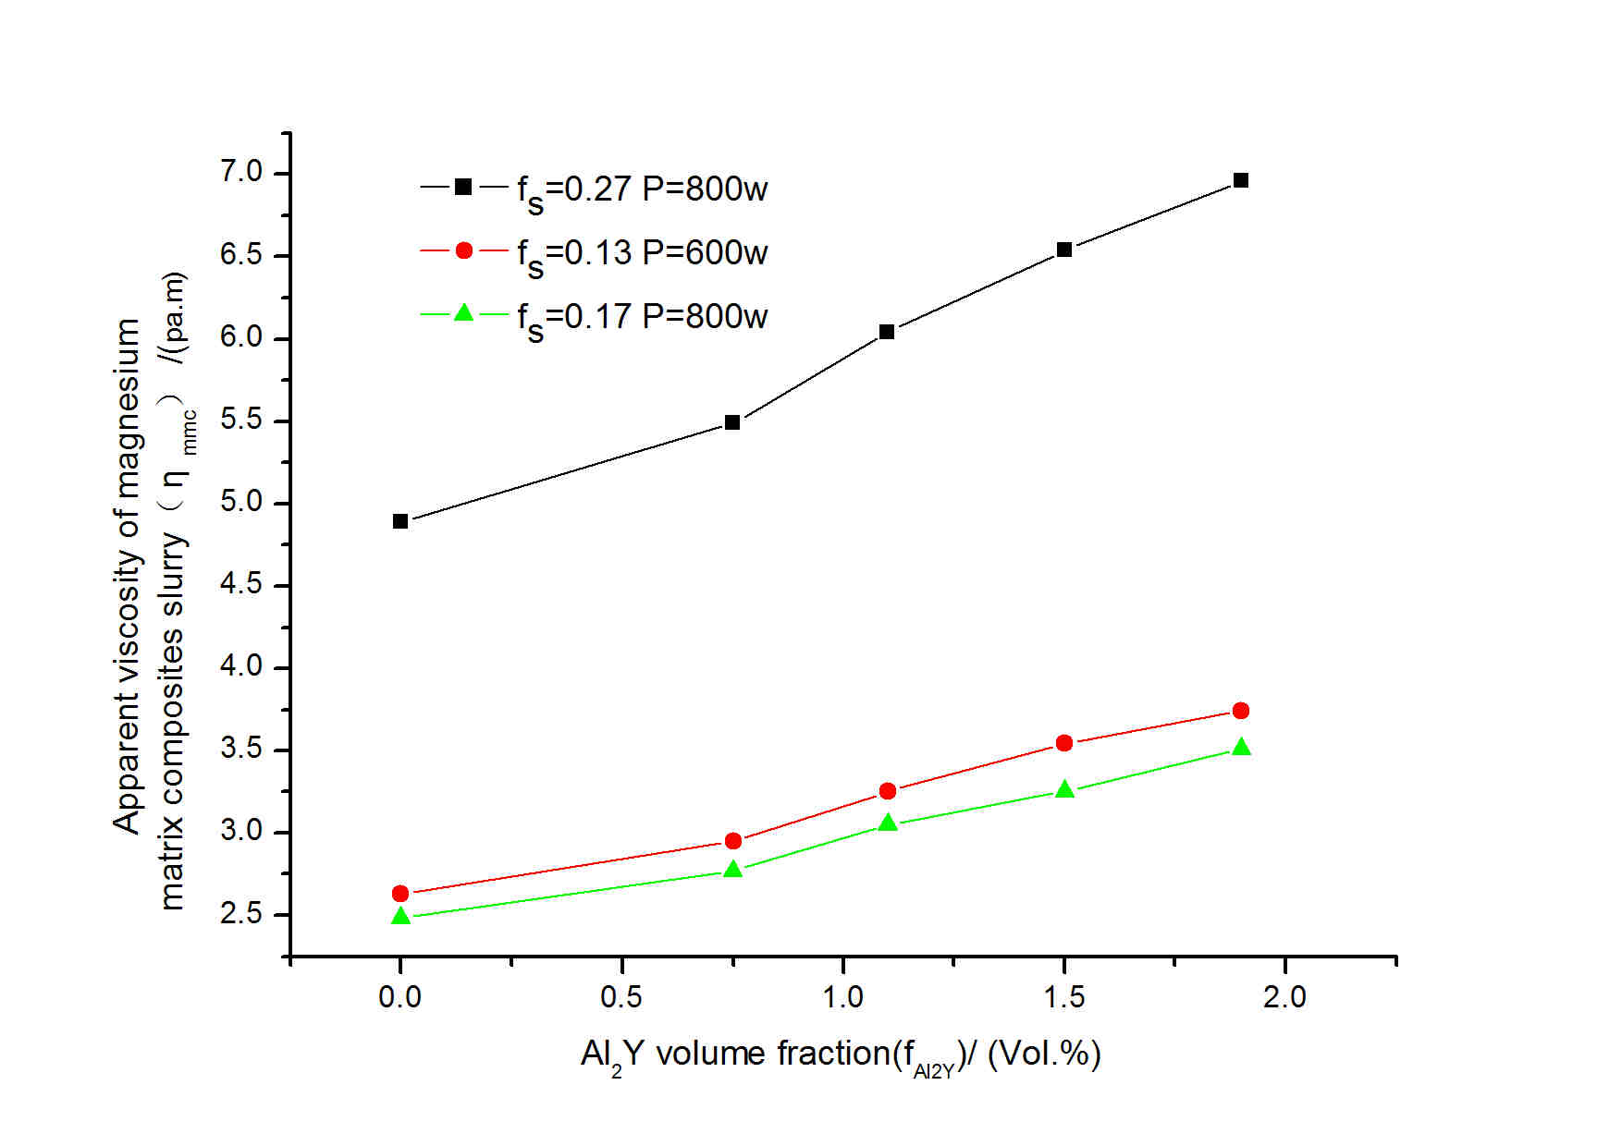
The schematic of ultrasonic vibration device used in this work is shown in Fig.1. It mainly consists of ultrasonic generator, transducer and fixed frequency, ultrasonic controllers, ultrasonic transformers, furance and temperature controller. The experimental material consists of AZ91 alloy (Al 9.163，Zn 0.538, Mn 0.218，Si 0.042，Fe 0.0028，Cu 0.0053，Be 0.0007，Ni 0.0056 and Mg balance, mass fraction, %) and Mg-30wt%Y master alloys. Mg-30wt%Y master alloys broken into particles were preheated to 300℃, the melted AZ91 alloys were heated to 850℃, then the Mg-30wt%Y master alloys wrapped aluminium foil were pressed into the melt of AZ91 alloys, the ultrasonic transformers was immersed into the melt, then ultrasonic generation system was turned on, after 2 min, the melt were poured into metal mould, Al₂Y/AZ91 magnesium matrix composites were gained.
Al₂Y/AZ91 magnesium matrix composites were placed in crucible, furance temperature were set at 750℃, during the process of melting the metal melt was protected by self-made covering powder and argon. When the temperature of melt reached the set value, the crucible filled with melt was removed into the furance of ultrasonic vibration device, the ultrasonic transformers preheated was immersed into the melt about 10 mm in depth, then the ultrasonic generation system was turned on. After vibrated, the apparent viscosity of semi-solid melt was measured by viscosity measuring instrument under different ultrasonic conditions. The relationship between ultrasonic temperature and solid fraction of melt can been expressed by Sheil equation:

（(1)

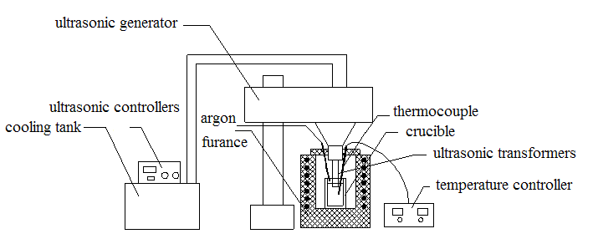
Where is solid fraction, is melting point of pure magnesium; is liquidus temperature of the material alloy; is temperature of slurry and is equilibrium distribution. coefficient.

Fig.1 Schematic of ultrasonic vibration device

3 Results and discussion
3.1 Effect of reinforcement Al₂Y volume fraction on the viscosity of magnesium matrix composites
Fig.2 shows the relationships between the apparent viscosity of semi-solid Al₂Y/AZ91 magnesium matrix composites slurry() and Al₂Y volume fraction() . The experimental data are gained under three different conditions which are ultrasonic power 800w and solid fraction 0.17, ultrasonic power 800w and solid fraction 0.27 and ultrasonic power 600w and solid fraction 0.13. As shown, under three different experimental conditions, the apparent viscosity of Al₂Y/AZ91 magnesium matrix composites increase with the increase of Al₂Y volume fraction.

Fig.2 Relationships between the apparent viscosity of semi-solid Al₂Y/AZ91 magnesium matrix composites slurry() and Al₂Y volume fraction() .

In order to study the relational expression of apparent viscosity of semi-solid Al₂Y/AZ91 magnesium matrix composites slurry and Al₂Y volume fraction, the ratio of apparent viscosity () of composite materials()and matrix material() are investigated. Fig.3 shows the relationship between the ratio of apparent viscosity () and Al₂Y volume fraction under three different experimental conditions, as shown in Fig.3, the relationship can be expressed by quadratic polynomial:
（2）

The coefficient a and b in formula (2) are calculated by fitting the experimental data obtained under three different experimental conditions. Table 1 is the value of coefficient a and b in formual (2). The average value of coefficient a and b is 267 and 17.52, respectively. Then the formula (2) can be expressed by

（3）
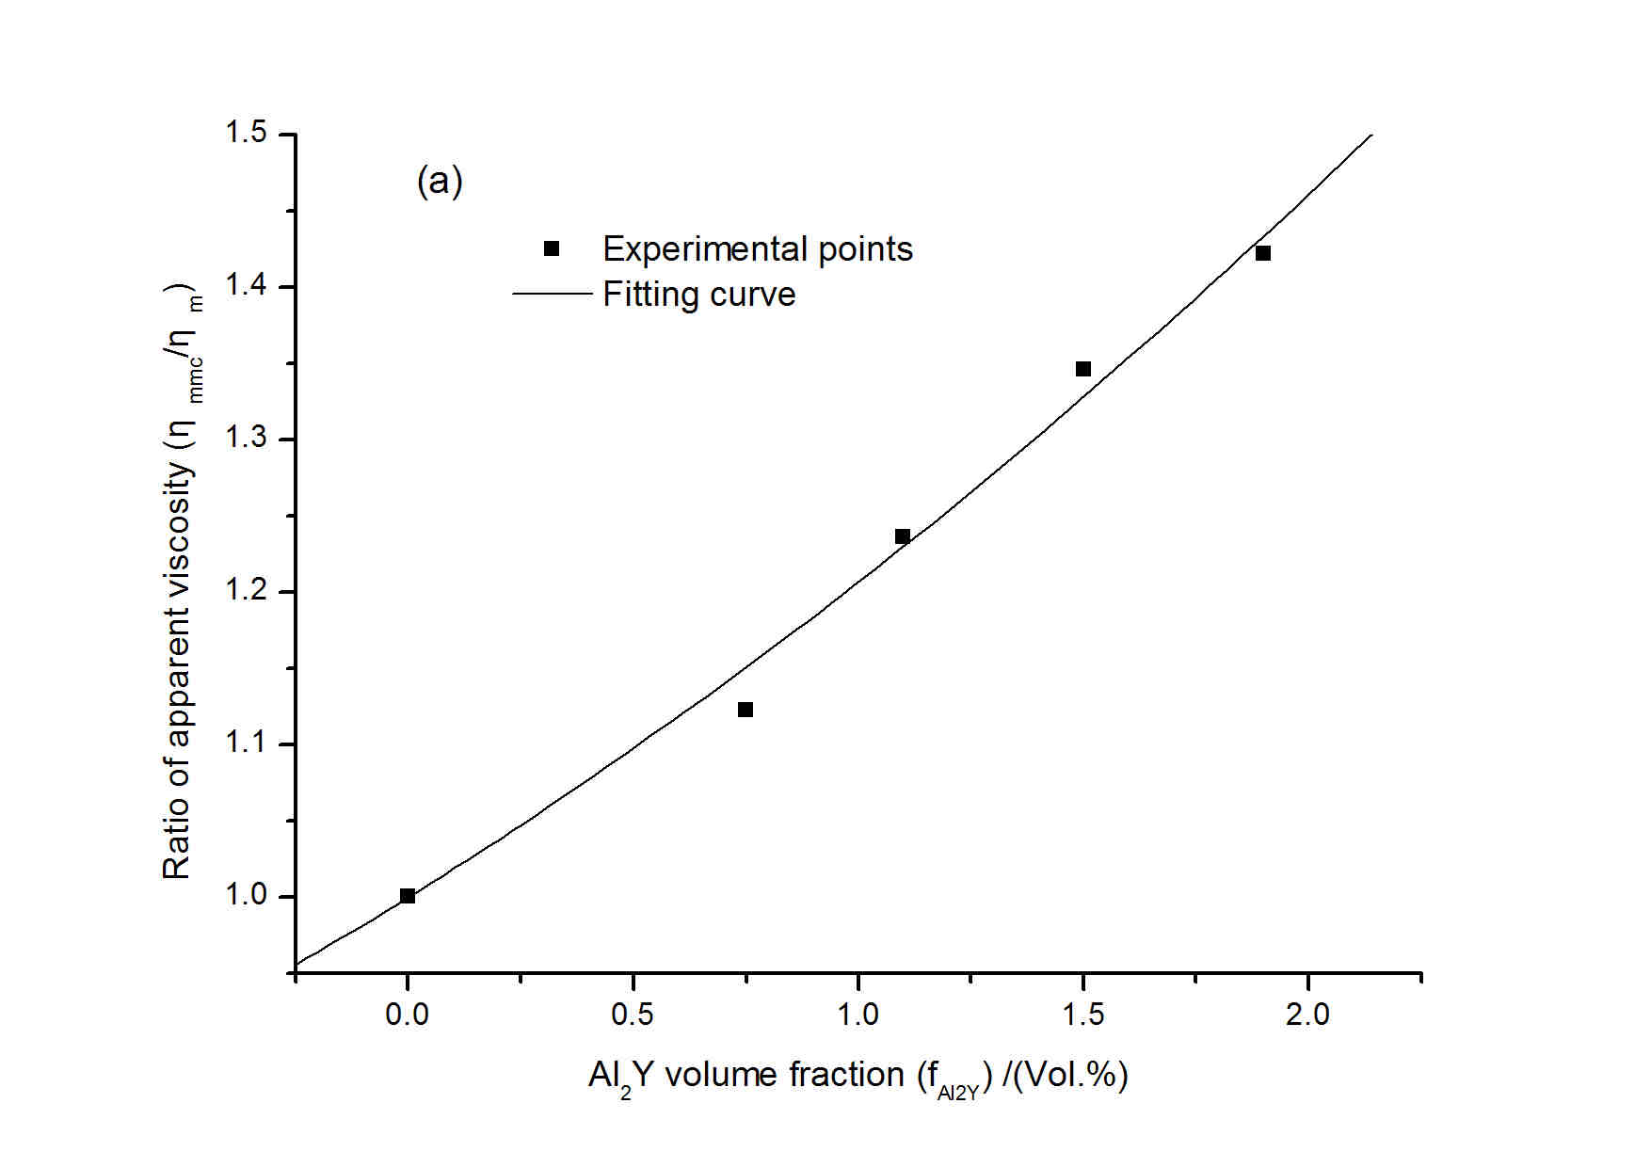

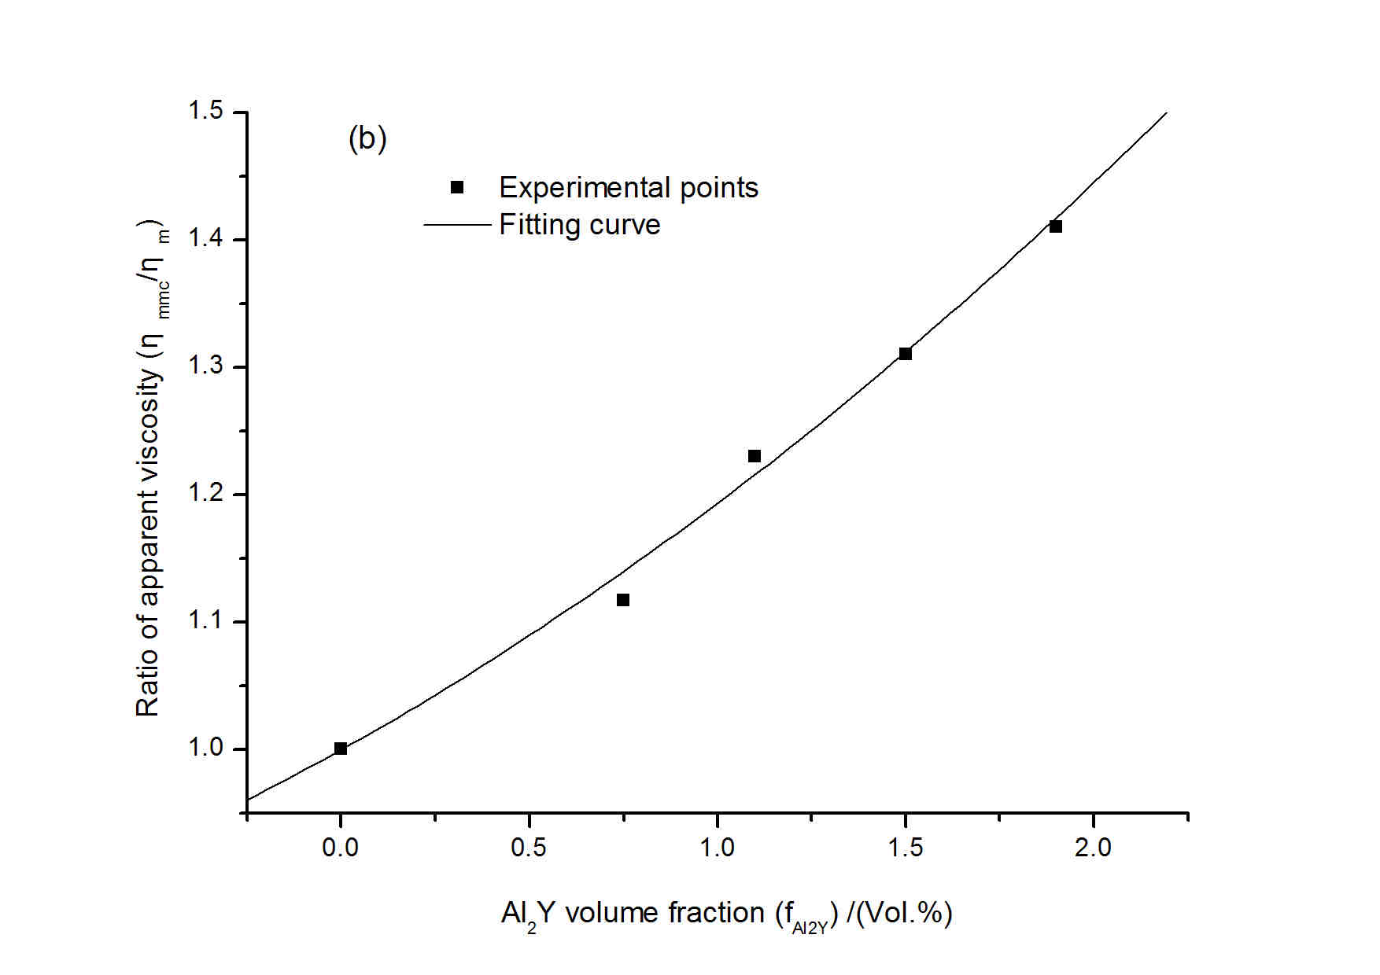

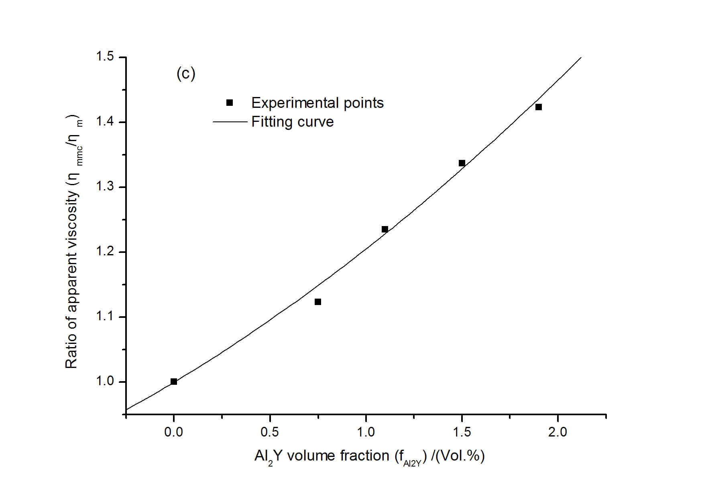

Fig.3 Relationship between the ratio of apparent viscosity () and Al₂Y volume fraction() : (a) ultrasonic power 600w and solid fraction 0.13, (b) ultrasonic power 800w and solid fraction 0.17, and (c) ultrasonic power 800w and solid fraction 0.27

The formula (3) revealed the relationship among apparent viscosity of composite material (), apparent viscosity of matrix material AZ91() and Al₂Y volume fraction(). So the relationship between apparent viscosity of semi-solid Al₂Y/AZ91 magnesium matrix composites and ultrasonic parameters can be obtained by researching the relationship between apparent viscosity of matrix material AZ91 and ultrasonic parameters.

Table 1 The value of coefficient a and b in formula (2)
solidfractionand ultrasonic power P (w) | a | b
=0.13 and P=600w | 235.9 | 18.34
=0.17 and P=800w | 291 | 16.45
=0.27 and P=800w | 274.1 | 17.79

3.2 Relationship between apparent viscosity of matrix material and ultrasonic parameters
Fig.4 shows the relationship among apparent viscosity of matrix material AZ91, ultrasonic power P and solid fraction. As shown, apparent viscosity of matrix material AZ91 increases with the increase of solid fraction, and when the value of the solid fraction is low, the apparent viscosity increases slowly, while the solid fraction becomes higher, the apparent viscosity increases quickly. In the early period of semi-solid slurry forming, solid fraction is relatively low and the primary а-Mg phase is relatively less, ultrasonic acoustic streaming effect and cavitation effect caused by ultrasonic vibration can effectively broken primaryа-Mg phase, which make grain turn into fine granular crystal and distribute uniformly in the semi-solid slurry, therefore, apparent viscosity of semi-solid slurry increase slowly. However, when the solid fraction become relatively high, the quantity of primaryа-Mg phase increase as well as, a number of large primary α-Mg particles may absorb and hinder ultrasonic in the slurry, furthermore, the macroscopic flow produced by acoustic streaming and the microflow produced by cavitation are limited, some primary α-Mg particles tend to grow up and even some particles agglomerate, which result in the viscosity of slurry increasing quickly. As shown in Fig.4, when the solid fraction is the same, the viscosity of slurry decrease with the increase of ultrasonic power. The effect of ultrasonic acoustic streaming and cavitation are enhanced obviously by the greater ultrasonic power, microflow and high pressure shock wave caused by ultrasonic vibration can effectively fragment the dendrite arms, In addition, the flow velocity of melt is accelerated by the acoustic streaming, thereby melt temperature tends to be uniform contributing to reduce constitutional supercooling of solidification front, therefore, the growth of primary α-Mg is limited. All of the above result in the decrease of viscosity of slurry with the increase of ultrasonic power. As shown in Fig.4, the relationship between and is similar to exponential law, which can be fitted by
(4)

Where A and B is coefficient. The fitting curve is shown in Fig.5. The value of coefficient A and B are shown in Table 2. As shown in Table 2, the value of coefficient B change little with increase of ultrasonic power P, which average value is about 5.76, however the value of coefficient A decrease with increase of ultrasonic power P, by the analyzing of value of A the relationship of coefficient A and ultrasonic power P can be fitted by power function. Fig.6 shows the fitting curve of coefficient A and ultrasonic power. The fitting equation is:
(5)

Where P is ultrasonic power, Therefore, the fitting equation of and is:
(6)

Table 2 The value of coefficient A and B in formula (4)
ultrasonic power P（w） | A | B
200 | 1.994 | 5.601
400 | 1.711 | 5.57
600 | 1.319 | 5.732
800 | 0.8768 | 6.153
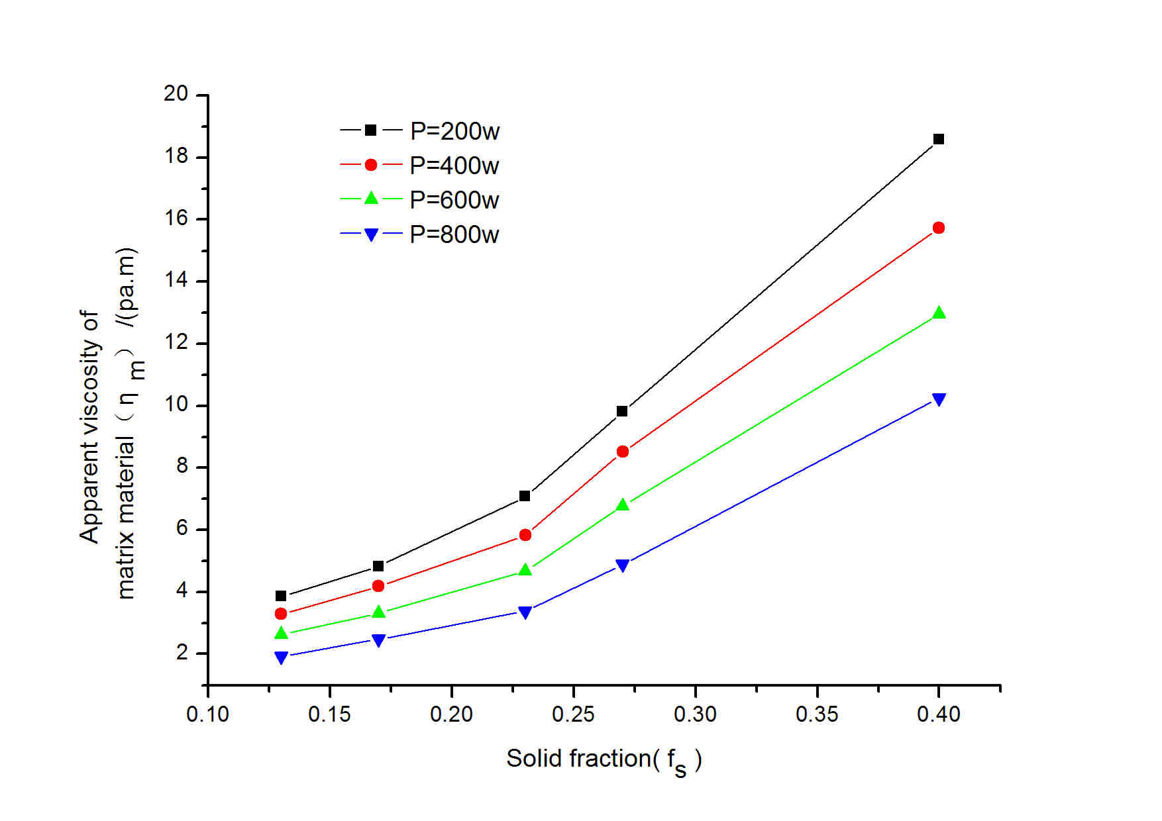

Fig.4 The relationship among apparent viscosity of matrix material , solid fraction and ultrasonic power P
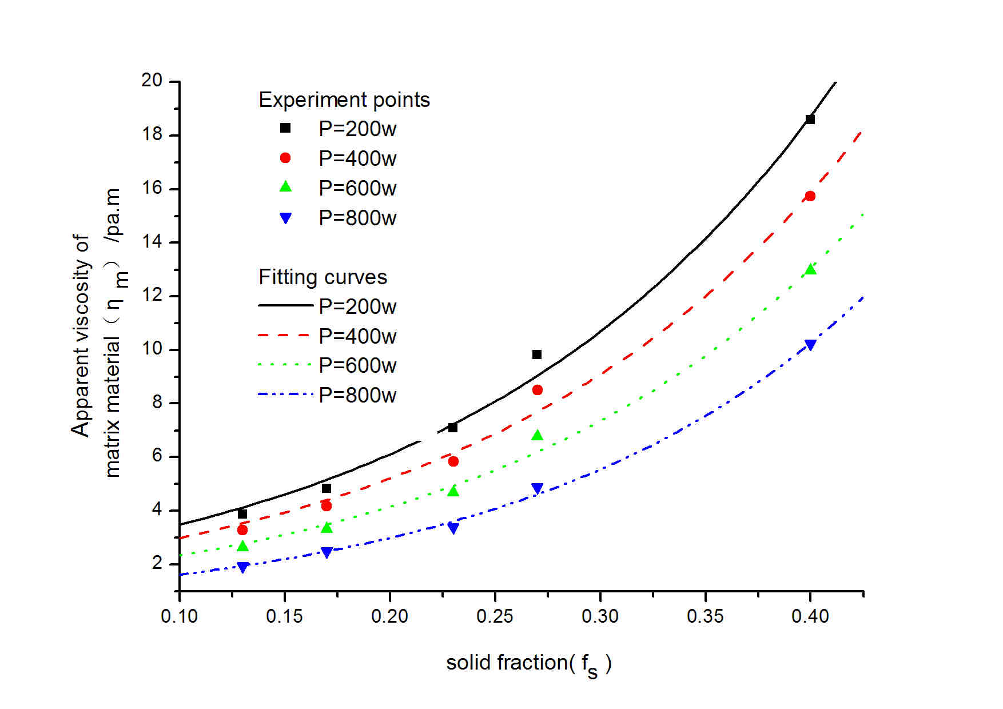

Fig.5 The fitting curve of relationship among viscosity of matrix material , solid fraction and ultrasonic power P

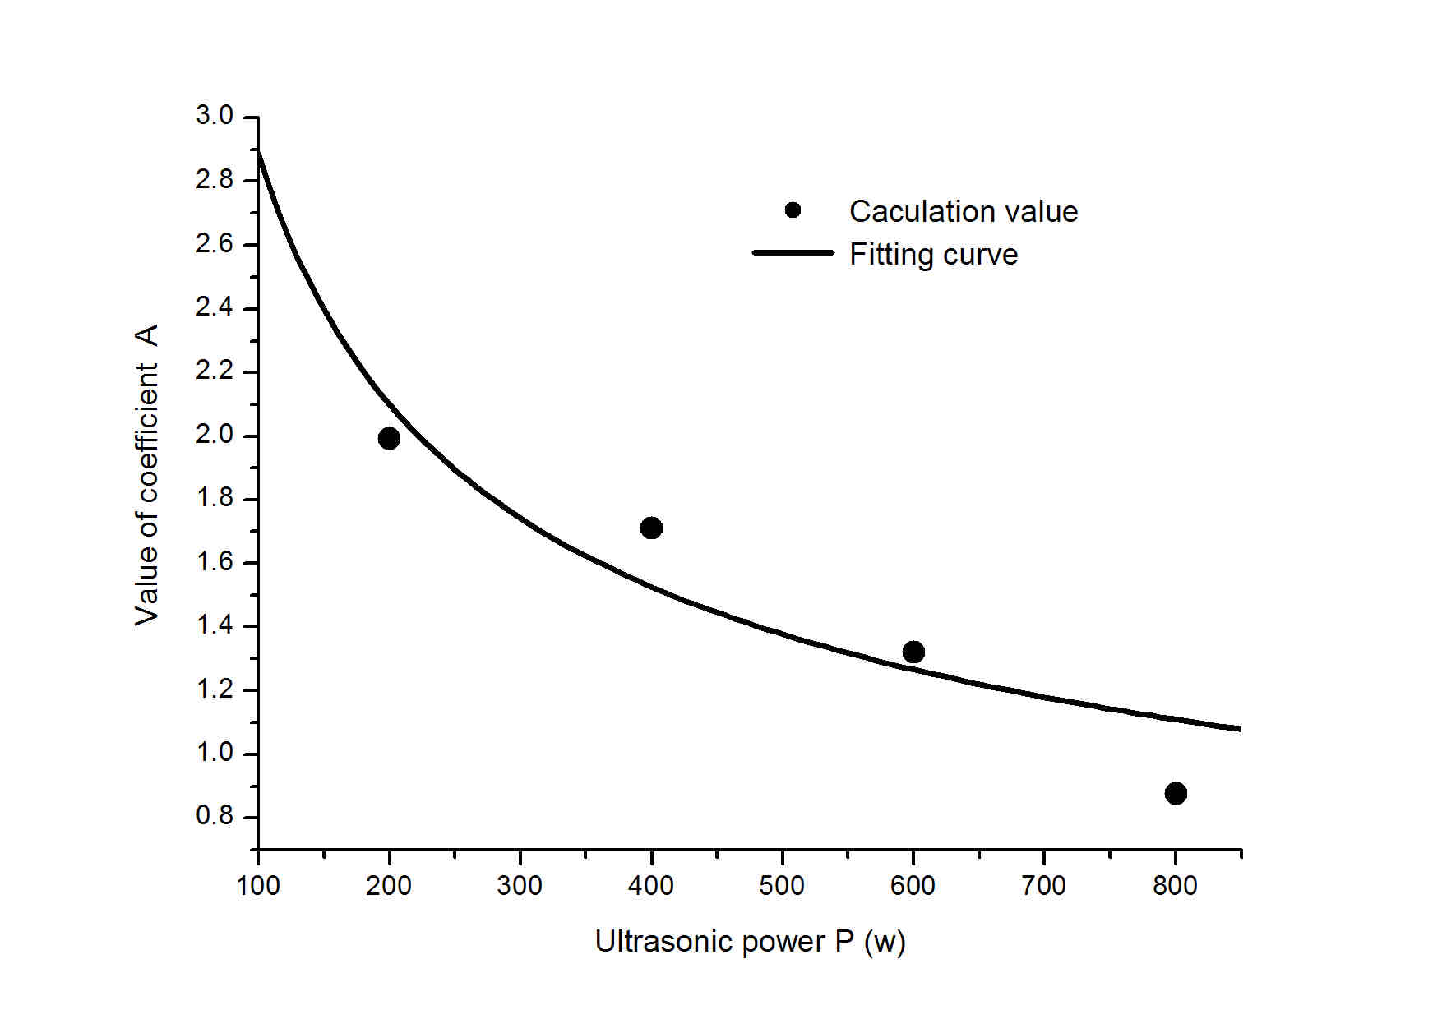

Fig.6 The fitting curve of relationship between ultrasonic power P and coefficient A

3.3 Rheological model of magnesium matrix composites
Based on the relationship among apparent viscosity of matrix material , solid fraction and ultrasonic power P, and the effect of reinforcement Al₂Y volume fraction on the magnesium matrix composites, the rheological model of magnesium matrix composites can be obtained by feeding formula (6) into formula (3):

(7)

4 Conclusions
The apparent viscosity of semi-solid Al₂Y/AZ91 magnesium matrix composites slurry was measured. According to the experiment results, with the increase of volume fraction of Al₂Y the apparent viscosity of semi-solid Al₂Y/AZ91 magnesium matrix composites slurry increases, the relationship between viscosity and solid fraction varies according to the exponential law, under the same experimental conditions, the apparent viscosity decreases with the increase of ultrasonic power. Based on the fitting of data obtained under the experimental condition in this work, the rheological model of semi-solid Al₂Y/AZ91 magnesium matrix composites prepared by ultrasonic vibration was established, which is:

Reference
[1] Shu L L, Shu S W, Chong L, Zu Q H, Ping A. Mater. Sci. Eng. A[J], 2011, 528:8635.

[2] Liao B C, Park Y K, Ding H S. Mater. Sci. Eng[J], A, 2011,528:986.

[3] Chen Y N, Wei J F, Zhao Y Q, Ma X D,Hao J M. Rare Metal Materials and Engineering[J]. 2012, 41:581.

[4] Wang L P, Chen T, Jiang W Y, Feng Y C, Dong W X, Wang Z W, Liang Z Q, Zhu Y. Journal of Rare Earths[J], 2013, 31:319.
[5] Mao W M，Zhen Z S, Yan S J, Zhong X Y．J.Mater. Sci.Techno[J]l, 2004, 20:580．

[6] Luo S J ,Keung W.C. KEUNG, Kang Y L. Nonferrous Metals Society of China[J],2010, 20:1805.

[7] Yan H, Rao Y S, He R. Journal of Materials Processing Technology[J], 2014, 214:612.

[8] Huang W X, Yan H. Rare Metal Materials and Engineering[J], 2013, 42: 2346.

[9] Zhu Z M, Wu S S, Lü S L, Dai W, Wan L, Liu L F. Trans. Nonferrous Metals Society of China[J], 2011, 21:325.
[10] Dai W, Wu S S, Lü S L, Lin C, Wan L. Special Casting & Nonferrous Alloys[J], 2011,31: 930.

超声原位Al₂Y /AZ91镁基复合材料流变模型研究

黄文先^{1，2，3}，闫洪^{1，2}
(1．南昌大学机电工程学院材料加工工程系，江西 南昌，330031)
(2. 南昌市轻合金材料制备与成形重点实验室，江西 南昌，330031)
(3．井冈山大学建筑工程学院土木工程系，江西 吉安，343009)

摘 要：利用高能超声法原位制备Al₂Y /AZ91镁基复合材料半固态浆料，对其半固态表观粘度进行测量，实验表明：半固态Al₂Y /AZ91镁基复合材料表观粘度随固相分数和Al₂Y的体积分数的增加而增大，半固态表观粘度与固相分数之间关系按指数规律变化，在相同的实验条件下，半固态表观粘度随超声功率增大而减小。在对实验数据拟合的基础上，建立了半固态Al₂Y /AZ91镁基复合材料的流变模型。
关键词：超声；Al₂Y /AZ91镁基复合材料；半固态；流变模型

第一作者：黄文先, 男1975生，博士生，讲师，南昌大学机电工程学院材料加工工程系，江西 南昌330031，电话：0791-83968873，Email:huangwenxianjgs@163.com
通讯作者：闫洪, 男1962生，博士，教授，南昌大学机电工程学院材料加工工程系，江西 南昌330031，电话：0791-83968873 Email: yanhong_wh@163.com

