Microstructure and Grain Refinement Performance of a New Al-5Nb-RE-B Master Alloy
Wu Xiaoyan¹, Zhang Huarui^{1,2}, Jiang Feng¹, Yun Ying³, Jia Lina^{1,2}, Zhang Hu^{1,2}

¹ School of Materials Science and Engineering, Beihang University, Beijing 100191, China; ² Beijing Key Laboratory for Advanced Functional Material and Thin Film Technology, Beihang University, Beijing 100191, China; ³ Sanmencia Polytechnic, Sanmenxia 472000, China

Abstract: A new kind of grain refiner Al-5Nb-RE-B master alloy with uniform microstructure was prepared by melt reaction method. The effect of Al-5Nb-RE-B inoculation on grain refinement of A356 aluminum alloy was studied. The results show that the Al-5Nb-RE-B master alloy consists of α-Al phase, Al3RE, Nb2Al20RE, and NbB2 phases. When the prepared Al-5Nb-RE-B master alloy was added in an amount of 1.0 wt%, the grain size of the A356 alloy was reduced from 800 μm to 200 μm. Analysis of the A356 alloy solidified at a wide range of cooling rates indicate that 1.0 wt% Al-5Nb-RE-B inoculation exhibits the lowest sensitivity to cooling rate.

Key words: Al-5Nb-RE-B master alloy; grain refinement; cooling rate sensitivity; A356 aluminum alloy

A356 aluminum alloy is an ideal and commonly used material in the automotive field due to its excellent castability, corrosion resistance, and especially high strength to weight ratio^{[1-5]}. Grain refinement has been approved as a crucial issue to improve the mechanical properties of this cast aluminum alloy^{[6]}. There are several methods to achieve grain refinement in the solidification process, such as adding grain refiners, rapid cooling conditions, mechanical or electromagnetic stirring, and ultrasonic treatment. However, the addition of grain refiner is the most common method in the industry.
Al-Ti-B master alloy has become the preferred choice for grain refinement of cast aluminum alloys^{[7]}. Nonetheless, many studies^{[3,8]} have reported that Al-Ti-B master alloy cannot effectively refine Al-Si alloys with higher Si content. When the percentage of Si is greater than 4 wt%, the reaction of Ti and Si leading to the formation of titanium silicide. This reaction will deplete the Ti melt and prevent grain refinement of alloys. Therefore, it is essential to develop a new grain refiner which can be free from this problem.
Nb is a promising candidate for the refinement of Al and its alloys because, like Ti, it is also characterized by the a peritectic reaction with Al^{[3, 8-11]}. Moreover, Nb forms isostructural phases with titanium aluminide, specifically Al3Ti and Al3Nb. Compared to titanium silicide, niobium silicide is a high temperature intermetallics. There will be extremely few probabilities to form niobium silicides at 800 °C, so the Nb-based phases will act as heterogeneous nucleation sites for aluminum alloys without poisoning effects.
Many studies^{[5, 12, 13]} on grain refiners have shown that RE metals have the effect of hindering nucleation particles from aggregating and precipitating. Meanwhile, they prolong the fading time of the grain refining and improve the refining efficiency. It is supposed that the refinement can be greatly improved if these elements work together properly in the melt.
It is well known that cooling rate has a great influence on the grain size. The lower the cooling rate sensitivity, the better the grain refiner. Therefore, it is essential to investigate the sensitivity of grain refiners.
In this work, a new grain refiner Al-5Nb-RE-B was prepared by melt reaction method. The microstructure of Al-5Nb-RE-B grain refiner and its refining effect on A356 aluminum alloy were investigated. Meanwhile, the sensitivity of the grain refiner to the cooling rate was also analyzed.
1 Experiment
The work described in this paper was divided into two main sections, namely (1) the preparation of Al-5Nb-RE-B master alloy, and (2) the addition of Al-5Nb-RE-B master alloy to A356 alloy.
For Nb melting is difficult in A356, Al-Nb master alloy was used as a raw material. The Al-5Nb-RE-B master alloy (M1) was prepared by commercial pure Al. Al-Nb master alloy, Al-RE master alloy, and Al-B master alloy were fabricated by melt reaction method in an induction melting furnace. As a conventional grain refiner, the Al-5Ti-B master alloy (M2) was used for comparison in this study. The master alloys used in the experiment were presented in Table 1.
The grain refinement performance between the M1 and M2 master alloys was compared. A356 aluminum alloy was a base alloy and its chemical composition was given in Table 2. Firstly, the A356 aluminum alloy was melted in an induction melting furnace at 740 °C. After holding for 20 min, the grain refiner was added into the melt and stirred thoroughly. Then it was poured into a preheated wedge-shaped graphite mold, as shown in Fig.1a. Three variations of aluminum alloys were investigated, which were A356 alloy, A356 alloy refined with 1.0 wt%M1 and 1.0 wt%M2. To evaluate the cooling rate sensitivity of grain refiners, K-type thermocouples were inserted into different locations of the mold and connected to a data acquisition system (Fig.1a) to record the solidification parameters during solidification.
Metallographic specimens of M1 master alloy were taken from the center of the transverse section of each sample. The metallographic specimens were etched with Keller reagent after mechanical polishing. Scanning electron microscopy (SEM Camscan-3400) with energy-dispersive spectrometry (EDS) was used to analyze the microstructures and components.
As shown in Fig.1b, microstructural analysis of the refinement effect was performed on the cross-sections of wedge-shaped specimens with different diameters (60, 40, 20, 10 mm). These metallographic specimens were mechanically ground and polished through standard routines. The Optical microscope (LEICA DM4000) was

Table 1 Preparation of the experimental master alloys
Alloy | Alloy designation | Preparation method
Al-5Nb-RE-B | M1 | Melt reaction
Al-5Ti-B | M2 | Melt reaction
Table 2 Actual chemical composition of A356 alloy (wt/%)
Al | Si | Mg | Ti | Sr | Fe | Mn | Zn | Cu
Bal. | 6.98 | 0.3 | 0.12 | 0.0159 | 0.113 | 0.003 | 0.02 | 0.005

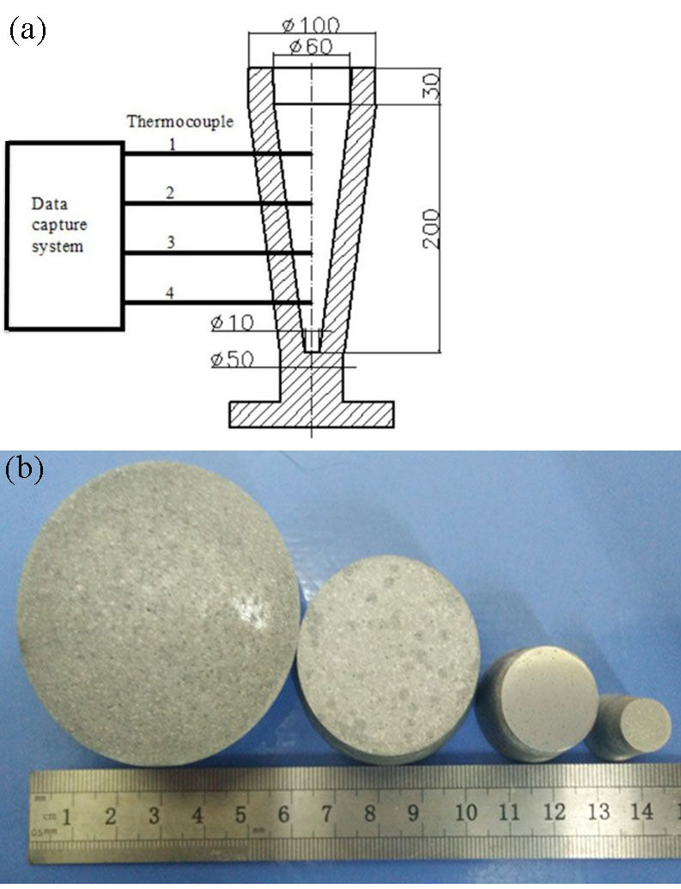
Φ100
Φ60
Φ10
200
30
Thermocouple
Data capture system
4
Φ50
3
2
1
a
b

Fig.1 Schematic of taper-shaped graphite mold and thermocouple positions (a); the samples obtained in the four locations with different diameters (b)

used to measure the grain structure. Average grain size values were obtained using a linear intercept method.
2 Results and Discussion
2.1 Microstructure analysis of Al-5Nb-RE-B master alloy
The SEM micrographs of the cross-section of Al-5Nb-RE-B master alloy (M1) with a uniform microstructure are shown in Fig.2. From the SEM analysis, it is found that in addition to the α-Al solid solution, there are also three different types of intermetallic particles in this new grain refiner. These three types of particles have the morphologies of dendritic structure (A), plate-like (B), and spherical (C). As illustrated in the picture, A and C particles with a mean size of ~4 μm are dispersed in the Al matrix homogeneously and the size of the globular C particle is the smallest. Many large particles B with a size of about 15 μm are distributed among these small particles.
In order to determine the composition of these three intermetallic particles, EDS analysis was carried out as shown in Table 3. The chemical composition of the particles A shown in Table 3 is AlRE particle composed of 61.13 wt% of Al, 12.86 wt% of La, and 26 wt% of Ce. Particles B and C are Nb-based intermetallic particles (AlNbRE and NbB phases)

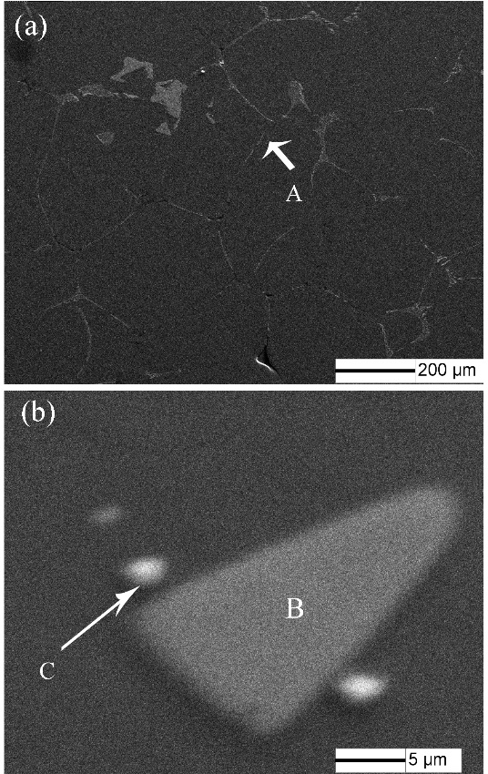
a
b
200 µm
5 µm

Fig.2 Microstructures of M1 master alloy

Table 3 Composition of intermetallic particles A, B and C in
Fig.2 (wt/%)
Particle | Al | La | Ce | Nb | B | Total
A | 61.33 | 12.86 | 26 | - | - | 100
B | 61.43 | 3.79 | 12.71 | 22.07 | - | 100
C | 19.8 | - | - | 38.68 | 41.52 | 100

which contained 22.07 wt% and 38.68 wt% Nb, respectively. In the preparation of Al-5Nb-RE-B master alloy, the individual reactions in the process are shown in Eqs.(1)~(4)^{[10, 14]}:
Nb+3Al→Al3Nb (1)
Al3Nb+AlB2→NbB2+4Al (2)
14Al+2Al3Nb+RE→Nb2Al20RE (3)
RE+3Al→Al3RE (4)
According to these four expressions, the second phase particles of the Al-5Nb-RE-B master alloy are mainly Al3RE, Nb2Al20RE and NbB2 phases, which is consistent with the EDS results.
Rare earth elements tend to congregate at the interface of the phases or grain boundaries, which is in favor of blocking the growth of the crystal phases^{[14]}. It has been reported that RE elements can improve the wettability between molten aluminum and intermetallic compounds. This behavior makes them difficult to aggregate or deposit, and then more intermetallic compounds will be effective nucleus^{[5, 12, 13]}. Therefore, small intermetallic compounds (AlNbRE and AlRE) are formed in the master alloy.
2.2 Refining performance
Fig.3 shows the microstructures of cast A356 alloy grains refined with different grain refiners at a cooling rate of 2 °C/s. A356 alloy without grain refiner (Fig.3a) exhibits a mixture of both columnar and coarse equiaxed grain structures with a size of ~800 μm.
Apparently, the microstructures of the refined A356 alloy show a very fine equiaxed grain structure with a complete transition from columnar to fine equiaxed structure. The grain size of A356 alloy refined with M2 master alloy is about 400 μm and that with M1 master alloy is about 200 μm. It could be calculated that the grain fineness of the M1 and M2 grain refiner is about 50% and 25%, respectively. Therefore, the M1 master alloy performs a better refining effect than the M2 master alloy under the same solidification conditions.
Due to the similar lattice parameters between Nb and Ti, similar compounds (NbAl3 and TiAl3) are formed in these two master alloys^{[9]}. However, no NbSi phase is found in the M1 master alloy, which indicates that no poisoning effect occurs during the refining process. Therefore, the addition of niobium element is more effective than the titanium element in refining the A356 alloy.
Meanwhile, the addition of RE has a great influence on the refining process. As stated in the former section, RE restrains the growth of intermetallic compounds and forms more

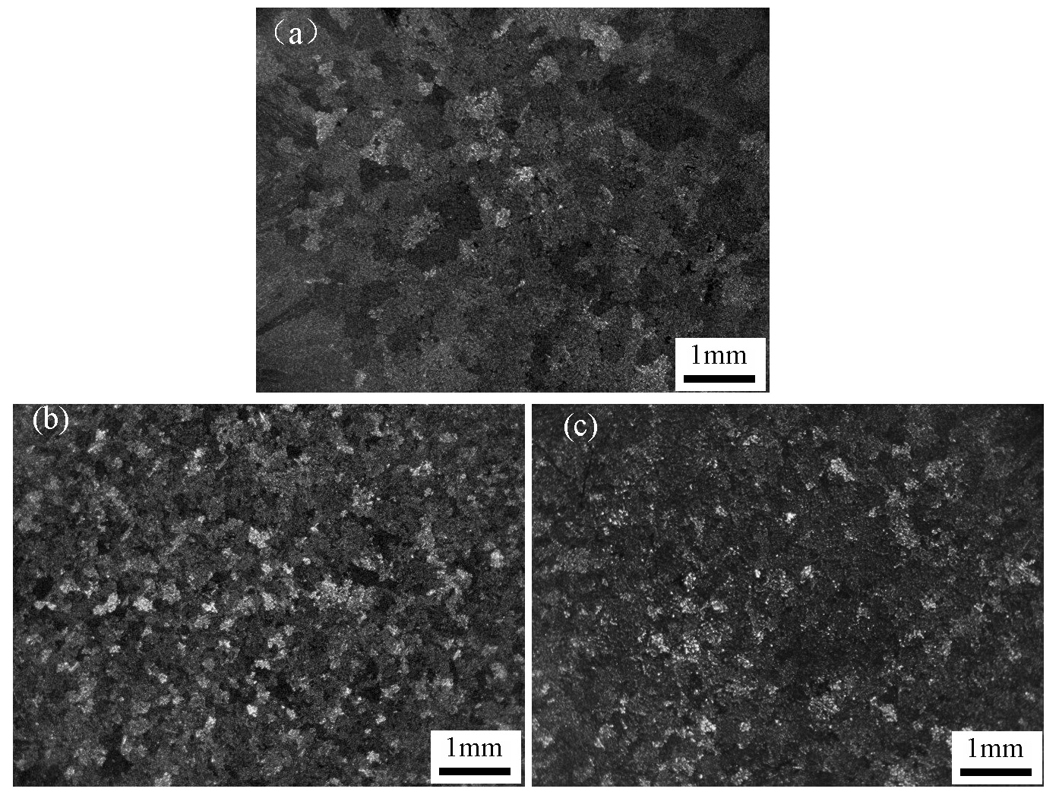
c
b
a
1 mm

Fig.3 Primary α-Al dendritic grain structures of A356 alloy with and without grain refiners at a cooling rate of 2 °C/s: (a) without grain refiners; (b) 0.3 wt% M1; (c) 0.3 wt% M2

nucleation centers. During solidification process, heterogeneous nucleation is the main nuclear mechanism. The smaller the size of the intermetallic compound, the finer the grain size is. Therefore, the grain refinement efficiency of the M1 master alloy is significantly improved by adding a small amount of Nb and RE to the master alloy.
The refining effects of grain refiners at different cooling rates are presented in Fig.4 and Fig.5. From analysis of the microstructure characterization, it can be seen that the grain sizes decrease with the increase of the cooling rate employed to solidify the material for these two kinds of grain refiners. This behavior is expected because the faster the cooling rate, the shorter the growth time of the nucleated grain.
From the micrographs of A356 alloy grains after the addition of M1 master alloy (Fig.4), it can be noticed that the alloy is characterized by very fine equiaxed dendritic grains in the range of 200~400 μm from the highest to the lowest cooling rate. From the representative micrographs of the addition of the M2 master alloy in Fig.5, the grain size changed from 500 μm to 300 μm with the increase of the cooling rate. Consequently, for the M2 master alloy, the M1 master alloy with Nb and RE elements leads to significant refinement over a wide range of cooling rates so that the final grain size is less dependent on heat extraction.
2.3 Cooling rate sensitivity of grain refiners
The comparison of the variation of grain size versus cooling rate for A356 alloy with and without the addition of master alloys is presented in Fig.6. The trend of the variation of grain size shown in Fig.6 is the ones expected on the basis of the discussion of the microstructural analysis. The variation as a function of the cooling rate is more flat for M1 refined alloy than M2 refined alloy. It suggests that M1 master alloy is a kind of grain refiner that has a lower sensitivity to the cooling rate and with a higher nucleation rate for the A356 aluminum alloy. Moreover, when the addition amount of M1 master alloy is 1.0 wt%, the aluminum alloy presents the least sensitivity to the cooling rate.
The cooling rate sensitivity is related to the undercooling^{[15]}. The smaller the degree of undercooling, the lower the cooling rate sensitivity. This is due to the introduction of a potent heterogeneous nucleation substrates which decreases the nucleation energy and favors the growth of a greater number of primary α-Al grains.
As a kind of surface-activated element, RE addition promotes the forming of NbB and AlNbRE phases. The undercooling changes with the concentration gradient. Thus, a strong constitutional undercooling occurred, which reduced the growth rate at the growing interface and restricted the nucleation growth of the α-Al phase. Therefore, the heterogeneous nucleation of α-Al after adding M1 refiner may occur at a lower degree of undercooling. Meanwhile, the extent of undercooling was proportional to the efficiency of the grain refiner in providing potent nucleating sites. All this indicates that the employment of M1 master alloy makes the change in grain size less dependent on the solidification process, especially the cooling rate.

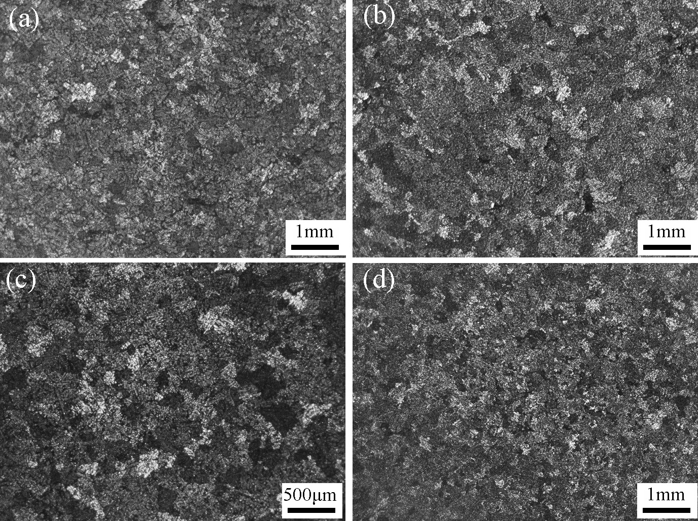
1 mm
500 µm
d
c
1 mm
1 mm
b
a

Fig.4 Microstructures of the A356 alloy wedge-shaped samples with M1 master alloy added at different cooling rates: (a) 2 ºC/s, (b) 4 ºC/s, (c) 16 ºC/s, and (d) 32 ºC/s

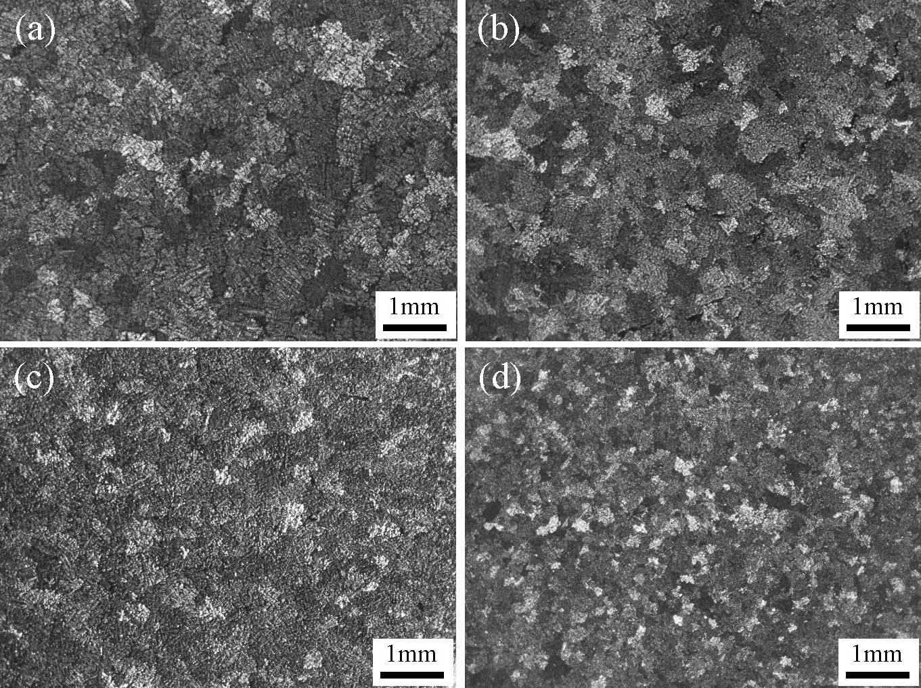
1 mm
d
c
b
a

Fig.5 Microstructures of A356 alloy wedge-shaped samples with M2 master alloy added at different cooling rates: (a) 2 ºC/s, (b) 4 ºC/s, (c) 16 ºC/s, and (d) 32 ºC/s

Fig.6 Grain refining performance of master alloys in A356 alloy at different cooling rates

3 Conclusions
1) A novel Al-5Nb-RE-B master alloy was prepared. This master alloy is mainly composed of α-Al solid solution, Al3RE, Nb2Al20RE and NbB2 phases. The addition of Al-5Nb-RE-B master alloy changes the grain size from 800 to 200 μm and the morphology changes from coarse dendrites to fine equiaxed grains. It is also confirmed that this new master alloy (Al-5Nb-RE-B master alloy) has more excellent refinement effect than the conventional Al-Ti-B master alloy in refining the primary α-Al dendrites of the A356 alloy.
2) The addition of 1.0 wt% Al-5Nb-RE-B master alloy to A356 aluminum alloy has the lowest sensitivity to cooling rate. Therefore, the employment of Al-5Nb-RE-B master alloy makes the variation of the grain size less dependent on the solidification process.

References
- Sha M, Wu S, Wang X et al. Materials Science and Engineering A[J], 2012, 535(7): 258
- Chen Z W, Ma C Y, Chen P. Transactions of Nonferrous Metals Society of China[J], 2012, 22(1): 42
- Nowak M, Bolzoni L, Hari B N. Materials & Design[J], 2015, 66: 366
- Merlin M, Timeli G, Bonollo F et al. Journal of Materials Processing Technology[J], 2009, 209(2): 1060
- Aguirre-Delatorre E, Pérez-Bustamante R, Camarillo- Cisneros J et al. Journal of Rare Earths[J], 2013, 31(8): 811
- Metan V, Eigenfeld K, Räbiger D et al. Journal of Alloys and Compounds[J], 2009, 487(1-2): 163
- Fan Z, Wang Y, Zhang Y et al. Acta Materialia[J], 2015, 84: 292
- Bolzoni L, Nowak M, Hari B N. Materials & Design[J], 2015, 66: 376
- Bolzoni L, Nowak M, Hari B N. Materials Science and Engineering A[J], 2015, 628: 230
- Nowak M, Bolzoni L, Hari B N et al. Materials & Design[J], 2015, 75: 40
- Bolzoni L, Nowak M, Hari B N. Journal of Alloys and Compounds[J], 2015, 623: 79
- Wang X J, Xu C, Muhammad A et al. Transactions of Nonferrous Metals Society of China[J], 2014, 24(7): 2244
- Zhao H L, Song Y, Li M et al. Journal of Alloys and Compounds[J], 2010, 508(1): 206
- Wang Zhengjun, Si Naichao. Rare Metal Materials and Engineering[J], 2015, 44(12): 2970 (in Chinese)
- Zhang H R, Liu Z B, Li Z Z et al. Acta Metallurgica Sinica, English Letters[J], 2016, 29(5): 41

Al-5Nb-RE-B新型细化剂组织和细化效果研究

武晓燕¹，张花蕊^{1,2}，姜 峰¹，员 莹³，贾丽娜^{1,2}，张 虎^{1,2}
(1. 北京航空航天大学 材料科学与工程学院, 北京 100191)
(2. 北京航空航天大学 特种功能材料与薄膜技术北京市重点实验室, 北京 100191)
(3. 三门峡职业技术学院, 河南 三门峡 472000)

摘 要：采用熔体反应方法制备了一种新型 Al-5Nb-RE-B新型细化剂，研究了Al-5Nb-RE-B细化剂对A356铝合金的细化效果的影响。结果表明，Al-5Nb-RE-B细化剂主要包含α-Al基体相、Al3RE、Nb2Al20RE和NbB2 4种相; 当Al-5Nb-RE-B新型细化剂添加量为1.0 %(质量分数)时，A356铝合金的晶粒尺寸从800 μm降到200 μm; Al-5Nb-RE-B新型细化剂的添加可以增大冷却速度范围，即新型细化剂具有较低的冷速敏感性。
关键词：Al-5Nb-RE-B晶粒细化剂；细化效果；冷速敏感性；A356铝合金

作者简介：武晓燕, 女, 1989年生, 博士生, 北京航空航天大学材料科学与工程学院, 北京 100191, 电话: 010-82319256, E-mail: wuxiaoyan@buaa.edu.cn

